Chapter 9
Mysteries of the Timing & Control Commutators
Some Things are just not going to be figured out that easily.

Any attempt to reverse engineer the EMA4 Free-Energy Engine must deal with the complexities of the partially disclosed commutator section. Despite the overall detail provided in the EMA0 there was no additional information to be found about this vital sub-system.

For years, and even on to this day, researchers pass over learning about the function of the many switching operations that take place in the front end of the Motors/Engines. Many assume that the important non-classical process is to be found in various designs of the external power supply. It probably has been further assumed that there is nothing special in a collection of rotating mechanical arc switches that were pretty much disclosed in patent 3,890,548.

If this author’s proposal is correct, in that the non-classical process takes place inside the engine, then an understanding of how and why the timing operations take place greatly impacts any theory of operation and any following successful replication.

General Discussion:

The E.V. Gray technology, from the beginning, has always been a very non-linear process. There were a large number of gross hard mechanical switching operations that need to be accomplished with each revolution. The early E-series pulse motors had provisions for 15 switching operations per revolution. The successful EMA4 Free-Energy Engine, according to a literal reading of the patent text, has as many as 91 switching operations per revolution. The much simplified EMA6 started with 27 rotary then went to 18 switches. The later EMA7, aka “The Blue Engine” finished the development history with 27 contacts.

Each operation of one of these switches means that a sub-system has been switched into or out of another subsystem. Granted there is a fair amount of redundancy built in, like the notes of a song that repeat in groups. But, knowing which order and for how long these notes take place determines wither the result will be a sweet sounding melody or some irritating noise.

Given the limited information we have to work with, it will be understood that we can’t hope to completely solve this puzzle. Then again given the importance of this subject we should still attempt to squeeze every clue we can from the technical crumbs we have at hand.

To get the most out of this specific exploration we need to look at the whole range of commutators that were used and look for correlations. Fortunately some do exist. We will then come back and focus on the complexities of the EMA4 commutator.

Overview of all the Cole/Hackenberger Commutators:
Variety is the spice (bane?) of reverse engineering.
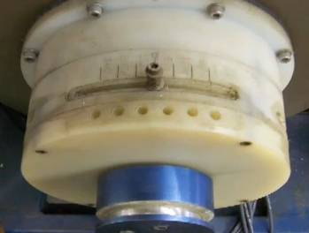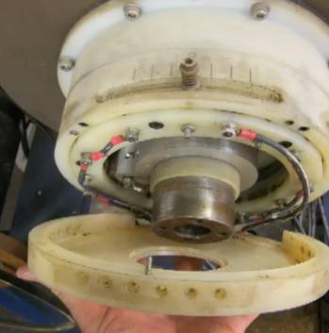

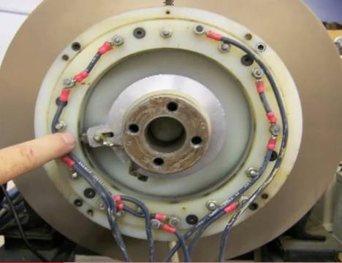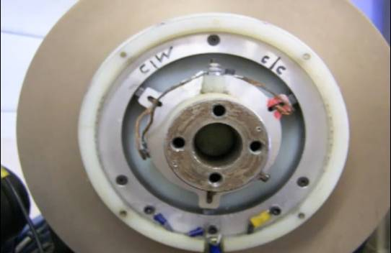

An outstanding series of photos provided by John D. Riley showing details of the E1 commutator and the back slip ring mounted just behind it. To date it appears that all of the E-Series Pulse Motors used the same design of commutator. When Marvin Cole moved on to the construction of true Free-Energy Engines these designs became obsolete and were placed in storage. This commutator was fabricated between 1961 and 1965.

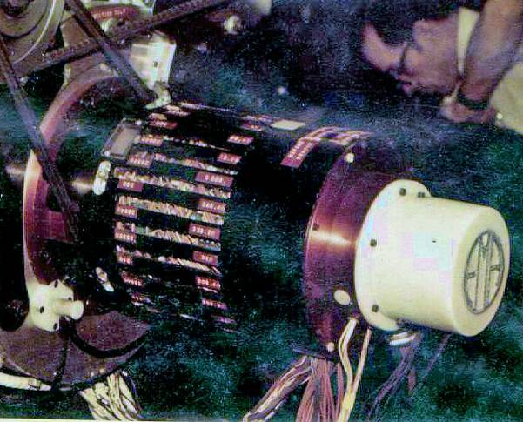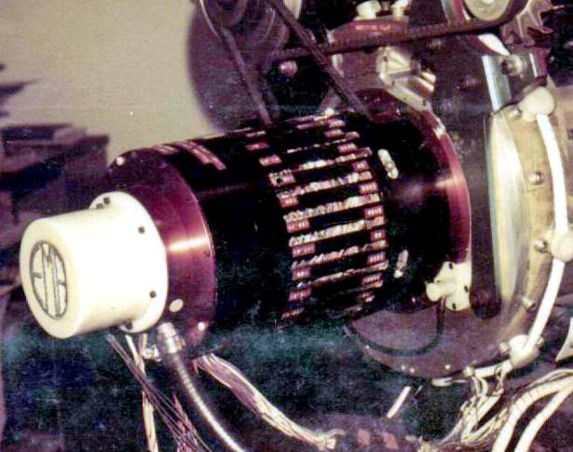

The next documented commutator on the EMA4 Free-Energy Engine proves to be far more complex than its predecessors. This machine worked and therefore this sub-system needs to be paid attention to, circa 1972.
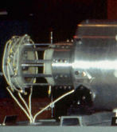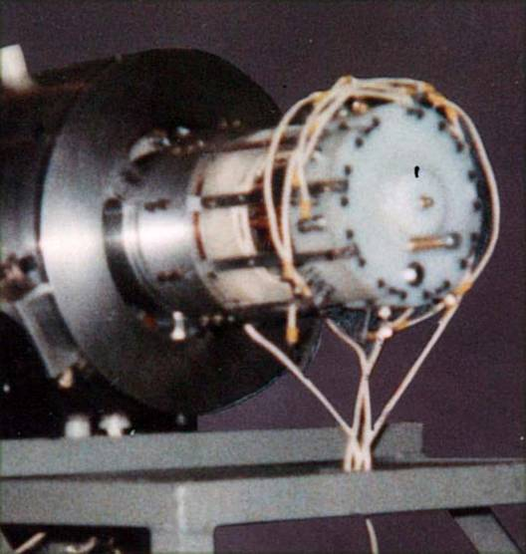

Photos of the EMA6 Free-Energy Engine commutator sub-system during its maiden voyage on Jan 9, 1976. This design appears to be a whole lot simpler than the commutator of the EMA4 engine. Unfortunately this engine only put out about 1/50 of what its predecessor did. It is unknown if the commutator was directly at fault but there is some circumstantial evidence that indicates it might have been part of the problem. Photos from GD Collection.

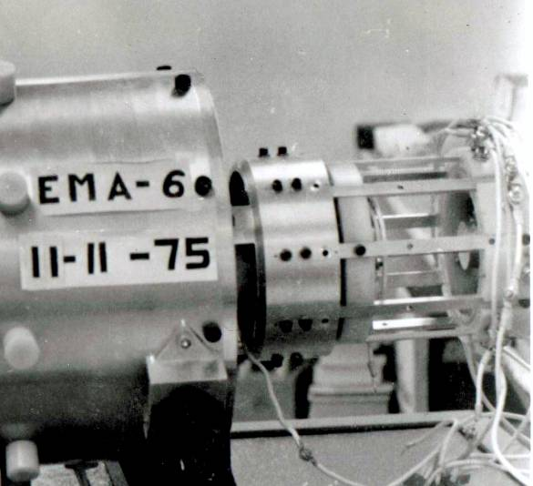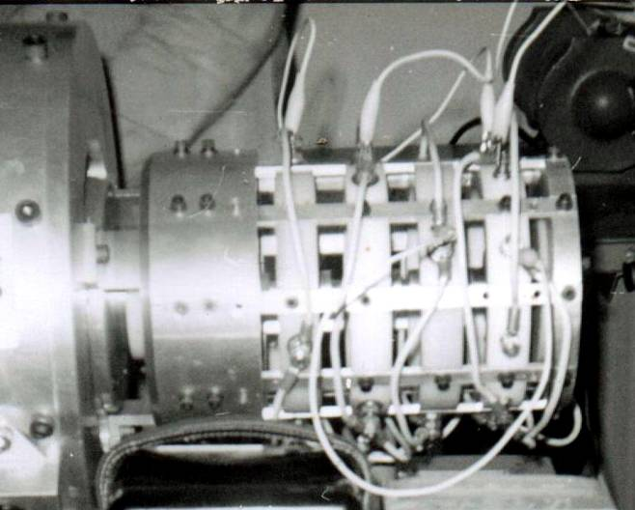

Here is a set of photos that contrast the original EMA6 commutator with the revised one fabricated in May, 1976.
It is suspected that the non-shielded construction of the new design got Gray and Hackenberger into trouble with the FCC when an excessive of EMI was produced during a successful trial run some time in 1977.

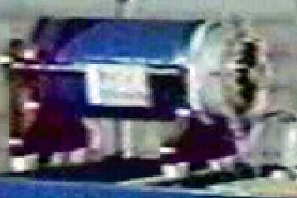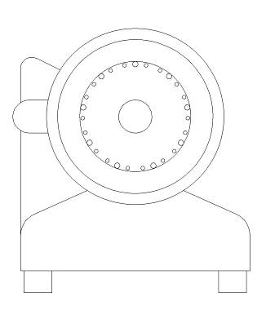

The EMA7 aka “The Blue Engine” the end of the Free-Engine line fabricated by Richard Hackenberger in 1979 in Kalona, KS. This is the smallest and assumed to be the simplest engine ever made. Commutator is seen on the right.

Overall there are only four designs of commutators known. The early series of Pulse Motors appear to have all used the same 15 contact design. This observation suggests that the switching system had been well established and that most of the improved design advancements were done on other parts of the motor.

When the Free-energy process was discovered and then studied in greater detail it seems that the engineering conclusion was that a different commutator design was needed. We see far more variation in the commutators employed for the Free-energy engines that what was ever noticed in the Pulse Motor systems.
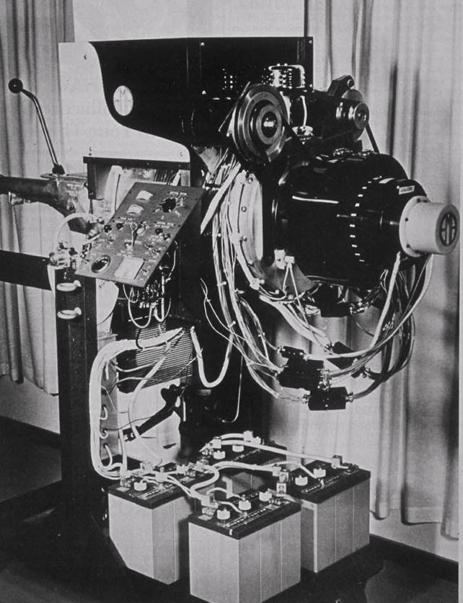
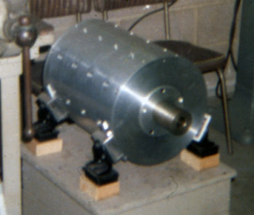
The cannibalized EMA3 in 1974. It is assumed that all the missing parts changed address to the EMA4 – including the internal electromagnets.
Photo from the GD Collection 1974

We have no information on what was used for the first two Free-energy Engines EMA1 and EMA2. It appears that the EMA3 was cannibalized to almost a bare case and that all of the removed components migrated to the EMA4. It is speculated that the EMA3 and the EMA4 Engines shared the same complex commutator system. As it is the commutator on the EMA4-E1 Free-energy Engine is the first one that we have photos of. The commutator of the renovated EMA4-E2 is essentially the same, save for any internal modifications that are unseen. The one observable change was that a large cowling that was on the original EMA1-E1 it was removed to allow observation of the engine during operation. With the cowling no longer present additional details can be seen, thanks to the photos taken by GD in 1974.
The earliest photo of the EMA4-E1 Free-Energy Engine. Note the round black cowling that surrounds the commutator section. It is thought this is for EMI shielding which was necessary due to a large number of machined slots underneath. Photo by Jack Scagnetti

The next commutator design is to be found on the EMA6 Free-Energy Engine that flew off the work bench on Jan. 9, 1976. There were two commutator variations for this engine. The first one was disclosed during the Sportsman Lodge media event. Five months later it was replaced with a different design.

Lastly the “Blue Engine” (1979) seems to display the smallest and most compact commutator of all the Motor/Engine designs. This suggests that Mr. Hackenberger had finally figured out a system that was functional yet much simpler than what Mr. Cole had started with.

Groups of Three
Papa Bear, two Mama Bears, no Baby Bear

Despite the observed variation among these different machines there is a common structure that the researcher should be aware of.

Consider the observed design of the E1 or the E4 Pulse Motor commutator. Notice the three clusters of three contacts. Here a larger contact is flanked by two smaller (1/3 the size) contacts equidistant on either side. Now this configuration is for a three pole machine.

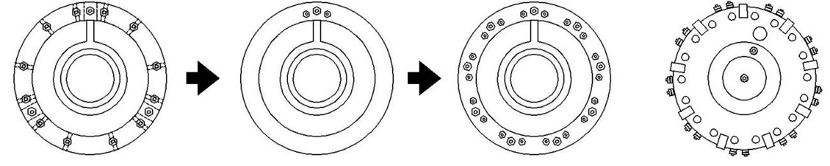
E4 Commutator One 3 group Cluster 9 equally spaced Clusters EMA6 Commutator

If this same theme were arrayed for a 9 pole machine then the result would appear very close to what can be observed for the EMA6 and the “Blue Engine” commutators. Figuring out just what these three contacts do and why would be a very big advancement in this endeavor. , There is something important that makes them a common feature among these different machines,

Details of the Commutator of the E-Series Pulse Motors
(Since it’s the one we have the most information on)

Norm Wooten and later Al Francoeur have provided the world with a hands-on opportunity to examine inside and out the rotary switching system of the E-Series pulse motors. It turns out that the commutator sub-system is essentially the same for the E1, E4, & E5. It is assumed that the E0 & E2 pulse motors will eventually be found to follow suit. It appears that while there were many changes in the electromagnet and case designs the fundamental switching sequence stayed the same for about 5 years during the entire reign of the Pulse Motor development (1961-1966).

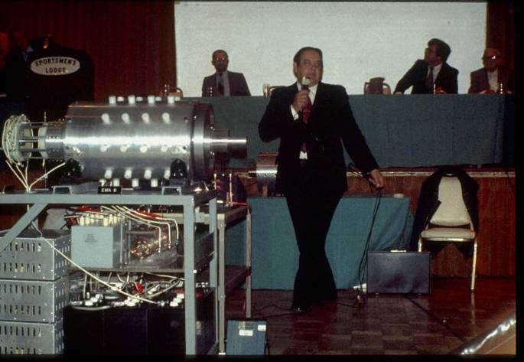
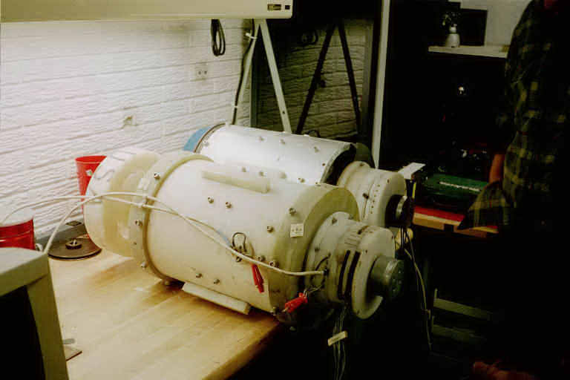
Prior to the recovery of the E4 & E5 Pulse Motors it was thought that the attached white cylindrical device seem on the back end of the EMA6 Free-energy engine was a simple rotary positional timing commutator device. According to patent 4,595,975 a commutator like device was included in the schematic diagram. It appeared to be some kind of mechanical rotary switch that controls timed pulses of power to flow through the anodes of the CSET. So when the patent and the photos are examined together the arrangement seems plausible. As it turns out the E1, E4, and E5 motors all reveled a much more complex component for researchers to consider. These commutators were constructed in such a way that they contained way more contacts than what would be needed for simple positional feedback. The units that came with each motor appeared to be all pretty much the same. An examination for wear on the commutator contact surfaces, from possible arcing and heating, showed almost no signs of degradation. The conclusion reached from this observation was that whatever energy passed through these devices must have been at a very low level. This being at least two or three orders of magnitude less than what would be needed to pulse all the stator and rotor coils at once. Estimated classical current levels of less than 1 mA at 200 Volts have been proposed as being an upper limit. Mr. Wooten examined these motors from a mechanical point of view, using his professional expertise, and reported that each motor appeared to have logged at least several hundred hours of operation. Yet, you would never conclude that much use by looking at the contact surfaces alone.
The EMA6 – with Control Commutator on extreme left. The cannibalized EMA3 motor is on the back table.
Photo by Tom Valentine 1976
The E4 and E5 Pulse Motors at the time of
recovery in 2000 in Dodge City, KS
Photo Courtesy of Norm Wooten

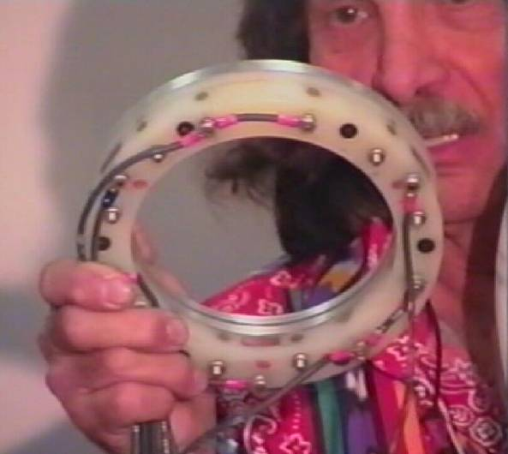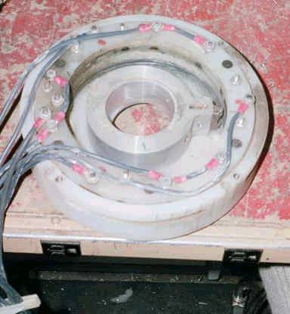

Norman Wooten displaying the Non-Disclosed Complexities of the Timing Commutator from the E5 Cole Pulse Motor at the 2001 KeelyNet Conference – Courtesy Peter Lindemann

Observing the lack of wear, the new belief is that the commutators were providing both control timing and positional signals to Mr. Cole’s energy converter. They were defiantly not directly switching the prime power that went to the stator and rotor coils. Furthermore, these timing signals were more complex than ever thought. In the recovered motors the commutator section and the motor electromagnets were wired independently.

There are 15 contacts and two independent aluminum slip rings in each commutator subassembly. Three of these contacts are rectangular (1/4” x ¾”) copper bars that are three times wider than the remaining ¼” diameter copper rod contacts. For both motors there appears to be two general timing patterns that emerge when looking at the angular spacing relationships of these contacts.

1.) The three large rectangular contacts and 6 of the smaller contacts are equally spaced 40° apart from each other around the circumference of the mounting ring. These would provide a continuous evenly spaced train set of short timing pulses, proportional to the speed of the motor, with every third pulse having three times the pulse width of the others.

2.) There is also a repeated pattern with three clustered contacts. This group is composed of two small and the one large contact. These seem to be related to the “firing” of the electromagnets when the wiper is about 12° past TDC.

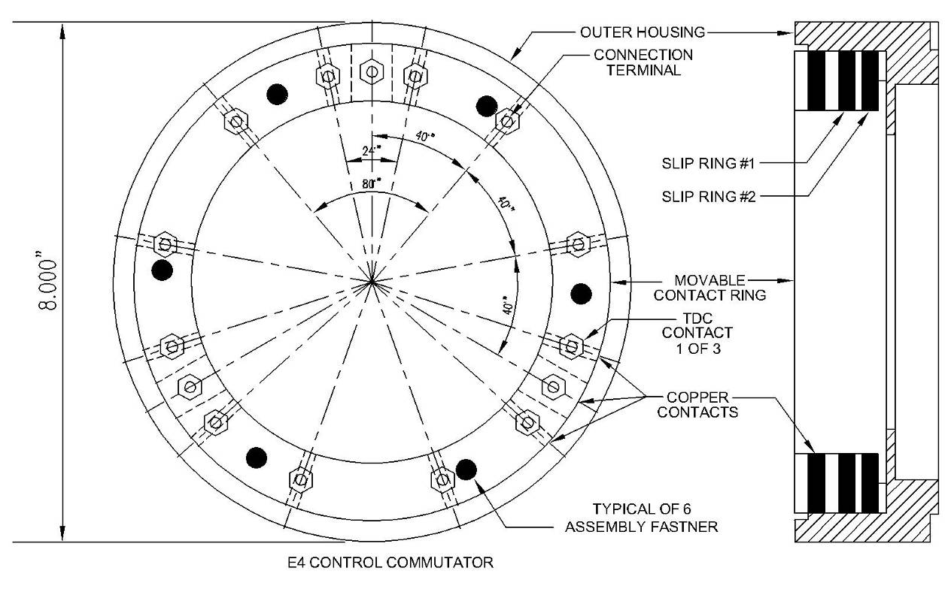
This is a drawing of the E4 Commutator derived from direct measurements taken from the real thing in 2004
Courtesy of Al Francoeur.
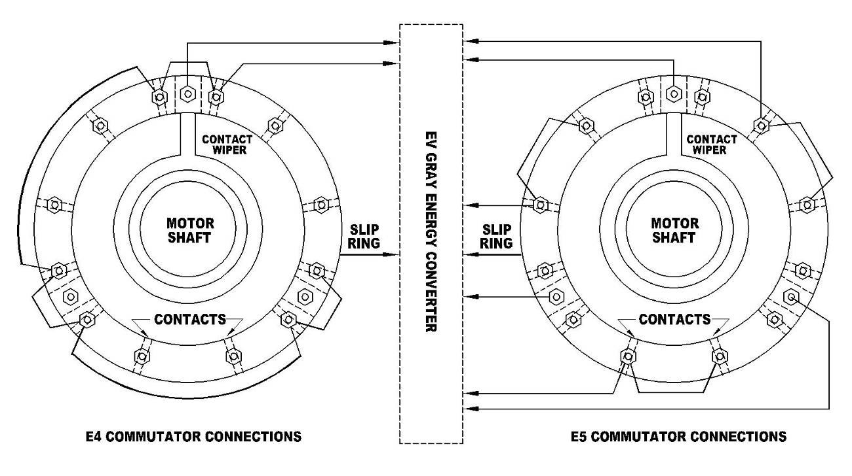

This is how the commutators for the E4 and E5 were found. The newly recovered E1 (2010) is wired just like the E5. These discovered wiring patterns are meaningless. This is how the Pulse Motors were retro-fitted in 1980 by Nelson Schlaft to get them to run by means of pulsed ignitrons. He claims to have removed all the previous wiring and only use what he needed. He may have also changed the Top Dead Center (TDC) reference point to fit with his design. The use of the jumpers between contacts was employed to allow operation in both directions.

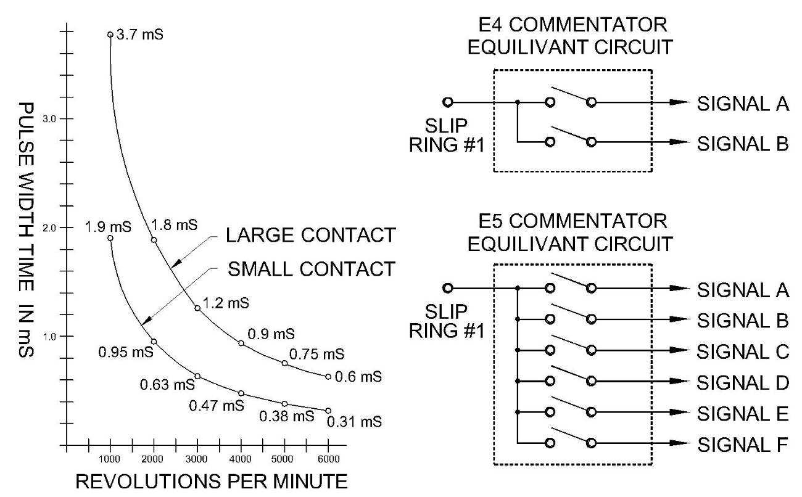
The rotary aluminum shaft wiper houses a spring loaded metallic “brush” that connects each
contact to the slip ring in a sequential order. A second aluminum slip ring was installed, but was not utilized in the retro-fit program. There is no doubt that this second slip ring was used in the original Pulse Motor operation. If the slip ring were considered a circuit common then the timing pattern shown in Diagram 01 would be the result.
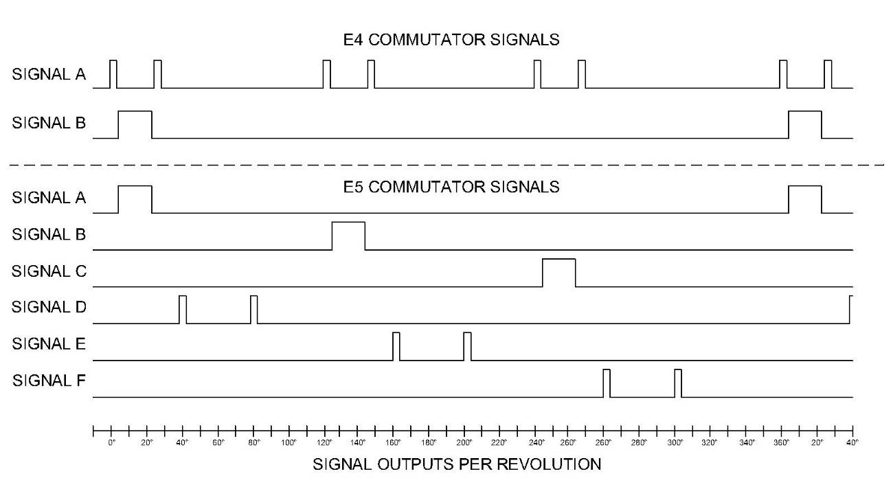
Timing Diagram 01 for Control Commutators for the E1 and E5 Cole Pulse Motors

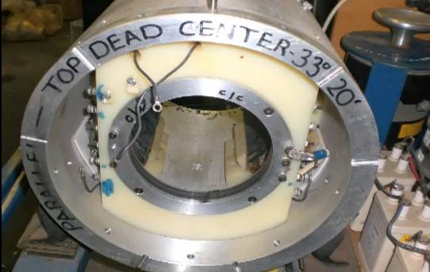
Mr. Cole used a construction technique that is not generally seen in rotary equipment. There are three slip ring assemblies used in each of these two motors. One assembly is used in the commutator subassembly and has two slip rings sharing a common wiper. The other two slip ring assemblies are used to conduct pulse power through the rotor electromagnets. One is in front and the other is in the back of the motor. All three of these slip ring assemblies have an uncommon internal design. This is because the wiper and “brush” are rotating around the inside of a stationary slip ring. This is just the opposite to 98% of all other industrial machines in the world that use slip rings. Almost always, the slip rings are attached to the rotating shaft and the contacts or “brushes” are stationary. The obvious advantage of this common approach is that it allows the brushes to be easily replaced when they wear down. Another important advantage is that the “brushes” can easily accommodate some imperfections in the roundness of the slip rings that rub against them. This is because the brushes are mounted in spring loaded holders that allow them to move back and forth. However, in Mr. Cole’s design, a brush or wiper replacement would require way more disassembly. Also, it doesn’t appear that this design could allow for nearly as much deviation from tolerance as the standard brush and slip ring arrangement can. We just don’t know what the application specific reason was that promoted this kind of solution; it certainly is not obvious from looking at the motors alone. Mr. Wooten contends that he could have designed a much better system to get the power into the rotor as well as several other major mechanical system improvements. So far no one has disputed his claim.
The back slip ring on the E1 aka “The Brown
Motor” Photo Courtesy of John D. Riley

It is interesting to note that the Top Dead Center (TDC), the position where the electromagnets are squarely aligned with each other, takes place when the wiper is on the first small round contact in the cluster of three contacts, rather that the larger rectangular contact. Mr. Nelson Schlaft designated this location as 0°. We have no idea as to where the original reference point was.
According to the jacket information the control conductors leading off from the commutators are rated at 25KV. Yet, their overall diameter is equivalent to common #14 AWG THHN household wire (.12” diameter). This is much smaller than typical electronic high voltage wire that has this kind of voltage rating. This wire was probably an expensive specialty cable installed in 1980.

The small spacing between the wiper and the contacts in the clusters of three suggests that Mr. Gray didn’t utilize any classical control voltages that had a differential greater than 200V. If classical electron flow were involved then voltages higher than this would have caused arcing at both the leading and trailing edges of the contacts as the wiper approached and receded from them. Again arcing was not observed. The commutators on the EMA4, EMA5, and EMA1 are all mounted almost independently and external from the motor proper. This construction feature might imply a need for a high degree of isolation between the motor and the commutator.
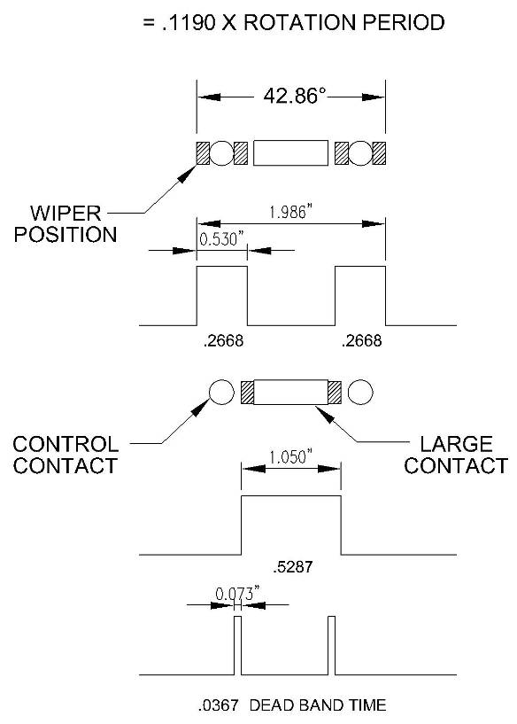
Nelson Schlaft recounted that when he started working for Gray that the previously hired technician was working with Thyratron switching tubes triggered with smaller vacuum tubes. Since the first technician had only been on the job less than 6 months it is highly unlikely that he could have designed, acquired the parts, and built all of those switching systems in that short of time. It seems he was much more focused with RF shielding matters as a means to cut down on EMI production. The author contends that Pulse Motors were brought out of storage with some original Thyratron switching systems still in place. Now, Mr. Schlaft did say that many of the multi-tapped power transformers that formed the heart of the power supplies were reported to be missing.

If vacuum tube amplifier circuits were employed to trigger the higher power Thyratrons then the lack of wear on the commutator surfaces would be understandable. This also means that these same
Timing details of the Cluster of Three contacts
Showing the actual size of the wiper brush
relative to the size of the contacts

vacuum tube amplifiers could be configured as latches, one-shot delays, or other forms of simple switching logic thus really complicating our reverse engineering efforts. This would explain the relative small size of the copper rod contacts. Only a momentary pulse would be needed to initiate some other switching process that could have been more complex. About all we can determine is that some process was started or stopped at these locations, and there are a fair number locations to consider.

The purpose of the various multiple timing signals has not been discussed at all within the Free Energy community. As a result no general conclusions have been tendered that would explain how this multitude of contacts affected the energy converter’s circuit operation.

It appears that the energy converter needed at least two data streams, only a portion of which was the simple positional information. The rest of these short contact closures are assumed to be signals that could prepare the energy converter for its next pulse or to facilitate some kind of energy recovery cycle. There are four contacts between each large contact; therefore there are provisions for as many as four changes of state per each power pulse.

All of the E-Series commutators are built so that the contacts are housed in a movable nylon ring. This ring was installed in a larger hollowed out cylinder that acted as a housing so that the whole collection of 15 contacts could be adjusted together in relation to the shaft position. A machine set screw allowed for a wide range of timing angle adjustments (-40° to +40°). Nelson Schlaft established that a setting of -16°, according to notes written on the commutator, that the pulse would run the motor backwards using his circuit. The original Pulse Motor most likely only ran in one direction. This is because the electromagnets are slightly bent to focus magnetic flux to maximize torque in one direction. The later EMA4 Free-Energy Engine was definitely documented to operate in only one direction.

After the recovery of the E4 and E5 motors the idea that Mr. Gray’s energy converters were dirt simple has come to be questioned. The revised thought is that Mr. Cole’s low energy technology (The Electrostatic Generators) may have been simple, but the higher power Pulse Motor and the Free-Energy Engine technology now appears to be far more complex.
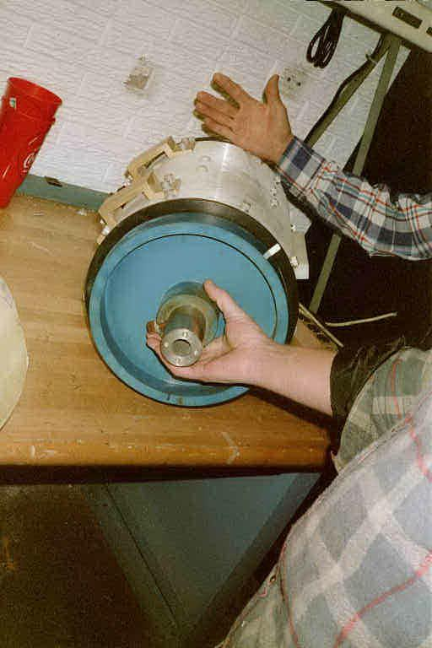
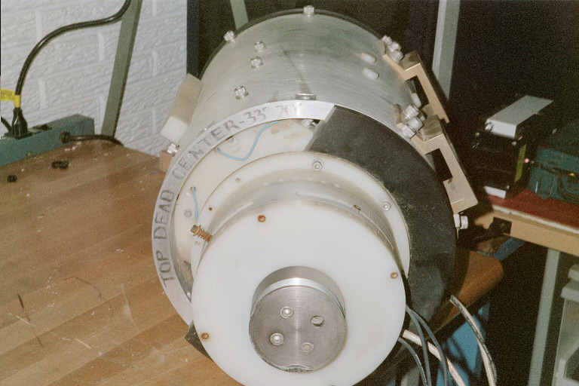
Close Ups of the E4 Pulse Motor

Front view of the E4 Pulse Motor Back end of the E4 Pulse Motor showing the white Timing
showing the blue flywheel and 2” shaft and Control Commutator. There is another slip ring just
behind the black partial end cap.
The Commutator of the EMA4
Face it; you will never be able to build a modern jet fighter from a few photographs of one.

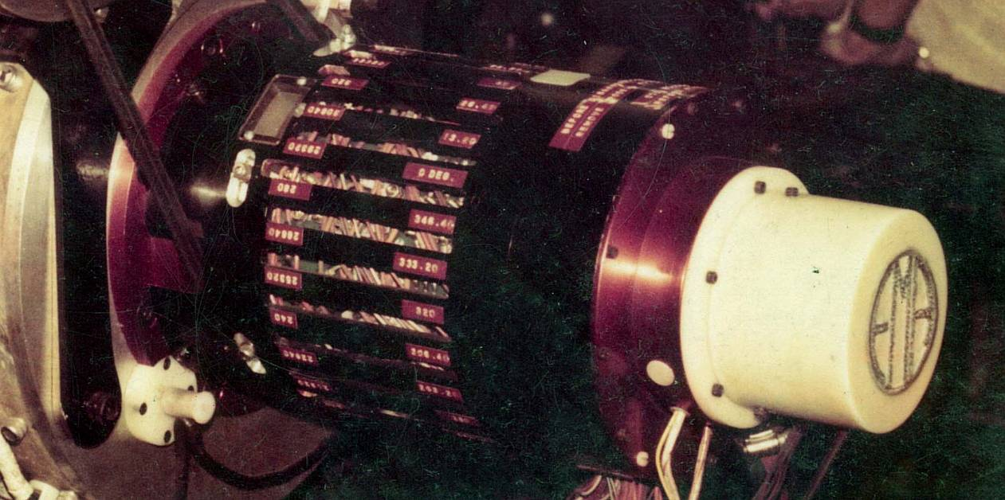

The EMA4 Commutator as it appeared in Jan 1974. The original EMA4 Free-Energy Engine burst onto the scene in Jan. 1973. There are no known photos or information about any technical events that took place before this time to help describe the evolution of this breakthrough machine and its complex control system. Researchers can gaze in utter befuddlement as they look into this rats’ nest of wires seen through the adjustment slots. Yes, there is probably a simpler structure that is repeated a number of times, but it is going to be awhile before we figure out just what it is.

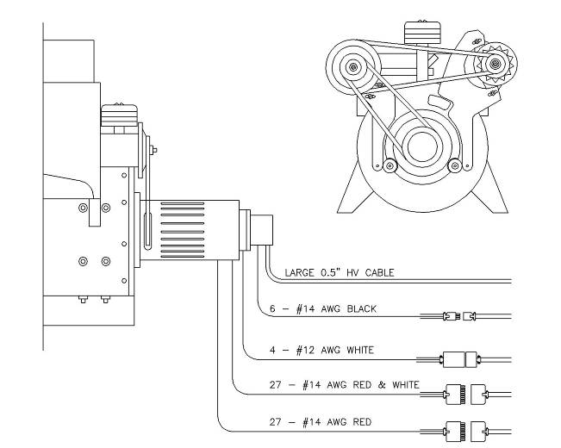
What we do know for sure about the EMA4 control Commutator is that it had a lot of wires connected to it. The best count so far is around 65 conductors, which is far less than the number that should be there if a literal reading of the patent text is correct (which we doubt). But, viewing through the adjustment slots one sees a fair number of crossed wires that make several connections to many assumed contact points. How many of those were actually needed to produce Free-Energy? Well, Marvin Cole thought they all were at the time he built this sub-system. No doubt there was a lot of design and expense that went into the creation of this device. No wonder it was removed from the EMA3 and reused (and possibly modified) on the EMA4 rather than having to fabricate a new one. Figuring this component out is going to separate the researchers from the talkers in short order. The first stop is the patent documents, but don’t get your hopes up. Yes, some details of the disclosed timing and control functions are presented, but don’t take their word for it. There are a lot of contradictions and meaningless descriptions that will leave you more confused than ever. Never-the-less we must plow through it and see what shakes out. The majority of the patent is thought to have been written by Dr. Chalphin for a fee. It is uncertain if he was deliberately hiding technical facts or that Gray and Hack were withholding information from him all along. Perhaps both practices were going on. Anyway the resulting mess is what we have to sort through. This author wonders how the patent commentary ever passed the reviewers approval.
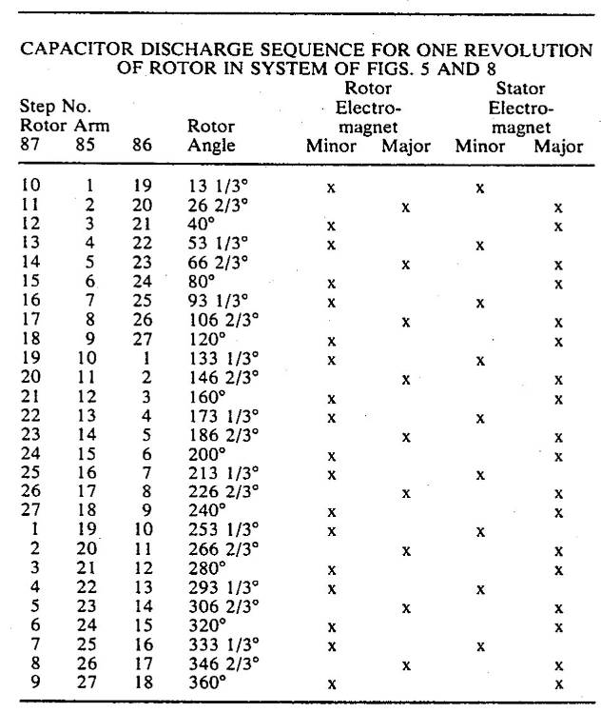
The first stop is this chart presented in the patent text that is suppose to disclose the “firing” order of the numerous electromagnets. It is unclear if this might have had some truth behind it at one time or if it is just pure fabrication that reads well?

The big engineering fallacy this author sees is that rotor electromagnets are being operated individualy. This might have been possible on the stator, but not the rotor since there are not enough control cables provided to even begin to accomplish this.

It has pretty well been established with the EMA0 that there are only three major connection points for the rotor electromagnets. Furthermore these only seem to be active in a 120° portion of one rotation – if other patent illustrations are correct. (See Chapter 4)

What this chart does tell us is that one rotation is split up into 27each 13-2/3° steps. This is verified by looking at the photo of the actual commutator above. Something is important about this degree of division. It might not have anything to do with the chart that is presented here, but we should keep it in mind.

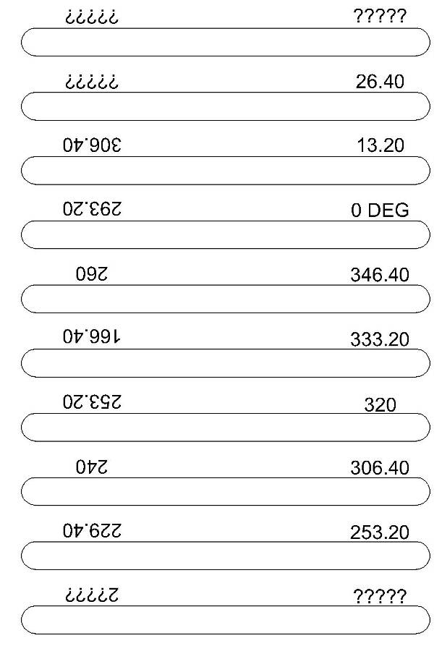
At the left is a drawing showing the numbers that are on the red labels on the above photo. Sure enough Marvin paid some machine shop to mill 27 slots into a 9” aluminum cylinder. We are sure he wouldn’t have done it if they were not needed. It is thought that these slots are to provide access to the various contact set screws so that they can be adjusted.

What is curious about these labels are that there are two sets with the row closest to the engine being upside down relative to the further row. Both rows increase in 13-2/3° increments in a clock-wise direction, which is the same direction the motor rotates.

The difference between these rows is 66-2/3°. This happens to be the angle (with the increments provided) at which the variable capacitance would be at a minimum or maximum (See Chapter 5). The degree numbers are in degrees/minutes so that 0.40’ = 2/3°.

Now we will look at Illustration 19 from the Pulse engine patent. This configuration is held out to be intended for speed control with an incomprehensible patent explanation given.
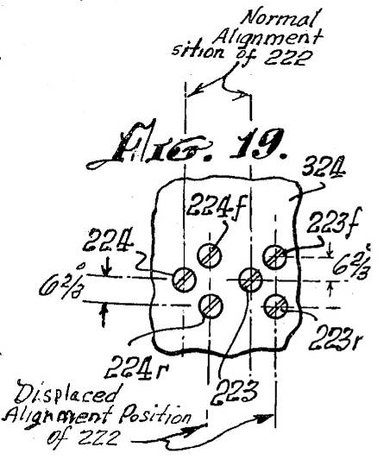
Never-the-less consider the geometry of these contacts. There is a central pair and then two equidistant additional pair on either side. This is the same “Cluster of 3” pattern that has appeared in all the other Pulse Motors and Free-Energy Engines, and mentioned previously near the beginning of this Chapter.

In the E-Series Pulse Motors the spacing was 12°, in the
EMA4 it is 6-2/3°. This is probably because the electromagnets in the EMA4 are about half the size of the ones used in the Pulse Motors. In the E-Series commutators all three contacts were hit one after the other with the same wiper. Here there are two separate operations. Something happens when the central contacts are hit. Then on a subsequent pass, if the clutch has been engaged, the two outer pair of contacts are struck one after the other.

This implies that there are two separate operations going on here that originally might have been done in linear sequence in a pulse motor but are now hardwired to be done at different positions of the rotational cycle in the Free-Energy Engine. This same timing delay configuration could have been done in the Pulse Motors but might have been accomplished with vacuum tube logic.

It seems that the later Free-Energy Engines (at least in the EMA6) were able to go back to the sequential approach and eliminated the need for the internal clutch sub assembly altogether.
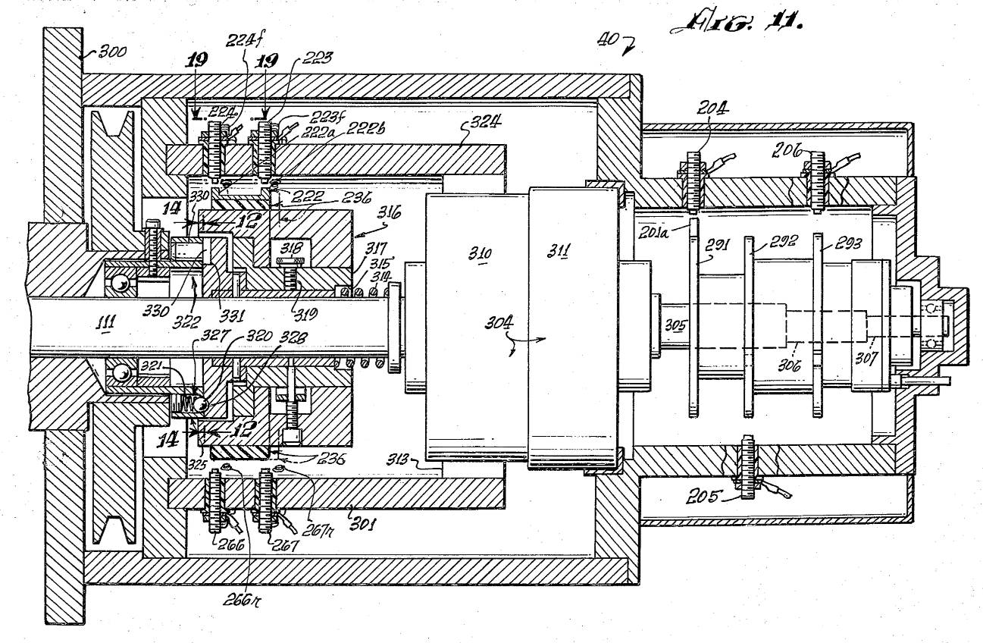

Speaking of the Clutch (component 304) it is another function that is poorly explained (if at all) in the patent text. If you have examined the patent then you will have noticed four illustrations that deal with slotted pressure plates and their associated locking pins (Figures 12, 13, 14, and 15). It appears that these mechanical hardware components were designed to ensure that the contact drum (component 316) always lands in one of the three 120° slots after having been pulled away from its normal (non-energized) position. This means (despite what confusion the patent text gives) that there is a 120° symmetry on whatever shorting bar pattern there is on the contact drum.

The Clutch (component 304) is composed of two sections. A fixed electromagnet is shown as component 311 and a rotating electromagnet component 310.(which needs a separate set of brushes and slip ring). According to the patent text when the Clutch is activated the contact drum (component 316) stops rotating relative to the shaft. If it does that, then how is connection to the contacts accomplished with a non-moving drum. You can search for a solution in your evaluation of the patent text but we haven’t found one.

From looking at the heavy #12 AWG wires that enter into the compartment where the clutch is controlled from we notice 3 or 4 wires are used. This would suggest that the fixed and rotating electromagnets are controlled separately. It is speculated that if the fixed electromagnet is activated then the contact drum moves into its alternate position to activate both outer pair of contacts in the group of three. The contact drum still rotates with the shaft and thus striking all the other outer pairs of contacts in order and missing the center contacts. Otherwise in the non-activate position the contact drum just hits the center contacts one after the other. When the fixed electromagnet and the rotary electromagnet are activated at the same time then the contact drum stops dead in its tracks. This would be a very effective means to decelerate the engine since all operations would cease for the duration of the contact drum stoppage. This would be a much more effective speed control scheme than what is held out in the patent text. Then again the idea of a two state clutch activation is not mentioned either.

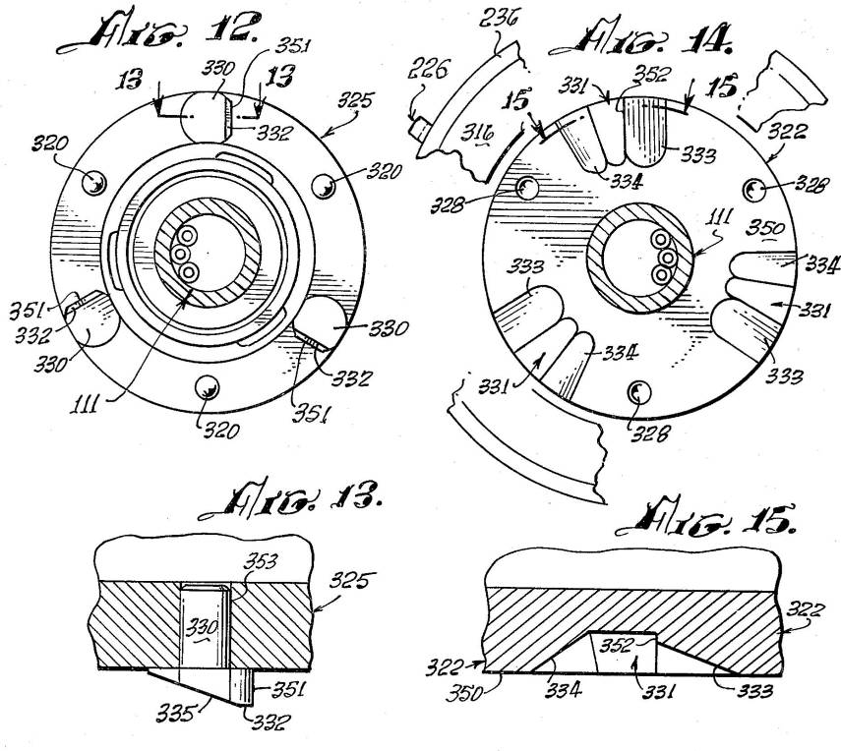
This is the hardware that ensured that the contact drum would always be in one of three positions on the Engine shaft.
The Missing Contacts

Generally the mechanical illustrations in the Pulse Engine patent appear to be reasonably accurate but there is one area where such is not the case. Again consider the photo of the EMA4 commutator.
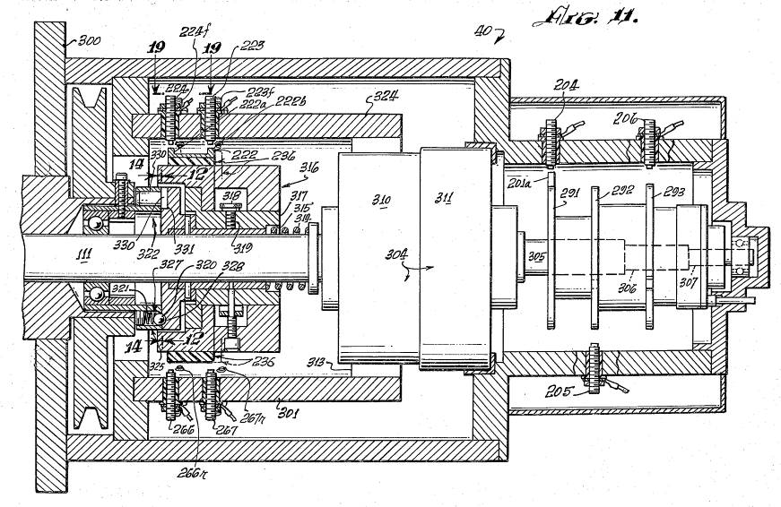
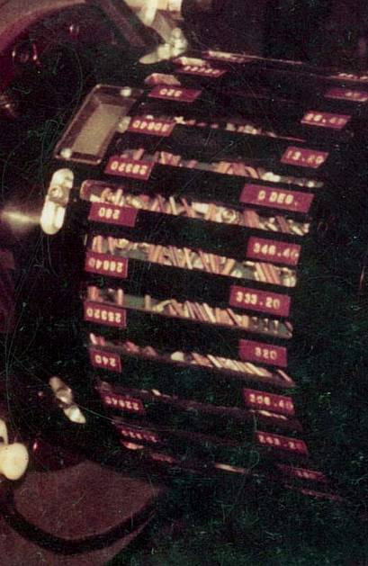

Consider the white circle in the photo of the EMA4 commutator above left. While not a lot can be seen through the adjustments slots there definitely appears to be a pair of #10 brass threads sticking up that closely match the contacts that are also seen on the other end of this same slot. It appears that there is a whole ring of contacts installed just forward of the contacts that are properly disclosed in patent illustration Figure 11. These additional front contacts are not shown in the patent illustration. No wonder the patent commentary makes little sense.

There are two possibilities for this situation:

1. These patent mechanical figures were drafted a number of years before the actual patent was applied for and certain improvements were added and then not documented after the fact.

2. This is a deliberate attempt to conceal additional switching operations that are required to get the Free-Energy process to function.

Take your pick.

A lot of switching operations were needed on the EMA4, so feel free to use as many discrete changes of state to accomplish the goals of you theoretical proposal.

The Commutator of the EMA6
Simplicity is great – That is if it Works.

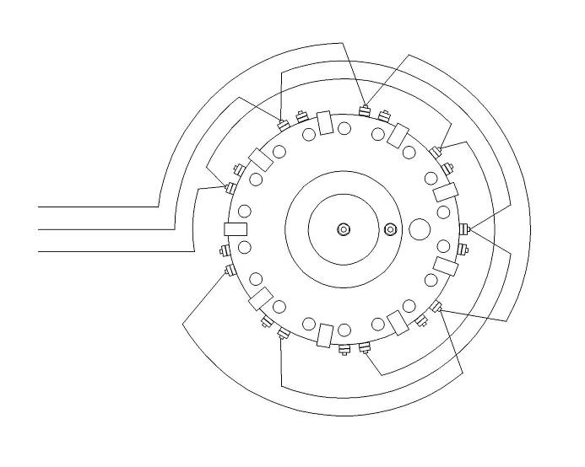

The Control and Timing Commutator built for the EMA6 Free-Energy Engine Jan. 9 1976
Photo from GD Collection

The EMA4 commutator is undeniably complex. The Commutator for the EMA6 is a lot simpler, too bad it didn’t work. However, just because it is simpler doesn’t mean we know how it functions. There still appears to be 27 contact points repeated in 9 groups of three. Only four external wires are seen, where the odd one is probably common. Internal connections to the engine have not been seen. It is suspected that this device is supplying low voltage timing signals to the power supplies under the motor (not seen in this view). Any delay or one shot timing logic is probably accomplished with solid state circuits.

There appears to be two sections to this approach. Notice the center white structure that has no protruding conductors. It is unknown what this component does, but it was not cheap to build either. Its location supports the idea that additional internal switching operations are being conducted here.

Chapter 8 puts forward the contention that the novel CSET devices were removed and the commutator section was remodeled. So what was done?
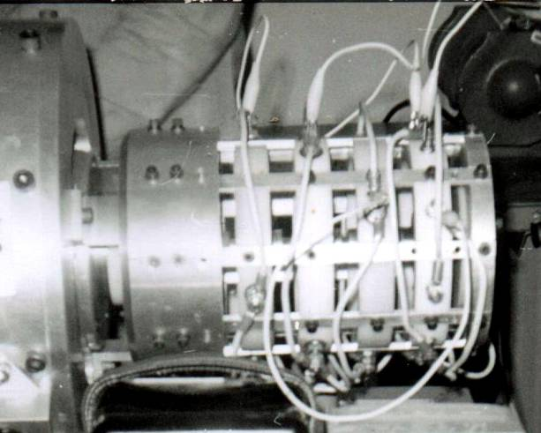
All of the Commutator hardware shown above was replaced with a newer and an even simpler configuration that is shown at the right. There must have been a huge change in engineering direction to do this because the original EMA6 commutators were not cheap to build and the replacement appears to have been fabricated for 20% the cost of the first one since there are far fewer slots, holes and contacts to have to deal with. There is a strong set of circumstances to believe that this setup worked, despite its simplicity. So there is some hope after all.

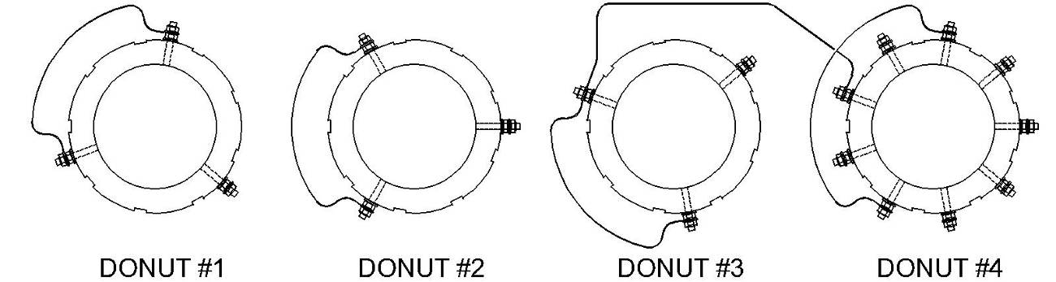

The above drawing shows what the “donuts” would look like if spread out flat. The black lines are connections that can be observed, but they are not the entire wiring layout. There are only18 contacts in all, quite a reduction from the 60-90 that populated the EMA4 commutator. It is unknown what the configuration of the wiper was (single or triple?).

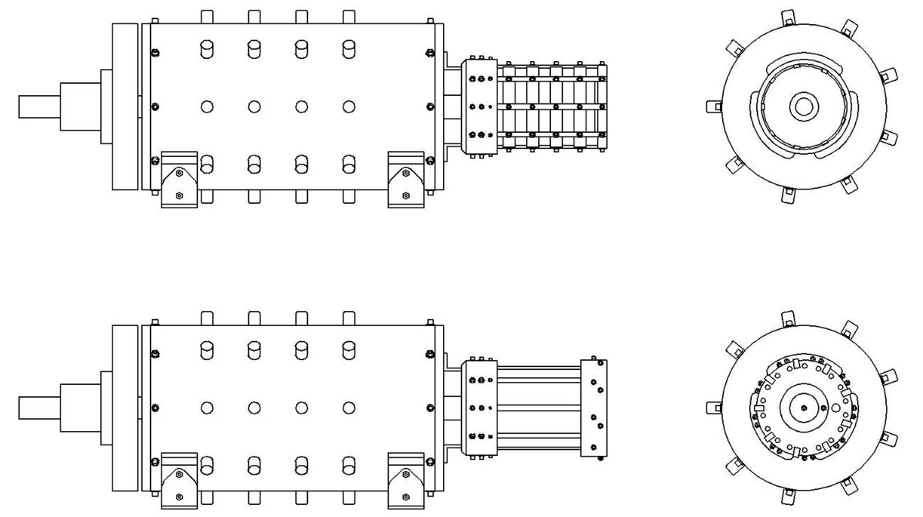

This drawing shows the before and after external configuration changes done to the EMA6 to make it work. The before condition is on the bottom while the after configuration is shown in the top sketch.

Richard Hackenberger is quoted by GD as saying something to the effect “The more donuts the more Power”. O.K. then why didn’t he install them the first time around and save himself a lot of grief? Obviously there was some vital bit of knowledge that made the difference between what he thought he knew and what actually worked. We can see some of the changes that were made to the external parts of the engine but whatever might have been done to the inside will never be known. There is a good chance that when he got his theory on the right track the motor itself was not properly configured and that might have taken a while to straighten out since it was about a full year before the magic was once again seen, just before the FCC rained hard on their parade.

The Commutator of the EMA aka “The Blue Engine”
A little bit of knowledge is dangerous – but a lot of ignorance is just a bad.

To be honest we don’t really know if “The Blue Engine” is the engine that Gray and Hack stole from Russell Audrey late in 1979 or if it is another early Pulse Motor from the early 60’s. The decision rests on the observation of the commutator. All of the known Free-Energy Engines were 9-pole machines. All of the Pulse Motors were 3-pole machines. Looking at the fuzzy frame capture photo of the Blue Device it is this author’s contention that we are looking at the same sort of pattern seen on the original EMA6.
The housing for the Commutator appears to be metal. All of the housings for the Pulse Motor commutators were non-conductive plastic. The layout of this device appears so much more advanced than what is observed in the early Pulse Motors, not that external appearance is any basis of functional analysis but it does sways one’s opinion. If this Motor/Engine never surfaces then it won’t matter. It still may be in storage in Kansas waiting for the right buyer.

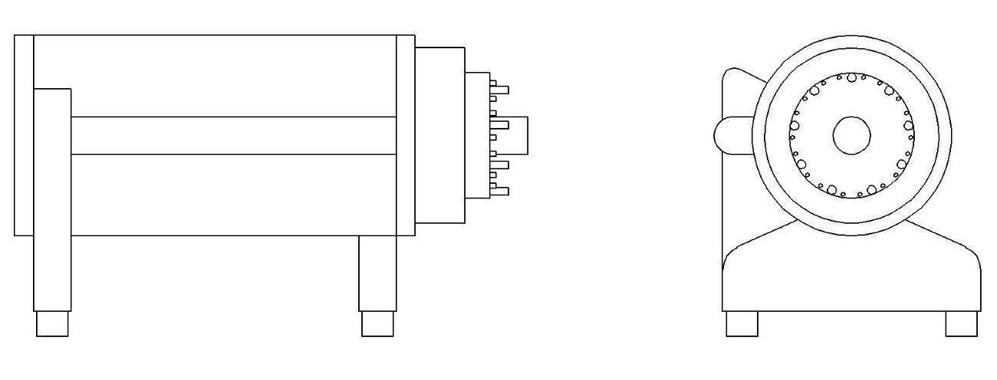

The Overall Analysis of Commutator Function
How we can make do with what little we know?

Figuring out what is happening at each one of those locations is a fundamental task to complete a successful reverse engineering effort. This chapter presents some ideas, but each researcher needs to come to their own conclusions as to what was going on and when. All of your future research and design work will be greatly impacted by the initial assumptions made in the evaluating the operation of the commutator.

Consider taking some time reviewing just what the existence of a complex commutator system says about the structure of the discovered (and then lost) Free-energy process.

An analogy can be made to an automatic dishwasher machine.

Process #1 Pre-Wash
Process #2 Wash
Process #3 Rinse #1
Process #4 Rinse #2
Process #5 Dry

Each process uses different sub-systems available inside the overall machine. Some sub-systems are common some processes and some are unique. But in order to get clean dishes each process step needs to start and stop for a proper duration and in the prescribed sequence. If steps are skipped, rearranged, or omitted then the result will be less than clean dishes.

90% of all non-funded Free-Energy research is generally focused on circuits and systems that deal with only one or two changes of state. The John Bedini Pulse Motors / Battery Chargers are an example of a well developed two state system. There is the coil charging phase then the field collapse and harvest phase.

The E. V. Gray technology is at least a 3 step process but more likely 5 or more states were needed to achieve the higher power levels. If any one of these steps are lacking or missing in the proper parameters then the hoped for Free-energy will not be so Free. This is the reality suggested by the operation of the commutators of the Cole/Hackenberger Free-Energy Engines.

So, just what are some candidates for state changes in this technology?

1. Discharging a capacitor through a set of opposing or attracting electromagnets to develop torque.

2. Striking an arc to charge a dielectric.

3. Quenching an arc to produce an RF electric field through a dielectric mass.

4. Applying an excitation magnetic field (AC or DC) at some angle to a dielectric mass.

5. Appling an electrostatic RF field or pulse train to a dielectric mass at some particular angle.

6. Injecting low voltage current carriers to the plates of a mechanical variable capacitor.

7. Harvesting a high voltage charge from a variable capacitor to store in a lower voltage capacitor.

8. Transferring charge from an capacitor or delay line to another capacitor or delay line.

9. Changing component configuration, as in series connection to a parallel connection.

10. Changing component parameters, i.e. more capacitance, less inductance, different resistance, etc.

11. A lot of other possibilities

The motivated researcher will have to examine all the surviving evidence and determine what happens, in what order and for how long.

An example exercise would be to examine the E-Series commutator and take a shot at figuring out what is going on there.

First a reference point needs to be established for the 0° location of the rotor relative to the stator. In this example we are using an alignment of the center of mass for the rotor and stator electromagnets. We then need to determine where our 0° reference position lines up on the contacts in the commutator. In this case we are using the middle of one of the large contacts. From here we just map the rotation angles of the rotor to the contact locations and see if something makes sense.
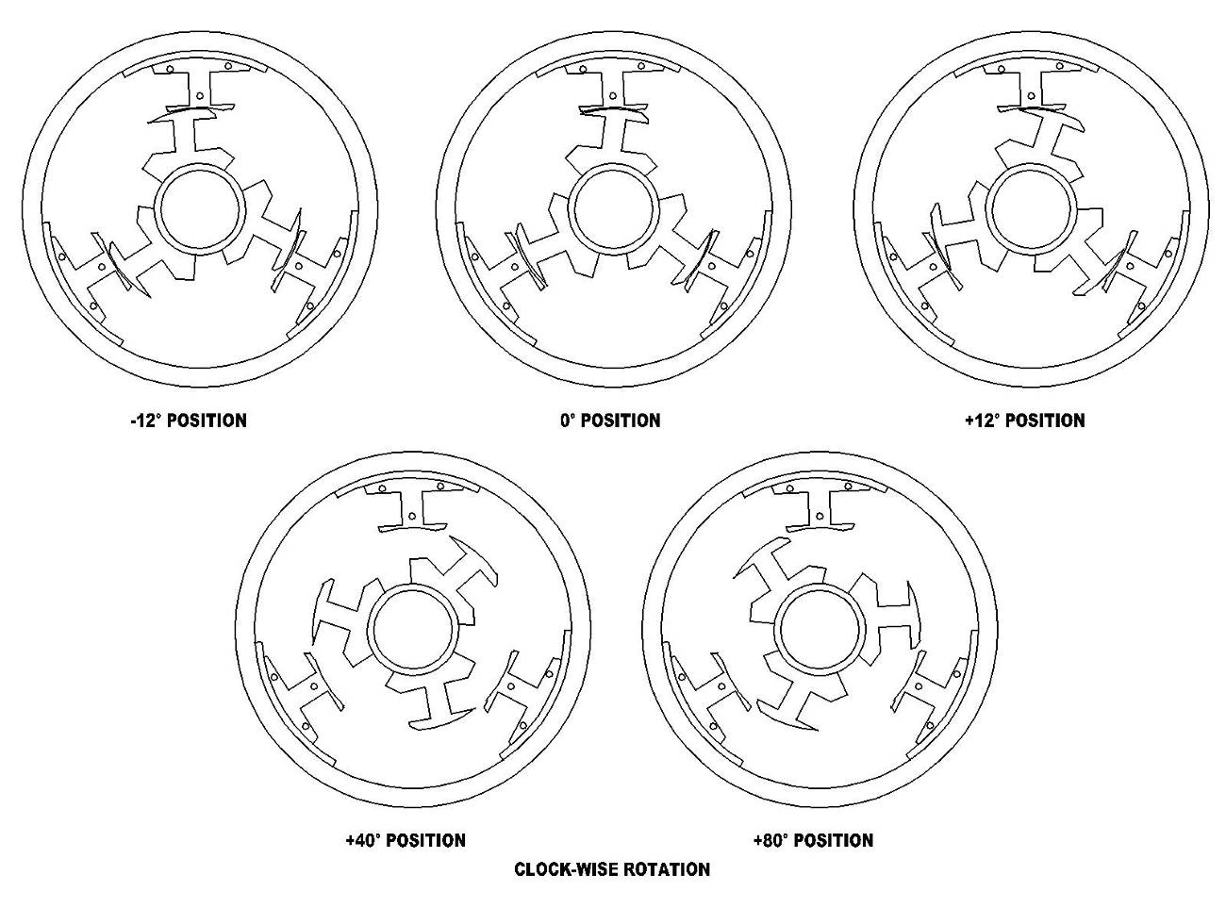
These are a collection of sketched cross sections of an E-Series Pulse Motor with the coil wire removed to better see the magnetic cores. Five rotational positions are mapped base upon contact angles observed in the commutator.

The next step is to determine which position is the starting cycle and why. In this machine there are five changes of state before the cycle is repeated. One proposal would be:

Step #1 -12° Pulse power applied to coils for attraction mode
Step #2 0° Capture of back EMF energy from first pulse
Step #3 +12° Recovered pulse power applied to coils for repulsion mode
Step #4 +40° Arc struck between Stator and Rotor cores then stretched
Step #5 +80° Arc quenched and resultant energy/RE particles harvested

Another, more exotic, proposal would be;

Step #1 -12° Storage Capacitor isolated from charging supply
Step #2 0° Creation of non-classical particles from magnetic compression approach
Step #3 +12° Store created non-classical particles in resonant delay line
Step #4 +40° Non-classical arc struck between Stator and Rotor cores then stretched
Step #5 +80° Arc quenched and resultant classical electrical energy stored

Again another idea, this time with a different starting step:

Step #1 +40° Classical arc struck and stretched between stator and rotor
Step #2 +80° Non-classical particles harvested and stored
Step #3 -12° Non-classical particles used for attraction mode
Step #4 0° Residual magnetic field used to generate classical electricity
Step #5 +12° Classical electricity use for repulsion mode

Another approach to unlocking the mysteries of the purpose of the multitude of contacts in the control commutators is to review one of the support patents listed in the Pulse Engine patent.

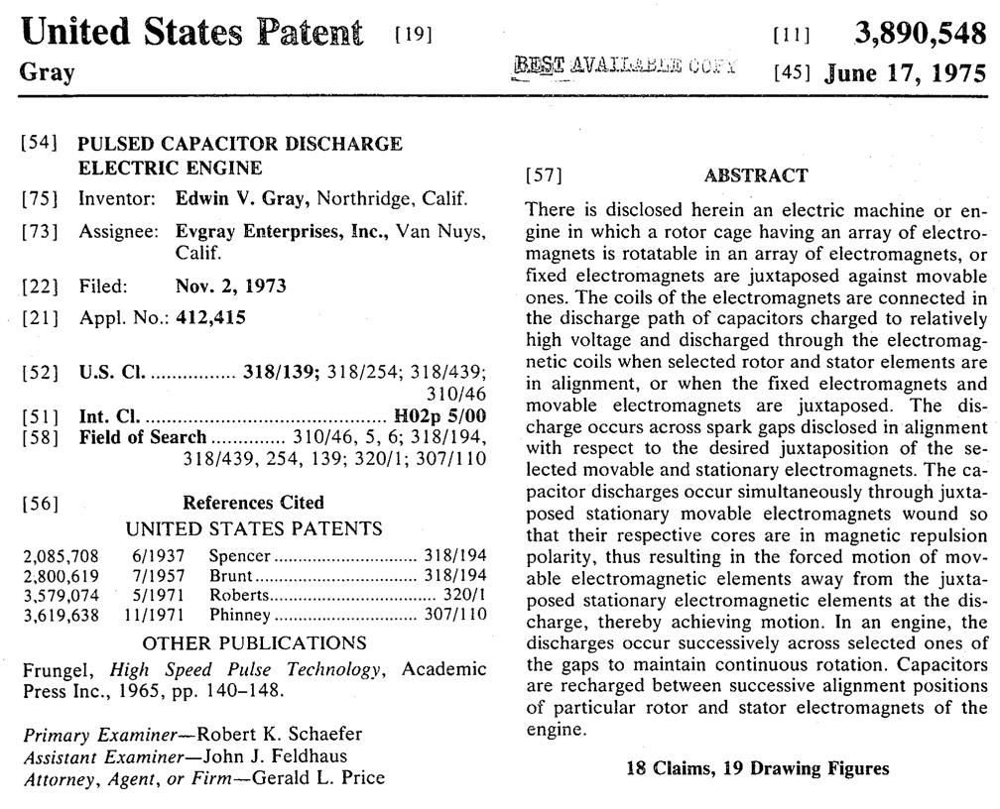

Examining the Robert’s patent will keep you busy for an afternoon (with no interruptions). Actually the invention was created by a Mr. Clement Richell and then assigned to Mr. Ray Roberts. For some reason the patent is indexed according to the assignee rather than the inventor. Going through these overly complex and now very obsolete power supply designs will have you asking the question “What in the world does this have to do with the Gray Pulse engine?” There are no multi-tapped power supplies or SCR’s even mentioned in the Gray patent much less the need for a variable voltage pulse output. Yup, none of that was mentioned in the patent, but a detailed study of the photos will reveal a clue you should follow up on. The fact is that both the EMA4 and the EMA6 employed a multi-tapped DC power supply that resembles the voltage source described in Figure 2 of the Richell/Robert’s patent.
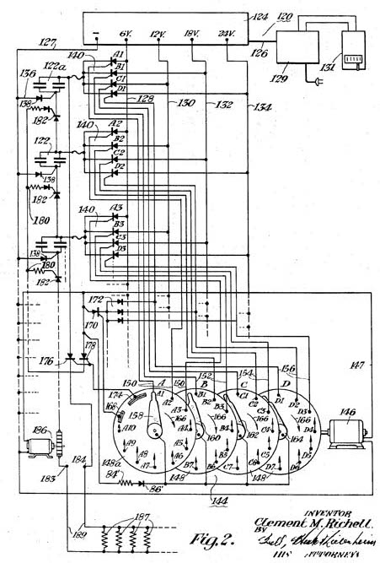

Figure 2 from the Richell/Robert’s patent disclosing a low voltage multi-tapped DC power supply
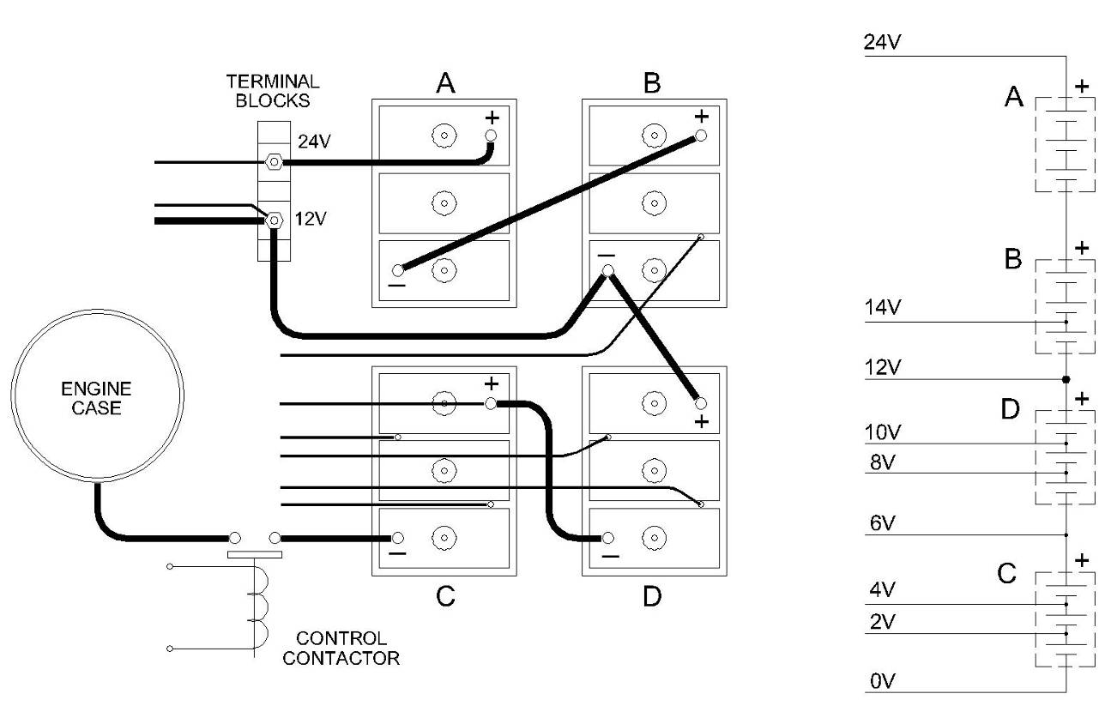
Here is a drawing showing how the battery array was tapped for multiple voltages on the EMA4. From the photos of the EMA6 it appears that these multiple voltages are used for speed control. None of this is mentioned in the patent documents since speed control is “supposed” to be achieved through the proper firing of certain electromagnets at different angles – not a variable step voltage controlled approach. The purpose of the Richell/Robert’s patent was to take low voltage energy sequentially charge a string of capacitors and discharge them all at once either in parallel or series. In Marvin Cole’s application the huge wet-well batteries could easily provide 600-1200 Amps of short circuit current so the need for a high amperage discharge seems remote. So if he did employ this circuit he was probably was seeking a higher voltage that was beyond what the batteries would provide but yet could also supply some substantial current as well. The vibrators that were disclosed in the patent appear to have been configured for 3000 volt operation. Since each vibrator only had a 30 Watt capacity then his available current was around 100 mA per vibrator power supply. It is now starting to appear that there were two vastly different power requirements needed for this machine. A high voltage supply / low current for striking arcs between moving electromagnets (speculated) and another lower voltage and higher current source needed to do something else (again speculated).

The Richell/Robert’s circuit is essentially a mechanical voltage doubler using SCR’s as switches now days we would use a properly designed switch mode power supply and think nothing of it. Marvin probably didn’t have this luxury and the Richell/Robert’s approach was workable and at hand.

So, what kind of second voltage did Marvin need and why? With as many as 27 contact steps per revolution and a selectable DC battery voltage between 2 and 14 Volts he could have had a choice of 54 to 378 Volts. A series string of 27 capacitors seems unlikely. A string of 6 to 12 capacitors seems more likely, but that is just a pure guess. He could have just as easily been pulsing high voltage transformers and use the same approach to generate some real high voltages.

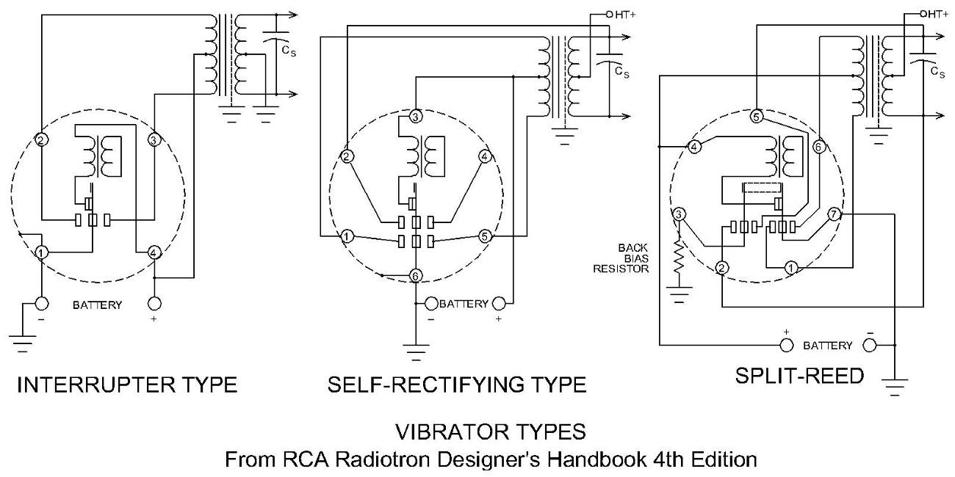The mechanical vibrators used in the twin power supplies disclosed in the patent probably existed and operated from the 24 VDC side of the battery array. John Bedini reported that he heard something that sounded like 100 Hz vibrators during the start up procedure of the EMA4 Free-Energy engine. Mechanical choppers have a limited operating range. If Marvin dropped the supply voltage very much they would quit working. The 2 – 14 volt supply range he had available is just too wide of a range for the vibrator to function. He would have had to have a separate supply for the vibrator portion and a separate supply for the input voltage to be chopped. Which is workable, but then why is the Richell/Robert’s patent listed as a reference? There must have been this funky series capacitor network used somewhere.

Then there is the issue of how much of a rotation was used to charge this speculated capacitor stack? In the EMA4 the design of the commutator suggests that there were two distinct operations. One operation took 120° and another took the remaining 240°. During the shorter portion cycle power appears to be applied to the rotor via rotating contacts in the rear most section of the commutator and not during the rest of the engine’s rotation. Arbitrarily we could assign the charging of the capacitor stack(s) to be going on during the 240° cycle and then used during the 120° portion. This tentative arrangement would allow anywhere from 6 to 18 charging steps to take place. There appears to be three firing positions in the 120° portion. This implies that there are three stacks of capacitors available to be discharged in this cycle. The Richell/Robert’s patent says that 50,000 uF capacitors are employed. The proposed string of 6 capacitor would cut the total effective capacitance down to 8,333 uF with a stored voltage between 12 and 84 volts or a pulse energy between X and X Joules

What electromagnets are involved in the 120° process? It appears that only the “Major” electromagnets are involved and the switching operations take place while they are at Top Dead Center (TDC). Now this is curious. When electromagnets are wired for repulsion all of the forces created are radial so there is no torque produce until there is some angular difference between the fields. For popping coils this works fine – but not in a motor/engine. So what is happening at the TDC where contacts appear to be dumping energy into the stator and rotor electromagnets at the same time? This same odd arrangement also takes place in the E-Series Motors as well. This is where the wider contacts are employed. It seems that knowing the start time and the ending time are important in whatever process is taking place.

Could this be where the non-classical process really takes place? Perhaps it is an arc compression environment rather than a stretched arc. Maybe there is no arc at all in this step process, at least not between the “Major” Electromagnets. There still is the stretching arc taking place and it is at the control discs. Incidentally this is where Richard thought the non-classical process took place. Well it is pretty certain that it didn’t involve torque at this part of the cycle since those commutator discs couldn’t handle 100 HP of torque. Now the anomalous RE particles might have been generated here and then utilized later in the 240° portion of the Engine’s rotation. This means that they had to be stored briefly and a capacitor appears not to be a good storage system, for RE however a delay line is and it just so happens that 18 of them were available

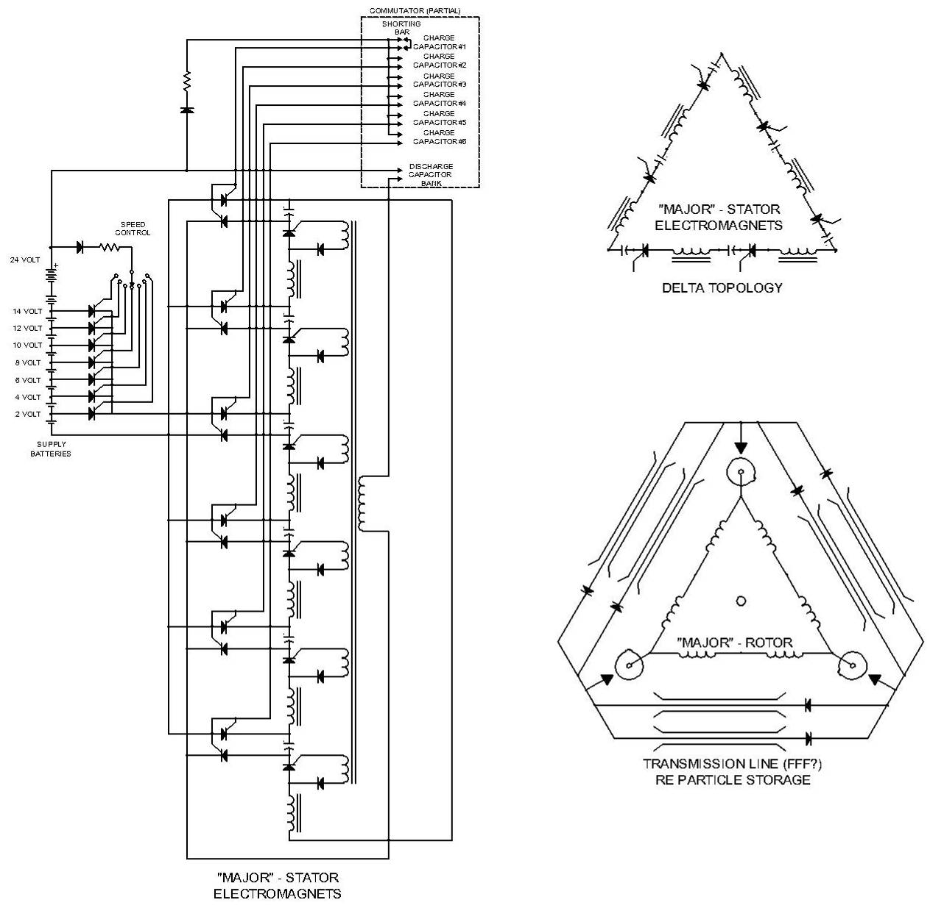

Combining the Richell/Robert’s circuit with the delta wiring topologies suggested by the EMA0 this is the sort of conceptual sub-system that one can come up with. What is novel with this very speculative design is the employment of Transmission Lines aka “Floating Flux Field” to briefly store the speculated non-classical Free-Energy particles (see Chapter 10) so they can be used in another arc stretching process to produce torque and recharge the storage capacitors. This circuit shows a direct connection to the storage batteries. It is more likely that the voltage was stepped up first before it was applied to the capacitors. The very tentative theory here is that the RE particles generated in the stretched arc process are separated from the remaining classical electrons that continue circulating around the delta rotor coils. Meanwhile the RE particles prefer migrating to the lower impedance loop of the transmission lines. Since RE particles are generated in pairs (180° spin difference) two loops are provided. Fellow researchers, this is just a wild guess to demonstrate how the Richell/Robert’s circuit might have been used (but not disclosed) in the EMA4 as a way to explain why so many contacts appear on the control commutator. The above stator circuit needs to be duplicated three times to deal with all the observed “Major” electromagnets. Another complete circuit is needed to address the utilization of the RE particles traveling around the Transmission lines.

An important concept to at least consider in the above very speculative circuit is that the excitation energy is coming out of the engine from the rotor and into the rear most chamber of the control commutator for “Fractionation”. The patent would have you believe that energy is being inputted here to be used by the rotor. Until we get a better handle on this all possibilities need to be considered. Fortunately these concepts are testable.

We do know that the emerging CSET devices were an attempt at removing those power arcs from the rotating part of the engine. With improved power supplies this became possible. However it didn’t work. Richard went back to rotating power arcs inside Delrin “donuts”. There is a strong possibility that the missing “Floating Flux Field”, system last seen on the EMA4, had been cleverly hidden inside those cans looking like dual capacitors. They very well could have been a capacitor / transmission line combination. The length of the transmission line needed could have easily fit, along with a substantial capacitor, inside those cans.

From this discussion and a review of some of the aspects of the Richell/Robert’s circuit we can easily see that the first thing Richard did when he came on board was to redesign the power supplies to get rid of all those obsolete wires. The EMA4 seems to be an evolving machine. Even though there was one major remodel in May of 1974 there are other photos showing a constant reworking of the number of conductors coming from the control commutator. If this author were in Mr. Hackenberger’s shoes the first thing to go would be the Richell/Robert’s circuit.
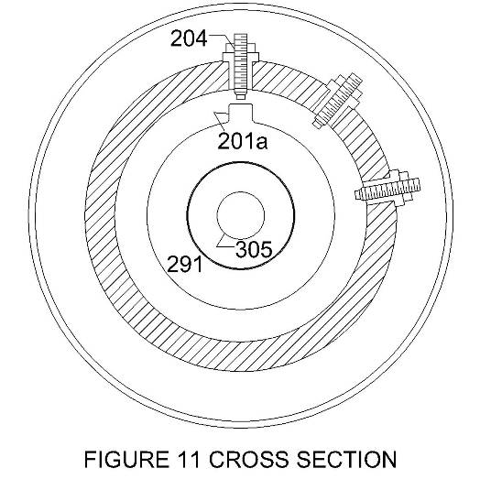
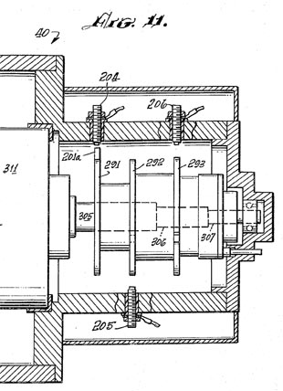
Here is closer look at the rear most commutator chamber. Notice how closely this cross section view resembles the “Donuts” that will be built for the EMA6. What made this section so special that it needed its own separate housing? Well for starters these discs connect to the rotor. It is odd but the EMA4 main commuter section houses a plethora of contacts while this one only appears to have only nine. Another difference is the amount of energy that is intended to be switched. It appears that the rotor switching section was set up (in the earliest photos) to have three larger (#8 AWG) conductors enter into the section. These were later replaced with 6 each #12 or #14 AWG conductors. Perhaps there now are two paired conductors to take the place of the three larger ones. Anyway it seem that a lot more power is being distributed here than in the main section. The main section has many #14 AWG wires that may go to the power supply and operate SCR’s. If so, then the contacts would have to have been redesigned for actual contact if there was not enough voltage present to jump the twin gaps.

Conclusions
All Good Things must End

This Chapter has been more about presenting challenges and proffering exotic speculations rather than being able to focus in on one sure shot solution. If we had these answers they would all be here. We have only attempted to demonstrate the observed diversity in the timing and control that this technology utilizes. We hope that this discussion has not discouraged your preliminary interests and that your perception can see through the maze of wires and draw out a engineering solution to one again bring this technology back from the grave.


Richard Hackenberger 1973
Photo by Tom Valentine

