Chapter 12
Supporting Classical Technologies
Sen. Engineer to Jr. Engineer, “Son, don’t re-invent the Wheel”.

This Book has proposed some radical ideas from stretched arcs to the creation of anomalous RE particles. These concepts are not with out connections to related work done by other researchers. This chapter is a short summary of what other people are doing that might relate to the lost E.V. Gray technology. The reader will have to decide is any of this is relevant in their technical opinion. There are probably at lot of other people who have done, or are doing, similar things far closer to what E.V. Gray and company had done, its just this author doesn’t know about them yet.

The Work of Ken Shoulders and his “EV Charge Clusters”

Mr. Ken Shoulders and his son Steven Shoulders have been doing work with electron clusters or EVO’s for quite some time in California. He appears to be largely self-funded and patented the basic method of creating these anomalous particles in 1991, but his research goes back to 1980. He maintains a web site that is loaded with several well written and professionally done papers at http://www.svn.net/krscfs/. There are a lot of documents available and it will take all evening to read just a third off these. In the morning you will have a greater appreciation for the work that has been done in this field – and then wonder where he got all the money to acquire that expensive equipment in order to take the many scanning electron microscope photos of his work. (He must really have a good job). This author has seen photos of his personal home/laboratory and it is a facility that most all non-funded researchers would only have in their fondest dreams.

It is unknown if Mr. Shoulder’s EVO’s are the same as the RE particles proposed in Chapter 10, but they appeared to be created in a similar fashion. According to his 38 page US patent 5,018,180, “Energy Conversion Using High Charge Density” granted May 21, 1991, one of his several embodiments to create these EVO’s is forcing an arc to travel along the surface of a dielectric.

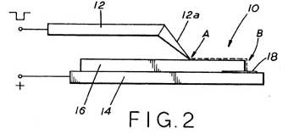
Essentially the apparatus appears to be a pointed electrode sitting on a sheet of dielectric that is supported by a conductive plate. A sharp DC pulse is applied and an arc strikes between points “A” and “18”. At location 18 there is a target in the form of a thin sheet of metal with various coatings. He then examines the bombarded specimen with his scanning electron microscope and looks for evidence of an interaction. The small craters that are produced are claimed to be the result of impacts from these proposed particles. From an analysis of the size, shape and depth of the penetrations a rough idea as to the amount of energy involved can be estimated.
Mr. Shoulders maintains that the particles he observes (after the fact) “introduces the notion of energy gain produced through a low energy atomic and molecular phase change coupled with high recombination energy release” or a Free-Energy process. He then goes on to develop a number of theories involving “electron-annihilation energy release based on the manipulation of fractional electronic charge.”

He does a lot of his work in a vacuum with travel distances of 1 cm using a 50 nanosecond pulse with a total energy of 20 micro Joules. That’s a lot different than what the E.V. Gray technology used; travel distances of 4-5 cm with 8 millisecond pulses using a total energy of 125 Joules per pulse in air at STP. Also the Gray technology electrodes are moving while being exposed to an axial magnetic field followed by a burst of electrostatic RF. So there are some differences to be considered, however, his work describes some interesting properties of the EVO’s that he creates.

His particles are “a highly organized, micron-sized cluster of electrons or EV’s (a Latin word for strong electron), having soliton behavior, with electron populations on the order of Avogadro’s number”. Recalling from high school chemistry an Avogadro number is about 6.23 x10²³, that’s a lot of electrons hanging out in one location. He goes on to describe the damage these clusters do when striking oxide coated aluminum foil “Using an ordinary thermal interpretation, a thermal gradient for bulk material greater than 26,000 degrees C per micro meter would be required to achieve these effects.” What he means is that in order to bore a hole as clean as what has been observed in a material that melts at 2,600 degrees C, the temperature of what ever created that puncture must be about 10 times hotter. I guess we will have to take his word for it. There is no mention of electron spin, at least in the paper this author was reading.

Some of the EV’s behavior also seem related to the Chapter 10 proposed RE behavior:

“it has been found that an EV must be terminated in its characteristic impedance just like any fluid flow or electromagnetic wave.”

“When the flow encounters a discontinuity, a reflection occurs.”

Apparently Mr. Shoulders has been attempting to develop a saleable Free-Energy process using the methods and ideas inspired form his works with the EV’s. Maybe by now (March 2011) he is on to something?

An example of an EV impact crater in metal shown in a paper presented at the MIT Cold Fusion Conference
May 21, 2005 by Ken Shoulders.
Here is a more detailed description of how Mr. Shoulders believes EV’s are created:

EVO Formation and Characteristics
In the simplest of EVO formation methods, electrons are extracted from a conductor by quantum
mechanical tunneling when applying sufficiently high fields to exceed what is termed the space charge
limit of emission. In this trans-space charge region, electrons are emitted as a coherent stream of fluid
having number densities equal to that of the conductor lattice template, being in the region of Avogadro’s
number. The fluid-like properties of this emergent stream, along with incidental electrodynamic forces,
determine how much emission occurs before quenching, hence, the size and spherical shape of individual,
emergent EVO’s as well as the stream flow properties producing the bound and entwined groups of entities
emitted. In this scenario, the foundation properties of the EVO always existed within the confines of the
conductor lattice. When the electron substance is pulled from the lattice by intense fields, a new container
form must be found.

Commentary:

Obviously something interesting is happening with the equipment Mr. Shoulders has developed. There are many more interesting setups shown in the patent documents than the single example shown above. At least his work shows that large groups of classical electrons can be associated together with out the classical electrostatic forces causing them to flyaway. How this is achieved will take some understanding greater than what a single college course in High Energy Physics can provide.

The EV’s that Mr. Shoulders describes are particles that have a hard time penetrating into metals, thus their energy is converted to heat and other atomic radiations at the boundary. The proposed RE particles discussed in Chapter 10 are at home in metals and many dielectrics. So, in the final review these are not quite the same animal, though they may have common roots.

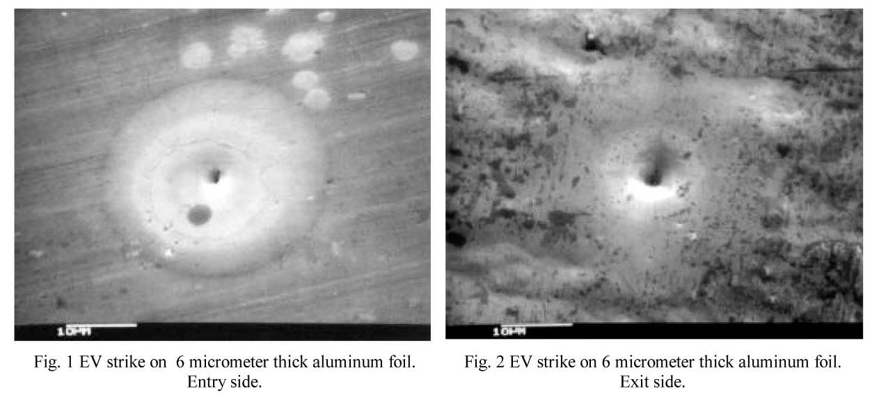
References:
K. R. Shoulders, EV-- A Tale of Discovery, Austin, TX, 1987. A historical sketch of early EV work having: 246 pages, 153 photos and drawings, 13 references.
Available from the author at: 365 Warren Dr., Ukiah, CA 95482, Email krscfs@svn.net, Phone: (707) 467-9935
U.S. Patents issued to K. R. Shoulders on EVs. 5,018,180 (1991) - 5,054,046 (1991) - 5,054,047 (1991) - 5,123,039 (1992), and 5,148,461 (1992).

The Work of Patrick Flanagan and his Electron Field Generator

G. Patrick Flanagan has been one busy fellow in the last 40 years. He has a Ph.D. in Physics and wrote an interesting book on Pyramid Power in the early 70’s, where he speculated on the proposed energy accumulation of pyramid shaped structures. He then went on to conjecture an alternate theory for the structure of matter (This author liked it). He also describe a circuit called the Electrophone that he had built in his youth. This device was later confiscated by the military. It took a long court battle to get it back. (His story concerning this matter is something all Free-Energy researchers should be aware of) He has been doing a lot of esoteric and fringe research all along the way. However his work with RF excited dielectrics done in 1988 is what appears to be relevant to the E.V. Gray technology.

His 1988 patent was for a novel electrostatic air cleaner, but the underling physics are what we shall focus on. The following is an excerpt from his patent describing the operation of applying RF to a simple capacitor structure surrounded by additional dielectric. This work seems closely related to the work of Thomas T. Brown who did anti-gravity work with high voltage DC fields (1 Million volts) applied to composite dielectrics. These were the same kinds of mixtures as describe by Dr. Flanagan below.

ELECTRON FIELD GENERATOR
Patrick Flanagan's US Patent # 4,743,275 of May 10 1988.
Referring to fig.2, the field emitter 18 may be seen to comprise a slab or sheet 22 of a solid dielectric material such as glass, paraffin, acrylic, epoxy or other suitable dielectric in which a plurality of small particles or granules 23 of conductive or semi conductive material are dispersed. A pair of planar electrodes 24 and 26 are mounted to the opposite faces 22A and 22B of the member 22 to form a capacitor which may be encapsulated in an insulator 28. The member 22 is square when viewed from the top as are the electrodes 24 and 26, but these members may, if desired, be circular or of some other suitable shape. The corresponding dimensions of the dielectric member are greater than those of the electrodes 24 and 26. The insulator 28 is also a solid dielectric material such as glass, paraffin, acrylic, epoxy or other suitable dielectric and may be DOPED so as to include conductive or semi conductive particles or granules 29 dispersed therein.
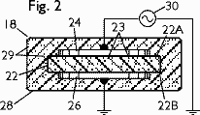
As shown, the electrode 24 is connected to one terminal of a high voltage, high frequency source of electric energy 30, and the electrode 26 is connected via ground to the other terminal of the energy source 30. The voltage applied across the emitter has a frequency of at least 20 kilohertz and a voltage of at least 5000 volts rms.
The reason why the field strength is increased by the presence of conductive particles in the dielectric material is not fully understood. However, comparative tests have proven that the electric field is strengthened and significantly improved air purification is achieved when such materials are dispersed in the dielectric, and it is believed that the work function of the dielectric is altered by the added material and this results in the increased emission from the device.
Referring to fig.3, there is shown a negative electric field emitter 35 which comprises a plurality of planar metallic electrodes 37, 38, 39 and 40 separated by a plurality of flat dielectric members 42, 43 and 44. The electrodes and the dielectric members are encapsulated in an insulating material 46. Conductive leads extend from the electrodes 37 and 40 through the insulating material 46 for connection of the field emitter 35 to a high frequency, high voltage source to develop a generally toroidal electric field around the field emitter 35…
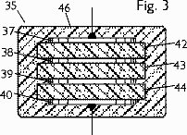
In order to substantiate the fact that doping of the insulator with different non-dielectric materials alters the resultant field and in some cases increases the field strength a substantial amount, several different experiments were conducted. In making these experiments, three different emitters of identical size and shape were constructed. The dielectric slabs were circular being 80 mm in diameter and 15 mm thick. The plates were 63 mm in diameter. In one emitter, the dielectric was a pure epoxy. In a second emitter the dielectric was epoxy containing ten percent by volume of small lead spheres dispersed throughout the epoxy so as to be insulated from one another. The spheres had a diameter of 0.7 mm. In a third emitter the epoxy was doped with SILICON CARBIDE GRANULES having a size of 75 mesh. These granules were of the type used in lapidary grinding and thus contain a substantial amount of elemental impurities wherefore the material is actually a crude semi-conductor. It is also PARAMAGNETIC.
The emitters were connected across a high frequency power supply of 24 kV at 44 kilohertz in the manner described in my US Patent # 4,391,773 using a Kiethly electrometer and an ion/electron probe.
[Additional data from his other US patent 4,391,773…When a power source having a voltage of 24 kilovolts at a frequency of 38 kilohertz was used, readings as high as 6.38X10¹³ ions per cm² were measured at a distance of 50 cm from the device 10. This negative field is sufficiently strong to purify air by discharging particulates entrained therein and to destroy bacteria in the air. An input voltage of 5 kilovolts at a frequency of about 20 kilohertz produced a negative field which appears to have about the minimum strength for purifying air. The measured field strength at 50 cm from the device was 500,000 ions per cm² per second.]
At a distance of ten centimeters from the emitters the following measurements were made.
Pure epoxy dielectric 2.98X10¹¹ electrons/cm²
Epoxy with lead spheres 3.97X10¹¹ electrons/cm²
Epoxy with silicon carbide 4.76X10¹¹ electrons/cm²
It may thus be seen that the addition of conductive or semi conductive or PARAMAGNETIC particles to the dielectric greatly increases the field strength of the field generated by the emitter.

Commentary:

Pat’s work is something to consider when dealing with the proposed electrostatic harvest method discussed in Chapter 6. The dielectric interpole blocks that are found in the EMA4 Free-Energy Engine are blasted with an electrostatic RF burst every time a stretched arc is quenched. The presence of any RE particles may have additional effects as well. The point is that the applied RF increases the DC electrostatic potential. This works well with the variable capacitor concept. This process is important since most of the proposed novel OU gains in the EMA4 are collected as torque. It is speculated that the electrostatic harvest method is what recharges the storage capacitors to repeat the cycle. As it was, it took Marvin Cole’s power supplies 30 seconds or more to charge the capacitor banks from scratch. After the initial start (after the engine had been speeded up to 500 rpm) the engine discharged capacitors at a rate of nine per revolution (minimum). At 1500 rpm this would be 25 pops per second per capacitor. Obviously the 18-24 on board (30 watts per vibrator) power supplies couldn’t keep up with that level of demand. There was some other novel source of energy that was recharging all those capacitors. The method proposed in Chapter 6 is one idea, but probably other proposals will emerge as well.

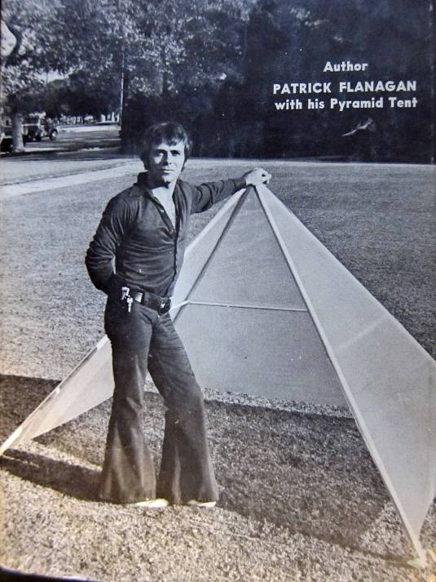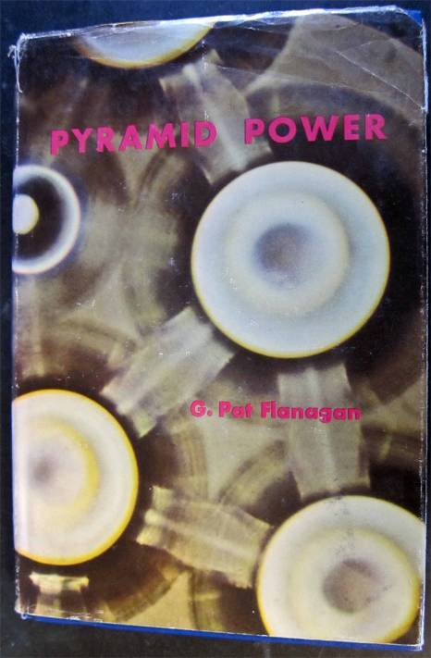

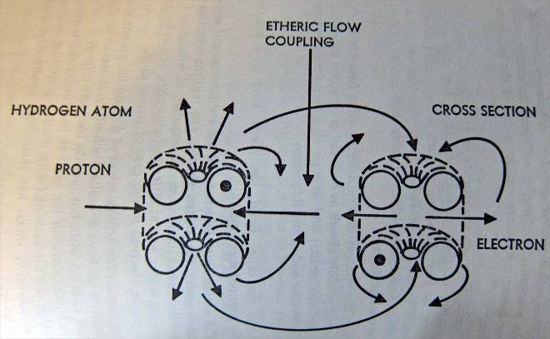

Spin Dynamics

To truly appreciate this classical study of the theoretical gyrations of electrons one must have an intimate knowledge of multivariable calculus, Fourier transforms, several courses in advanced physics, and a generous helping of RF analog electronics. If the reader is not blessed with all this expensive training (including the author) then despair not. For the purposes of advancing a reverse engineering solution to the Free-Energy challenge suggested by the E.V. Gray Technology - all you need is a graphical understanding as to what seems to be going on when multiple magnetic fields are applied to electrons.
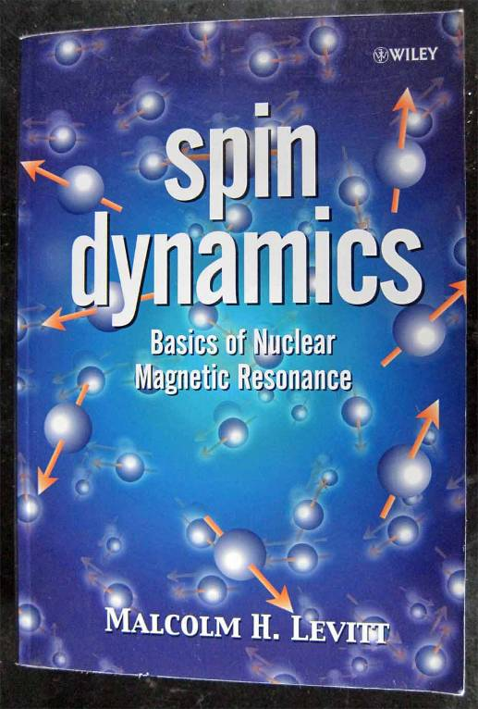
Chapter 10 in this book has proposed an exotic model for RE particles. The central theme was the phase locked nature of the electron spin parameters to explain the speculated super conductor properties of these aggregations. But there are some more basics that the researcher should be aware of, like how the electron spin can be manipulated in the first place. This is technically called nuclear magnetic resonance and relaxation. This is the physics behind medical Magnetic Resonance Imaging (MRI) systems and no doubt has a lot of money involved with its technology, production, and advancement.

To be overly simple, when matter is exposed to a strong magnetic field a fair number of the electrons align their spin parameters somewhat parallel to this external field. This alignment is not perfect, but rather produces a consistent wobble around the flux field lines. In introductory texts on the subject an analogy is made to the precession of a spinning toy top.

This is a nice visualization, but it has its limits. First off, just what electron spin is has not been exactly determined. It is some measurable parameter that repeats itself every 720º, that’s twice the angular rotation of a physical 3-dimensional object. In high school physics the concept of
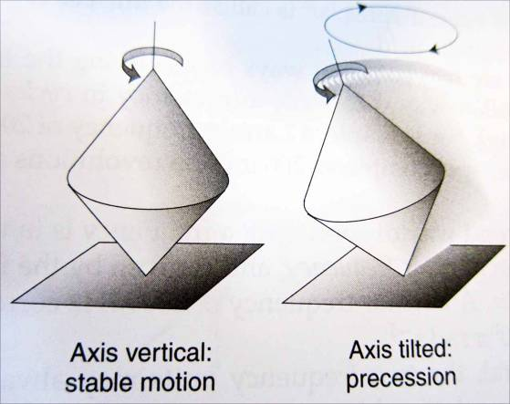
spin is presented as little marbles spinning on their axis that generate an amount magnetic flux. Well, spin is like infinity, gravity, reflection, and sex; teach the student just what they need to know. The higher up you go on the academic food chain the more the theories and explanations change to handle the ever increasing complexities that have been encountered.
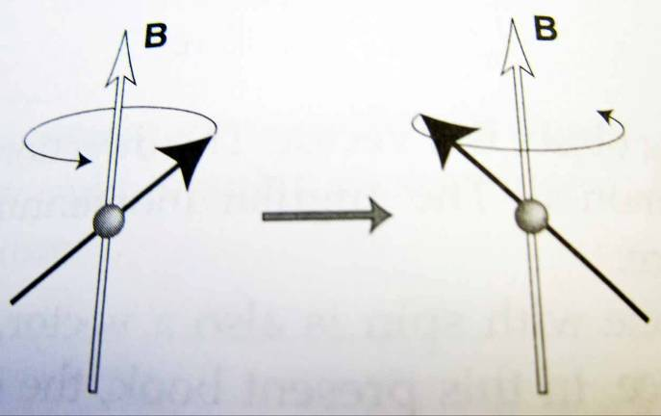
What you need to know about this phenomena, which was discovered in 1959, by Pople, Schneider, and Bernstein, is that it all started out using paraffin wax which has properties similar to the Delrin plastic we have proposed as being the active dielectric in the E.V. Gray Technology. When a magnetic RF burst of the same frequency as the precession frequency is applied at 90º to the strong steady state magnetic field that has already been applied, the electrons just go nuts and fall all over them selves. They appear to briefly flop over and precesses along the axis of this outlaw RF burst vector. But they quickly regain their composure and again begin to realign themselves back to their previous state. This takes a little bit of time. While they are doing that they emit RF signatures of their own. This plethora of electromagnetic radio waves are detected and analyzed to determine what kinds of molecular bonds generated these signals and where they came from.

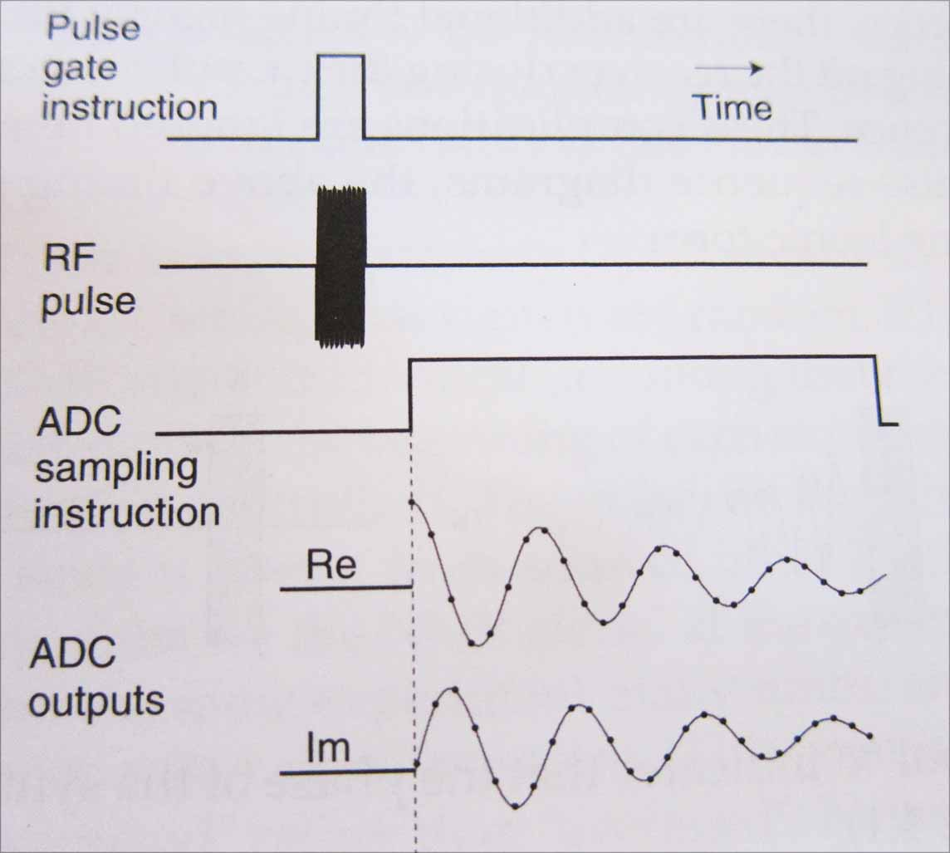

It is this relationship of a strong steady state magnetic field and then a sudden RF burst at right angles that causes a huge change of state to the spins of the electrons involved. In the E.V. Gray Technology we seem to dealing with this kind of process, except here the applied RF burst is electrostatic and not magnetic. It is the angle at which this burst is applied and its frequency that should be considered when making engineering judgments about how to design your particular setup.

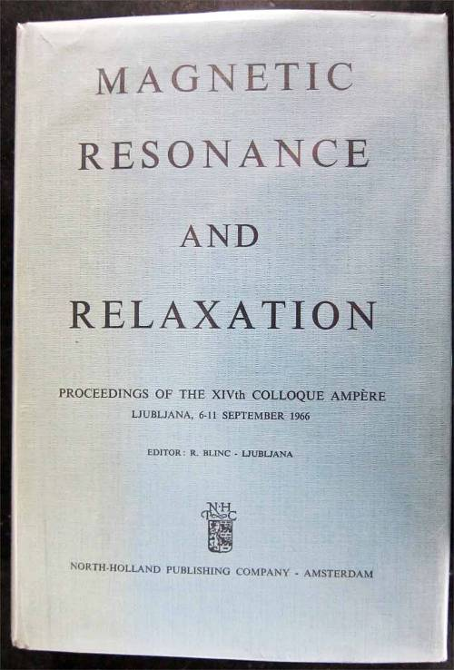
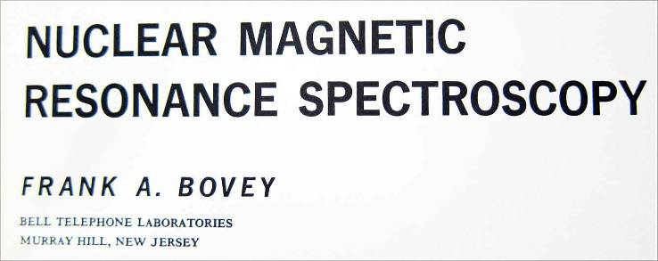

Books on this subject are expensive. The Spin Dynamics book by Malcolm H. Levitt pictured above was $85.00. There are older volumes available for much less than that and contain the same useful basic information. The book on the left was $10.00(1237 pages) while the one above was only $6.50. All of these books are from Powell’s Technical Bookstore in Portland, OR which has a fine online selling service. The prices for the same titles should be about the same from Amazon.

The Tesla Connection

Novice to the Master; “Oh Great One, bestow upon me thy infinite knowledge of the Universe”. Master to the Novice: “Get me a beer… make that a six pack, this might take a while.”

Any Free-Energy researcher who has gotten this far in this document already has (or should have) an intimate knowledge of Nikola Tesla and his extraordinary work. It has been proposed that Dr. Tesla was the foundation of the E.V. Gray technology from the beginning, but this hasn’t been proven for sure. Wither he was or wasn’t, most researchers are already convinced that he was working with the same phenomena long before Andre Poppoff and Marvin Cole ever stumbled across it in the early 60’s. Peter Lindeman, in his book “The Free Energy Secrets of Cold Electricity”, has already put together a pretty good connection between these two technologies.

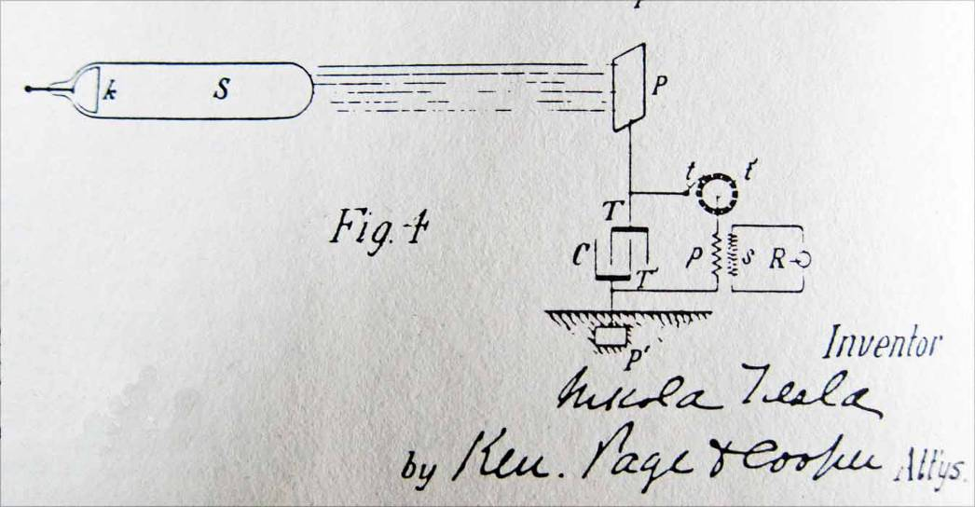
Nikola Tesla Patent 685,957 Nov. 5, 1901 Apparatus for the Utilization of Radiant Energy
from “The Complete Patents of Nikola Tesla page 512
Unfortunately, the concept of Radiant Energy has a ways to go before it is taught in high school physics, alongside simplified concepts of electron spin. It is the authors’ intent to just point out a few correlations that might be useful in attempting your own replication effort.

One central theme in this book has been the speculated idea of generating novel RE particles by means of a stretched arc across a dielectric. Again this needs to be proven as well, but when you go back and review a number of Dr. Tesla’s disclosed devices that are associated with “Radiant Energy” some connections do appear.

Consider one of the first patents # 514,168 granted Feb 6, 1894. This was for generating “Electric Currents”, actually high frequency currents. Many suspect that something else was being generated as well that Dr. Tesla didn’t completely disclose at that time. As it turns out Dr. Tesla never did disclose the entire secret behind his “Radiant Energy”. He did attempt to protect the fundamentals by spreading the information out over several patents, but he never put all the information in one sock that mortals could understand. If you read his personal history, especially with all the patent infringement court cases, you can appreciate why it was done this way and possibly why this knowledge was lost in the process.

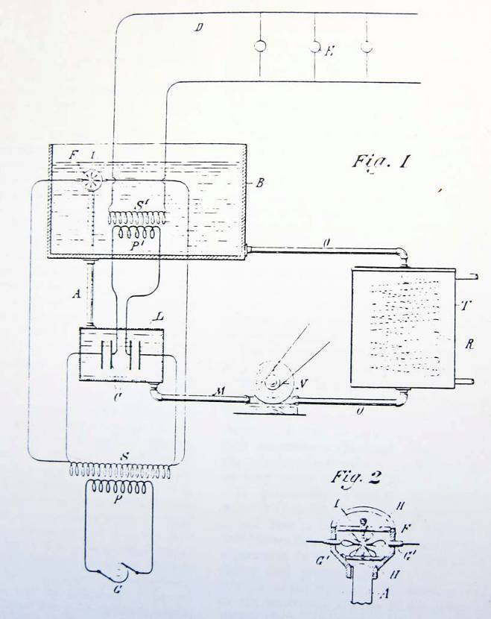
This simple appearing device is far from simple. This is the result of exploring at least a hundred circuit variations starting in 1891. Dr. Tesla was pretty well self funded at the time with the money he made from the Niagara Falls project, so he had the best equipment and an all star team of support technicians, plus a shop that would put even Mr. Ken Shoulder’s facility to shame.

Take a closer look at Fig. 2. It appears like a simple sketch, not too much detail. This author can assure you that the actual device was built with the precession of a Swiss watch and would have taken several detailed drawings to attempt to reproduce it. Dozens of important construction requirements are not disclosed. Even the synchronization between the alternator and the rotation of the paddle wheel has not been discussed.

What you need to look at is a few lines in the overall short patent text. “I have found that greatly improved results are secured by causing the discharge to take place in and through an insulating (read dielectric) liquid, such as oil, and instead of allowing the terminal points of the break to remain at a uniform distance from each other, to vary such distance by bringing them periodically in actual contact or sufficiently near to establish the discharge and then separating them, (read stretching the arc) or what is the equivalent of this, throwing in and out of the gap or break a conducting bridge at predetermined intervals.” This is the same process we propose that was taking place in the Marvin Cole Free-Energy Engine.

More over Dr. Tesla goes on, “To obtain the best results, moreover, I find it essential to maintain at the point of discharge a flow of the insulating medium, or, in general such a circulation of the same as will constantly operate to cut off or break up the discharge as fast as it is established.

Well, breaking up the discharge, or stretching it faster, had its purpose, but replacing the used dielectric with a new surface might have been just as important. This comment coincides with the requirement of the Cole Free-Energy Engine to have fresh air always circulating around the stretched arcs, in the Engine proper and in both of the Commutator sections.

Many suspect that Dr. Tesla already had the fundamentals of his Radiant Energy system pretty well figured out by 1892 or sooner, but he wisely choose to keep his cards close to his chest until he could find an unquestionable and profitable application for his new discovery. Presenting scientifically advanced lectures to the various professional societies with a full house was a great ego trip but was not going to pay the rent (or buy all the toys he liked to play with).

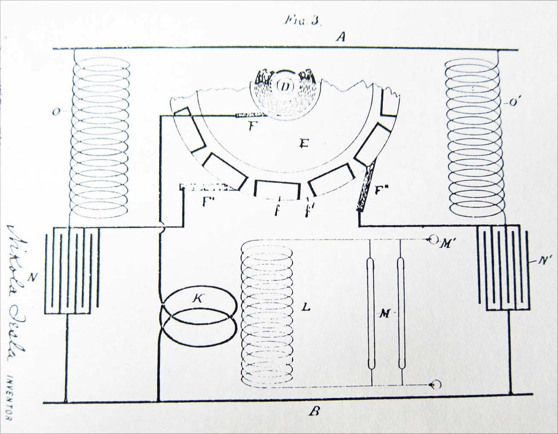

Figure 3 from Patent 577,670 granted in Feb. 23, 1897 “Apparatus for Producing Electric Currents of High Frequency”

By the time of this patent Dr. Tesla has barley recovered from his assignation attempt and the destruction of his laboratory in 1895. The big boys fumbled the ball on attempting to get rid of any possibility of Dr. Tesla’s new technologies from messing up with their monopolies on old technologies. Dr. Tesla was not oblivious as to why he was targeted. He had to stop to rearrange his personal concepts of humanitarian scientific advancement, financial reality and the ugly power brokering of his day. Thus he had to deal with what could be marketed and just how new discoveries could be protected and minimize the wrath of the corrupt industrial complex. It certainly set him back and it made his patents that much harder to decode. Many concede that a lot of Dr. Tesla’s “Good Stuff” went underground after 1895.

Patent 577,670 is just a sample of several different systems protected after 1895. Many of them share the same components and concepts, yet each one hides an import engineering feature that researchers to this day are still attempting to ferret out.

Assuming our concept of a stretched arc is a viable procedure, then here is one method that Dr. Tesla explored with an arc being stretched over a rotating commutator surface. He states “By the interposition of mica or other suitable insulating material between the two heads of castings c c’ are insulated from each other.” The rest of the paragraph discloses details of the brush dimensions and construction.

This is certainly not a proof of the stretched arc concept, but it does show that something like this was taking place in Dr. Tesla’s lower powered equipment.

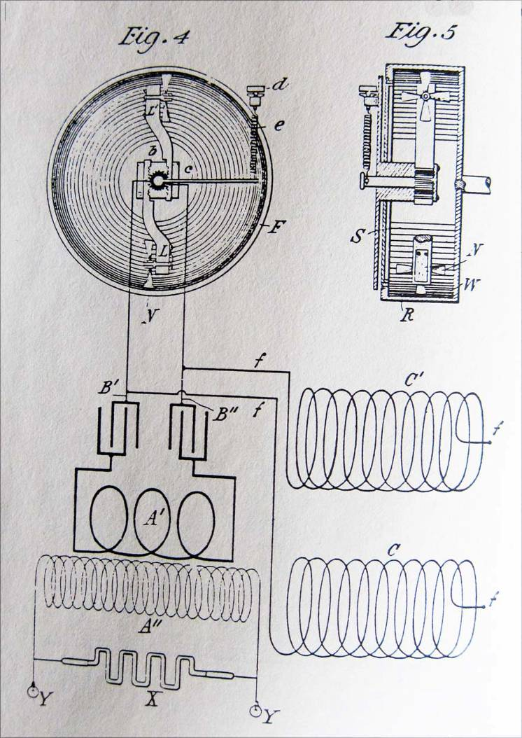
This design is interesting because of the features it hides while seeking full patent protection.

The cylinder spins during operation. The inside space is filled with mercury and Kerosene. When the unit is up to speed the two liquids separate with the conductive mercury being close to the outside wall. The Kerosene then takes up the remaining space. As it whirls around it caused the little fan blades to rotate. They hit the mercury and strike an arc that is stretched a short distance in the dielectric.

The little thumb screw adjusts the depth of the fan blades to the surface. This is a nifty device and was probably the smallest RE generators ever built. It was limited to its power ranges and so larger designs, based upon these hard won principles were concurrently developed.

Note the Tesla “Equal-Drive” split capacitor system employed.

Patent 609,251 granted Aug. 16, 1898 “Electric-Circuit Controller”

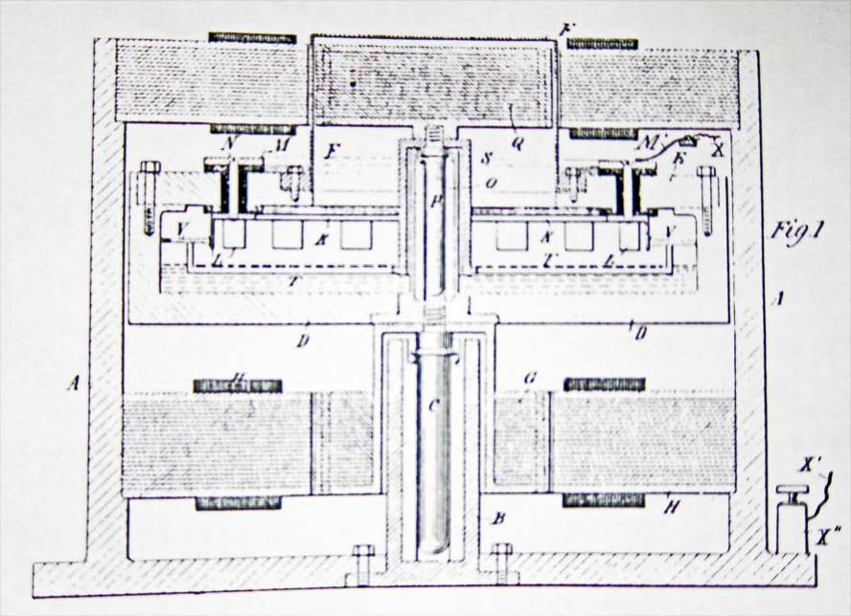
Patent 613,735 granted Nov. 8, 1898 “Electric Circuit Controller”

This is the last patent in this series of improved Circuit Controllers. Whatever Dr. Tesla was attempting to protect he certainly hit it from several angles. This one uses pressurize mercury jets and two counter rotating motors. It was probably intended for higher power operations. It was not disclosed if the intervening space was filled with a liquid dielectric or just left empty; the reader will have to come to their own conclusion. Consider what the impact of the magnetic fields from the two motor armatures is on the arcs that are being struck.
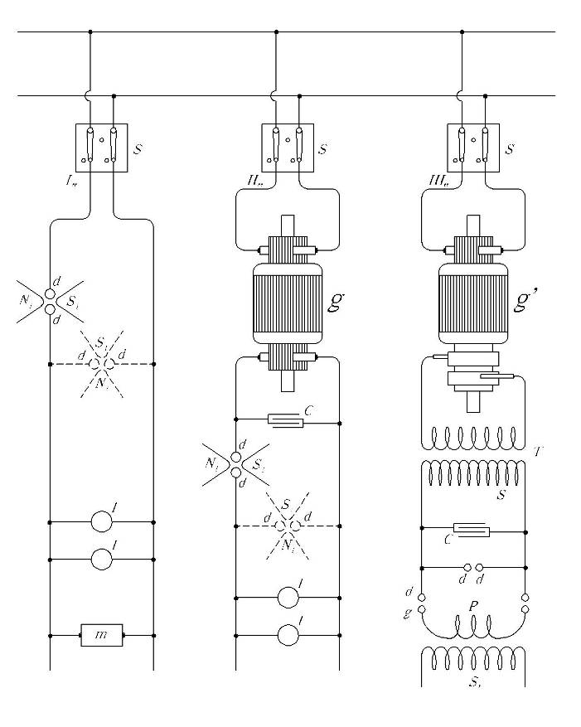
This is one-half of the famous Fig. 1 from Dr. Tesla’s February 1893 Lecture. Peter Lindemann has already done a great job of explaining the importance of this schematic and its relation to what was going on at the time. Despite the many reviews and theories concerning these circuits there is one important overlooked detail that the Free-Energy researcher should be aware of. According to Dr. Tesla the circuit that worked the best was topology II, or the one in the middle as shown above. Here we have a DC source driving a DC to DC rotary converter. Now the input voltage could have been anywhere from 100 VDC to 500 VDC. The voltage gain in the converter could have been anything from 2X to 10X. It was really limited by the design and quality of insulation. A voltage of about 3.5 to 5.0 KV DC supplied to the storage capacitor would not be out of the question. Next he shows a magnetically interrupter apparatus in series and another one that is connected in shunt but shown in dashed lines. The indication is that both methods work but the series system is better. Notice there is no intervening transformer and yet in this circuit, and the one to the left of it, both generated the new form of electricity that he realized he had found in late 1892.

This means that a properly designed gap popped with a capacitor will generated the proposed RE particles. The only problem is not many success stories have been posted using this approach. Again, Dr. Tesla only presents diagrammatic schematics in his lectures and patents - the details of the real device is another matter. Now, magnetic arc quenching systems seems to only work well with high current applications in the range of 10 Amps or more. The device that was disclosed and illustrated seems straight forward enough. Not many people are going to deal with 3.5KV at 10 Amps (pulsed) and live to pay the power bill or deal with the FCC on the EMI issue. Dr. Tesla had the money, the equipment, the drive and the knowledge to go where no mad scientist had gone before. Plus he didn’t have to worry about the FCC.
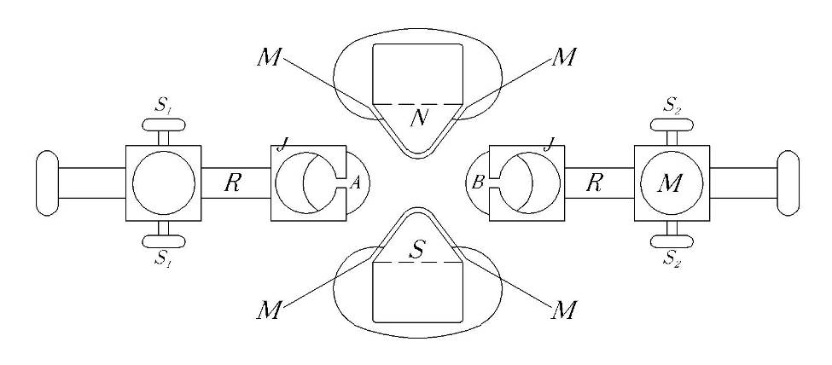

Details of a Magnetic Interrupter using Mica sheets to prevent the shorting of the arc to the pole faces. The fact that this additional insulation was needed shows that the there was an issue with the plasma hitting the surface. Illustration from the lecture delivered before the Institution of Electrical Engineers, London February, 1892.
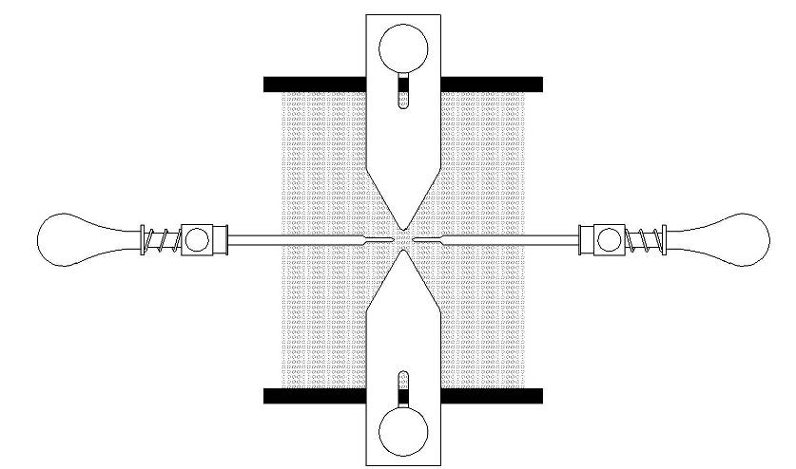

Disclosed DC Magnetic Interrupter from the February 1983 Lecture delivered before the Franklin Institute, Philadelphia (Assumed Top View)
Between the 90º applied magnetic field, the circular field generated around the arc, and the heat caused by the plasma the result is a very dynamic twisting affair. The method will break the arc up but not until it has been significantly stretched, twisted, and distorted. So, what we have here is a stretched arc process.

If you read the text of the lecture Dr. Tesla explains how he had also inserted two sheets of mica to protect the magnetic pole faces - which are not shown in the illustration. Now we have a stretched arc being drug across a dielectric surface. Does this sound familiar by now? Not only that, but mica is the same insulation he recommends in the 577,670 patent above. This author is sure that it didn’t take the Master long to figure out what was going on (if we are on the right track) and then quickly improved on it, except now he started moving in on to lower power methods. Probably once he got the generation part figured out it was the collection and focusing of this novel energy that became the challenge. Thus a lot of work was done with some very precession wound custom transformers. This is where all those odd rules of thumb like equal mass for the primary and secondary might have come from.

The Gerry Vassilatos Connection

Peter Lindemann certainly gives Gerry his just due by including in his book “The Cold Energy Secrets of Free Energy” a complete copy of Gerry’s first chapter from “Secrets of Cold War Technology: Project HAARP and Beyond.” Peter then acknowledges the impact of this book by titling the copied chapter “The Rosetta Stone”. This author highly recommends both of Gerry’s books, the one just mentioned and its companion “Lost Science”. If you go to the Borderlands site you will find that Gerry also complied several other volumes on different fringe subjects. These loose leaf spiral bound works have no less than 400 pages each. They are a collection of patents and articles that are started off with a long commentary by Gerry on the subject at hand. If any of the topics interest you they are well worth the $50.00 or so each.

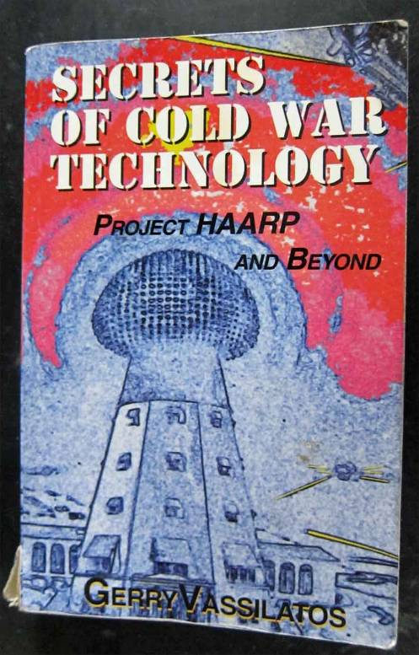
But who is Gerry Vassilatos? He certainly hasn’t posted anything on the major Free-Energy web sites lately– which this author knows of. From present understanding he probably hasn’t and probably will not do so in the future.

Jerry’s day job was a middle school science teacher on the East Coast near New York City some where. His off time avocation was historical research into all kinds of esoteric energies. He had the uncanny ability to be granted access to restricted privately held archives of important documents concerning these subjects. If you review the long list of acknowledgments you will see the kinds of foundations and collections he was able to dig through. After years of this kind of study he became quite an expert. Apparently, he also had a small garage non-funded laboratory/work shop where he reviewed some of the practical applications of the technology that he was exploring. Just reading the contents of either of his books will display his broad range of interests.

Needless to say he also was a good writer and could take limited circumstantial facts and string together into a very convincing set of speculations. (Remind you of anybody?) With the few hours left in a week after working (but he had the summers off) being able to chase down and write as much as he did is certainly an achievement.

Gerry seems to have been very active in the mid to late 90’s. In 1997 he was interviewed on the nationally syndicated Laura Lee show where he presented a live commentary where transcripts were still being requested five years later. “Lost Science” was copyrighted in 1997 while “Secrets of Cold War Technology” was done in 2000. Gerry was also an active contributing writer to the Borderland’s organization.

Then something happened. One day during a regular weekly conference call at the Borderland’s office Gerry resigned from his unpaid position and verbally passed on all the publishing rights for his two books, the Compendium Series, plus what ever other articles or copyrighted documents he had done with the organization. He didn’t say what the issue was, but he did say in closing that he didn’t want anybody to attempt to contact him.
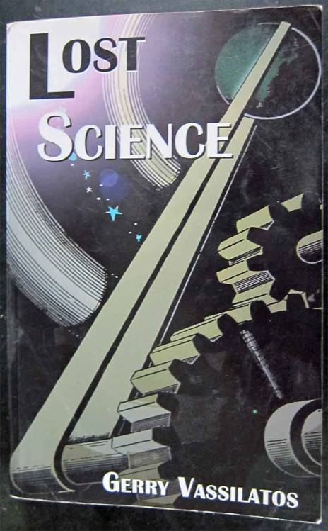
Later it is rumored that one of his readers (with $$) was so interested in some of Gerry’s ideas, concepts, theories, and stories that they hired a private detective to seek Gerry out. The purpose of this expense or the reason for doing so was not known. Apparently Gerry was found alive and doing fine teaching middle school science. He didn’t want to be found, he didn’t want to be interviewed, speak at a convention, write another book, or sign autographs. He wanted to be left completely alone from any fringe science aficionados. Fair enough. At least he hadn’t become a statistic at the hands of the MIB. (Or had he?)

So what happened? Who knows? Some speculate that his wife had laid down an ultimatum concerning the addictive nature of his hobby. Certainly this is a plausible idea, but we just don’t know for sure and really it’s none of our business. This same sort of thing happens in a lot in other people’s journey where one activity becomes grossly out of balance with the rest of life, be it jogging or fly tying.

Reading some of Gerry’s work is certainly a mind trip. He appears to explain what was happening technically in Dr. Tesla’s projects in a manner that seems so much more exciting than all the accounts provided by contemporary biographers. Gerry’s writings can sure inspire some interesting ideas for the novice researcher, but be careful. Despite the huge value that is to be found in Gerry’s work this author recommends some cautions be taken.

First off, it’s hard to distinguish between Gerry’s facts and Gerry’s speculations. This is a big deal if you are attempting to reverse engineer any of the subjects he touches upon. Gerry doesn’t bother to super script his factual statements with a reference number so that the reader can go back and study the original source material word for word. The proper referencing of stated facts separates professional research papers from informative commentary. You can build things from research papers; you can only do more document investigation from a commentary. Yes, Gerry provided lots of copies of documents in his compendiums, but the information this collected material provides is not incorporated into his text. Yes, it takes a lot of time to properly reference every fact when writing, but it makes the difference between reading engineering guidance and a novel.

Second, Gerry appears to “make up” what he doesn’t know. This is what Tom Clancy does in his block buster technical novels. In fact Tom is so good at it that it is rumored that he has been interviewed by the military and INS to find out just how he learned what he writes about. The human mind (some minds anyway) have the ability to extract the truth out of thin air. This ability is sometimes called Remote Viewing and is an extensive subject in its own right. Some people can do this, most of us mortals can’t. Could Gerry do it? Well that is for the reader to decide. Keep this in mind when you read his analysis. There are many areas where Gerry makes bold statements about Dr. Tesla’s research where the actual facts are just not available.

No doubt one of Gerry’s favorite subjects is the work of Dr. Tesla. Gerry had the good fortune to interview people who had worked with Dr. Tesla. (Mr. Preston Nichols and Mr. D. Crnosiya) He also had access, through these contacts, to dig through some private Tesla archive collections on Stanton Island. So, Gerry did have some sources that others may not have been exposed to. That being the case there is merit in taking Gerry seriously. For purposes of reverse engineering the E.V. Gray Technology it might be helpful to review what Gerry’s reports on Dr. Tesla’s work in creating Radiant Energy.

This commentary comes from the “Lost Science Book starting on page 110 under the heading of Shocking Discovery. Gerry describes the step by step experimental discovery “Radiant Energy”. No dates are given or references sited so one has to follow along and see how the presentation holds together. However we are told that these events take place in the New Your Laboratory, so this has to be prior to 1895. Dr. Tesla starts out with exploding wire experiments.

Gerry Vassilatos:

[Dr. Tesla] developed a small lightning “generator” consisting of a high voltage dynamo [15 KVDC] and small capacitor storage bank. He wanted to observe the mechanical explosive effects which wires sustain under sudden high-powered electrifications.” “Charged to high direct current potentials, his capacitors were allowed to discharge across a section of thin wire.”

Commentary:

Just how small was that capacitor and how thin and long was that wire? These are important parameters to know when reproducing these kinds of experiments. Let’s say Dr. Tesla had a 1 uF capacitor that was charged to 15 KV that would be a 112 Joule pulse. You can get the same amount of energy with a 9 uF capacitor charged to 5KV. With Gray and the EMA6 they were using (allegedly) 5KV at 12 uF or a 150 Joule pulse. We just don’t know how large of pulse Dr. Tesla was experimenting with given the information disclosed. 150 Joules is chump change in professional exploding wire experiments. Obviously this was a single event experiment since it is implied that the wire had to be replaced with each shot. The whole point of these experiments was for Dr. Tesla to experience some kind of shock wave that passed through various shields. It odd but it’s been more than 100 year since these very basic experiments were done. Has anybody followed up on them? Observing a sensible something that penetrated Faraday shields would make a pretty good Master’s Thesis in EE. No doubt there would be military potential in this kind of low level EMP process. Some people propose that Dr. Tesla was half psychic (if not a whole one) and was perceiving this anomalous “something” using his special sensitivities. Therefore these same effects would be probably completely over looked by a mere mortal. This is one reason given as to why no one has been able to do an experimental reproduction of this kind, even though used equipment to do this can be had for less than $200.

Gerry Vassilatos:

“Tesla configured his test apparatus to eliminate all possible current alternations”

Commentary:

Now this is important when dealing with high current unidirectional capacitor discharge pulses. A certain amount of series resistance is needed to critically damp the resonate system – and all loop circuits are resonate at these current levels. Not much, but some. In bench experiments when dumping 3000 volts from a 5 uF capacitor into a ½” diameter brass rod 18” long (for mass resonance experiments) the added series resistance needed to quell the oscillations turns out to be 0.9 Ohms. This type of setup appears as a short circuit to the storage capacitor and seems similar to what Dr. Tesla was doing with his exploding wire experiments.

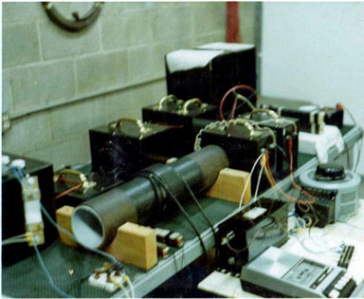
This is one of E.V. Gray’s demonstration Popping Coil setups as it was seen in 1974. Notice the component circled on the left. This is a high current meter shunt. It is normally used in conjunction with a low voltage meter to measure much higher current values. Example: a 50 millivolt meter can accurately measure 500 Amps of current flow using this device. The component itself is a high current low value resistance. In this case 0.0001 Ohm 5%.

Since no meter connections appear in this photo it is thought to be employed as a damping resistor. Even if there was a meter attached it would be completely useless since the pulse would be so fast as not to be noticed. Only a digital or storage oscilloscope can record events like these.

Gerry Vassilatos:

“When the speed of the switch-action is brief enough, and the power reaches a sufficiently high crescendo, the effects are not unlike a miniature lightning stroke.” “He quickly closed the large knife switch held in his gloved hand. Bang! The wire exploded.”

Commentary:

Well you have to take this statement with a little salt. The switch that is being discussed is an old exposed blade knife switch (large). It doesn’t matter how fast of an arm anybody has. The fact is at 15 KV in dry air the high voltage will arc-over when the two copper surfaces come within about 0.250” of each other. This event takes only 10 nano-seconds. By the time the actual copper blades are properly seated the exploding wire event will be all ready be over with. Gerry goes on to promote the idea of fast mechanical switching actions. Really, in relays and mechanical switches it takes between .1 and .5 milliseconds to establish a low resistance connection. Compared to the speed of the arc-over process there is a 4 order difference in magnitudes. The speed of the mechanical transition has nothing to do with the arc process. Now, the repetition rate is another matter. Dr. Tesla quickly moves on to continuous repeated pulse processes in the following experiments as describe by Gerry.

Gerry Vassilatos:

“Closing the dynamo down, he rubbed his face, neck, arms, chest, and hands. The irritation was distinct.”

Commentary:

Let’s assume that Dr. Tesla was only slightly psychic but the sensation he reported would have been experienced by anybody. O.K. then why hasn’t this same effect been reproduced with capacitors charged to 15 KV and suddenly discharged across an exploding thin wire. This sort of thing is regularly done by graduate students taking college laboratory classes in high voltage transmission systems? What’s the difference? Consider the piece of equipment that Dr. Tesla was shutting down in that last sentence– a dynamo, or a DC generator that was probably powered by another DC motor at a constant speed. That was a special machine and to understand the full extent of the described experiment we have to look at the entire power supply and not just the charged capacitor. True, charge capacitors explode thin wires all the time. But something was different in this experiment to cause the novel effects reported.

Dr. Tesla:

In the lecture delivered before the Franklin Institute in February, 1893 Dr. Tesla disclosed:

“…. a continuous-current generator is employed, which is often convenient. It is desirable that the generator should possess such high tension as to be able to break through a small air space”

Commentary:

A high voltage (assume 15 KV) constant current generator? Do you know how rare that piece of equipment is? Low voltage constant current generators are made by the thousands today for portable arc welders but their open circuit voltage rarely exceeds 80 Volts. But Dr. Tesla needed something different. At the time he could have afforded the construction of any kind of custom dynamo he need and not worry about the copper cost. He could have easily designed it just the way he wanted and had it built in his own shop. The sad fact is you won’t find one of these on eBay any time soon. (Or anything similar even if you could afford the copper wire)

When a generator like that is connected in parallel with a high voltage capacitor the response of the entire power supply to a direct short is no longer that of a discharging capacitor alone – but something else. The difference of the energy profile that is being presented to the arc plasma may be the critical difference between generating anomalous particles that produce a noticeable irritating shock wave or just making a lot of noise with a brief light show.

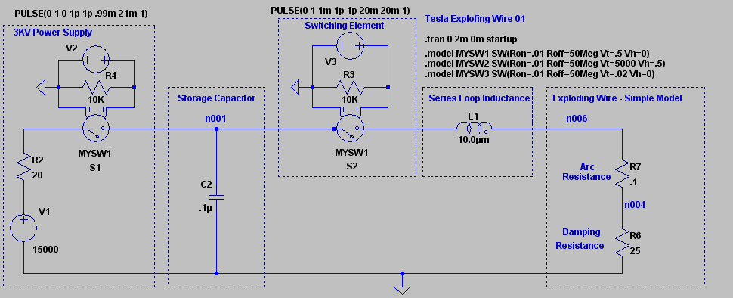

Consider the above SPICE III simulated circuit of a simple exploding wire experiment as might be done by exploring hobbyists. A 15 KV voltage source, typically the rectified output of a Neon Sign Transformer, is used to charge a high voltage low value capacitor. A mechanical switching means is employed to deliver this energy to a length of thin wire, shown here as a .1 Ohm resistor. The total loop inductance for all the connections, capacitor inductance, and test leads is assumed to be 10 micro Henry’s. 25 Ohms of damping resistance has been added in series to eliminate ringing and keep the current flow unidirectional.

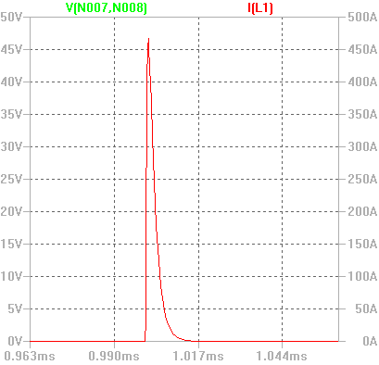
When the switching element is closed the simulated trace on the left shows the voltage and current that the exploding arc would see. Since the exploding wire is modeled as a pure resistor the voltage and current are exactly the same shape.

Even though we started with 15KV at the storage capacitor the simulated exploding wire only sees about 46 Volts peak across its terminals, due to its low resistance.

What the exploding wire really sees is a huge current pulse. This response is what happens when a capacitor is the only source of energy and it has been isolated prior to discharge.

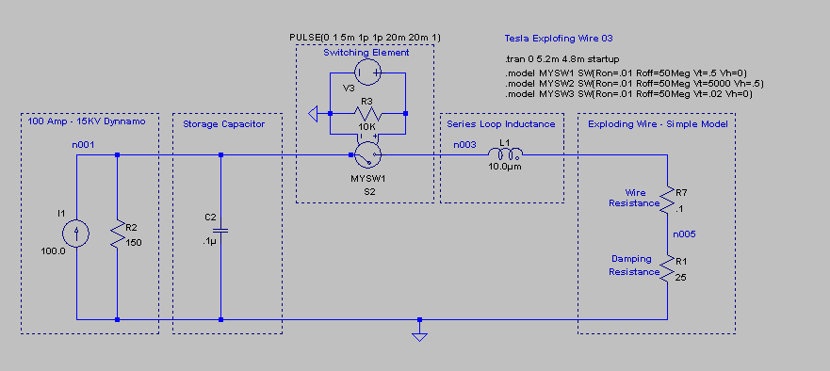

Now consider the situation when a constant current dynamo is connected in shunt with a small capacitor and the mechanical switch is closed.

Now the response pulse width is a little wider since the dynamo helps charge the capacitor during the discharge phase. Other than the width the current pulses are pretty similar until the tail is reached. Now the constant current nature of the dynamo comes into play and maintains the current flow at its designed rate.

If this were an arc it would burn continuously at this current limited value as long as power was available. Dr. Tesla’s next logical step was to develop a means to shut it off after a certain short period of time. The point is that the arc plasma is still being fed energy after the initial strike. The value of the capacitor determines the magnitude and width of the initial peak current.

It appears that if we are to attempt to reproduce the effects that Gerry Vassilatos claims took place with Dr. Tesla, then we will have to dig deeper into the actual apparatus and look for the details that have been over looked for the past 100 years. This above analysis only points out one possible factor. There are more than likely others that are just a subtle.

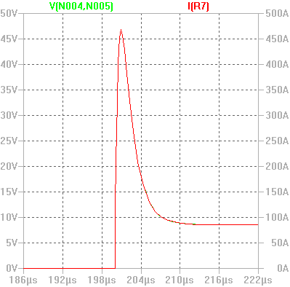
It just so happens that the idea of a high strike voltage, high initial current pulse, followed by a near constant current tail then actively quenched seems to fit the observed topology in the EMA4 Free Energy Engine.

Gerry goes on to develop his ideas as to how Dr. Tesla made his advancements all the way up to the Colorado Springs experiments. It is interesting reading, but review it critically and cross check the assertions with all the solid engineering you can muster, knowing full well that something non-classical was going on and that was being covered up. Maybe not quite the way Gerry tells it, but no doubt similar.

