Appendix 6

Interview with Dowd R. Cannady, an E. V. Gray Observer

This report is transcribed from a tape recorded by Carl Lennon in June 2006. It is an informal interview with Mr. Dowd R. Cannady, a former EV Gray observer who recounts his experiences with E.V. Gray in 1973.

Mr. Cannady is currently an inventor living in Mims Florida. Prior to this experience Mr. Cannady was once employed by the US Air Force as a radio mechanic. He therefore had considerable technical experience to better evaluate what Mr. Gray was presenting. This material covers two meetings at Mr. Gray’s office/shop in Burbank, LA some time in 1972 or 1973. The first visit was Mr. Cannady’s introduction to Mr. Gray. The second meeting was a follow up visit a few days later.

The demonstrations described below were being set-up and presented for the benefit of a group of trust managers from the Bing Crosby Foundation. These executives were exploring the possibilities of investing in Mr. Gray’s work. It was fortunate that Mr. Cannady came along at this time or else he might not have been able to see this many technical details disclosed as compared to Mr. Gray’s typical “run-of-the-mill” investor demonstrations.

A Flash from the Past

My name is D. R. Cannady and I live in Mims Florida, and I’m a friend of Carl Lennon. We have known each other on & off for 10, probably 15 years. Anyway he asked me about my experiences with Edwin Gray and I told him that Edwin Gray was introduced to me by a promoter by the name of Tom Robe, from Palsbury, CA.

Tom took me and Charles Henley to E. V. Gray’s office and as we drove up to it, where the cars parked, there were three big limos in the front yard. I didn’t know at the time why all the security, it makes you wonder. There were three guards there, and armed. They checked us over for weapons as we went in the door. As we walked in there was a desk off to the left. There was a slight built man there in about his forties. Tom walked us over and introduced us to this gentleman. This guy was the attorney for Bing Crosby Enterprises. They had been looking at this to see if [or] what merit it had, and one thing or another. I guess to help him [out, financially]. Later I find out, I think that [Mr. Gray] picked up something between (the rumor) $23 and $29 million dollars on this thing.

Not one person would ever deny that it didn’t work, because it did. He took us, as we got through saying hello, to this guy and shaking hands, getting in his car and one thing or another. Gray walked in through a doorway off to our right and said “Who have we got here, Tom?”, or something to that effect. Tom introduced us to Mr. Gray. Gray is a very soft spoken very mild mannered person and a “Big Guy”. He probably weighed 260 lbs, big shoulders, but just a real gentle guy. I don’t know, I took an immediate liking to the guy. So then we go in the other room.

Popping Coil Demonstration

“We have a couple of things here to give you, to kind of break you in on the thinking of this thing. We don’t use normal electricity”. He say’s “we are using opposing fields” and he took us into this room. On the side where he had a table there and he had a 12 volt battery sitting on the table. And, the wires went from the 12 volt battery to an adjustable spark gap arrangement to give the line a load, I guess. And then, it went from the spark gap it went to a timing mechanism where he could set like 30-45 seconds. And the electricity went from there into a step-up transformer to this coil thing. I think it was three big coils, can’t remember it was two or three. They were bigger than, each one was the size of a half gallon of milk.

Question by Carl Lennon: Capacitors?

Yea, big capacitors, right. And, then the electricity came from the capacitors down to a drop cord, that was just a great big drop cord rolled up in a 30”-35” circle and maybe only 5-6 turns of it laying on the table and that 5-6 turns at 30” had 15,20,30 feet there (actually 39 to 54 feet). He said it was called a “Reese’s Choke”.

“Other wise when I show you this demonstration [it] will knock everyone’s TV out for a second” and he says “don’t need any complaints from that department”. So, at the end of this coil he had this single throw double pole (SPDT) switch, the old fashion knife switch. And then he showed us these two rolls of wire he had #18 AWG automotive wire. He said, “there is about a 100 turns in each one of these”. He put the two plus (+) sides that means where the electricity is going into the coils. A together and he put two toothbrush handles between them and then he set that 30 second timer over there. So any way the just found then there was two long pieces of wire from the top coil of course one wire went to the ground and the other wire went to the knife switch. And then, on the bottom coil one went to ground and one went to the other side of the knife switch. Cause that was when he fired these things [and the 3”coil] jumped up in the air. We measured it after the 3rd go and it was jumping up in the air, as I recall 39”. It might have varied an inch or two [but] that’s about where it was at.

And he said “now this is the [kind of] power we are using”.

And he shoved down that handle and that thing went “WHAM” just like a “thirty-odd-six” (3.06 caliber rifle) and everybody come up out of their chair. I mean it was so loud and sharp it was just like a gun shot and the top coil flew up into the air like I say right around 40”. And then, he loaded it up and set the timer for another 30 seconds and fired it again.

Now he said after the 4th or 5th time, he said, “I’d like to have you feel that” and the wiring was absolutely cold, and he said “This is called cold electricity that we are doing this with”. “We have stepped the voltage up from the 12 volts to a higher voltage range”. I think on that one he said it was right around 3000V. I don’t remember at this moment, but I’m pretty sure that is what he said. And he said “When you step the voltage up like that you loose your amperage before you end up with Cold Electricity, because amperage causes heat.”

And then, everybody was quite impressed by the way that happened. Then he took us in the other room and he had a bench all along the left wall.

Question by Carl Lennon: This 100 turn coil, what was the diameter of it?

He wrapped it around his hand and so I would say it really didn’t have much definite shape to it, but I would say you are looking at 3-12/” to 4”.

The EMA4-E1 Motor

So then we go in the other room. Here is one of these shop cart dollies with the four wheels on it. It had a platform in the bottom with four Golf Cart batteries. I believe they were all just a tall “high boy” 12 volt. And on the top of that he has this strange looking motor on it. And on the end of the motor on top he had an adjustable thing for controlling the speed. It looked almost like a wheel balancer like the different rings to balance a wheel out just before you put the weights on. It had to do with the control of the speed of that motor.

The next thing he did he reached over and flips a switch and this thing roared, RRRRR… like this, very loud. And your hair went pointed straight towards it. There was a lot of magnetism in this thing. He had a transmission on the back of it and he had a dyno-motor on the back of that with a gauge showing how many horse power it was pulling down. I recall he had it pulling down 25 HP. This motor was maybe 34” – 36” long and the diameter was about a, I’d say probably pretty close to 18” to 20” in diameter. It might have been a little bigger that that. This is just from… it’s been a long time ago, 1973, a heck of a long time ago.

Then he explained to us that this thing, no matter what he did, it would eventually die – it would go dead, because even if you had a charger on it and charged your own batteries sooner or later you would run out of juice. At 25 Hp it would depend upon how much you used and how much he was using for generation to keep your batteries charged. Then he explained to us that this motor made ice as it ran, as it was running. Then he had this fan pump on there that looked like almost like an oil filter thing hooked up by a fan belt to the front of it. That whole thing was designed to pump air into the center of this and keep the moisture out of the center of the motor to prevent ice build up. And that was our first trip in there.

The Gray Military Mortar

Then he took us into another little room up front where we came in. Maybe it was 8’ x 8’ or something. He had this big, looked liked Monel metal [Monel is a high nickel-chrome-copper special purpose steel alloy], it was not copper color and not a bronze color, but it was in that feel of family of metals (nonmagnetic). This was like a reel that you reel up wire on. It was real thick and heavy built. [The end plate] must have been 5/8” of this on the bottom of the reel and in the center. [It also was constructed] with this big roll of wire on it. He had it made, he said he used this to propel [objects] using some kind of mechanism he had, using two opposing fields of wire. He showed the military, they had a big plane out there at the place in Burbank, at the airport. The government wanted to finance him to use his patents with out [payment] if they help furnish the money. He said you could fire that thing 10,000 times with a 12V battery and each time it fired they had a 25 lb projectile that would fit down the center of this thing. When he hit it, that thing would go clear out of sight, gone. He said it’s just a matter of putting a mechanism on the back to crank the height and zero in your shots, if he wanted to lobe a mortar for example.

But the cost to operate it was virtually nothing compared as what you save from munitions. This guy, he was way ahead of everybody and then….
Carl Lennon: Describe that thing a little better you said it was like Monel metal, I didn’t…

Well, the overall diameter of it must have been awful close to 20” – 22” and then it was, and the center had a core that was 3-1/2” – 4” and that is what the could put this projectile in and then you would tilt it at whatever angle you want and you hit the button. The opposing fields would hit it and soot it right out of there with such terrible force you wouldn’t believe it.

Carl Lennon: Did you see him shoot it?

No, I didn’t seem him shoot it while I was there. He explained to me how it went. He told us how he showed it to the Army. He had a drawing there.

Another thing he had at the same time was a small electric hand drill that he was working on that would be completely self powered. It was really well done, a small piece of machinery.

Now the next thing…..

Carl Lennon: Back on this mortar thing. Did he have capacitors sitting up there too? I assume he did same kind of capacitors?

No, he had capacitors for the charging of the power supply [for the coil popping demonstration]. He had it sitting on the floor; he was using it like a coffee table, kind of. This thing was big, it wasn’t little. I mean I doubt if two men could lift it. This thing was about this big around and there was this roll of wire from this 3” – 4” core. There must have been quite a bit of weight. This [was] made out of 5/8” based Monel metal with two rings around it.

Carl Lennon: What were those rings for?

Well, it was a reel to hold the wire in. You know how you make a reel to hold wire? You got the wheel on each side and the pipe in the middle to roll wire on, that’s what it was. Beautiful machine shop job, I’ll tell you that was very impressive.

End of First Meeting

Then he said “I can’t spend anymore time with you guys today, but he said if you want to come back at a latter time, I’ve got an appointment right now.”

He had his wife there and she was a German girl. I don’t know where he met her at but I believe her name was Star. Star was a very beautiful person with snow white hair so she was called snow white.

The Second Shop Visit

So we didn’t hear from him for two or three days and he gave us a call. He say’s “if you get a little time come on up. Maybe with not so many people [here] we can talk a little bit.” I said, man I really like what you are doing here. I told him I had been a 778 in the Air Force, a radio aircraft mechanic, in the radio department. But, I didn’t have anywhere near the knowledge he had with what he was doing, that was for sure.

The Black Box Converter

So, then I went up the second time. The second time he took us in the back room. There was a black board on the wall and a [near by] table. On this table he had these 10 pig tail [lamp sockets] wired together to each other in series. In these 10 pig tails he had a 100 watt light bulb in each one of them. At the beginning of this he had a little motor cycle battery [that] was about an 1” thick, say 4” wide and 5” high, more or less those measurements. One of these measurements may be in the wrong place.

Once again it went to a little spark gap thing and it went to this little black box there. I said, “What on earth do you have in the black box?” He said, “That is nothing but a trickle charger from Western Auto that I rewired and added a couple of things to it.” Down at the end of these pig tail lights he had a 24” or 20” TV. I guess it was wired into that same wire [as] a series connection. One unit was connected to the next unit to the next unit, all series, no ground. It came on around and he had a big ½” cross pipe handle drill motor there. That was hooked into [the circuit] and came out of the drill motor and went into a Remington [electric] razor. Anyway, then the wire came from the razor back down to the battery and I noticed it was split. One wire went back over to the trickle charger and the other went to the ground [on the storage battery]. I believe I saw a diode going to the ground.

The juice going to the ground couldn’t go back up to it. It could go to ground, but the ground couldn’t go to it with this diode. And that thing there, when he turned it on all these lights lit, the TV lit, the drill was running, the Remington razor was running and he said they tested it out and they could get 7 days on an average with that little bitty battery with all that power being used up, constant running. He said he was getting 99.99% usage by recycling it.

But, he said the proof of the whole thing is the fact that Cold Electricity will run anything, you don’t have to have the frequency,[and] you don’t have to have the voltage. It just has to be in that certain range. I said, “What voltage do you have here?” “Well,” he said, “it runs somewhere between 1200-1400 volts.” So he had a little battery stepping it up through that little trickle charger.

And that gave me nightmares for 35 years. I’d lay awake at night dreaming about that damn thing. I said, “To Hell with the rest, that box is worth a fortune, you know the way he’s got that done.” Because of that I, later on as the years went by I developed some thoughts about this thing.

It doesn’t matter if you use that type of a system there or wither you use small capacitor banks that are discharging opposing each other. As the juice goes through one capacitor bank and through the field windings out through the rotor and out through the other side to the other capacitor bank on their way to ground. The secret to the whole thing is the timing mechanism. I got to the point where I could just about visualize one of these [in] every piece of electrical equipment that was made and be self sustaining.

Carl Lennon: Let’s back up a little bit on this thing. I understand all the light bulbs in series and the drill in series and the razor, which is irrelevant…

Well, no the interesting thing about the razor is that it doesn’t take much power. And you got all these things in series…

Carl Lennon: But, what is driving all this?

The 12 volt little motor cycle battery.

Carl Lennon: But something has too….

It went through a step up transformer in a trickle charger. A trickle charger you plug it into the wall at 120V and you get 12 volts out to charge your motor. He put the thing in backwards. Of course he had to, how could you get 1400 Volts out? You got to have 12 volts going in. So, if the 12 volts is going in….

Carl Lennon: Well, he had to do something else to hook it up backwards. He has got to have a vibrator or something.

There has got to be a timing mechanism. There has to be a 555 switch or something.

Carl Lennon: Well, they didn’t have 555 switches [back then].

No, he didn’t have 555’s. So, it would have to be a multivibrator – yea, no argument.

Carl Lennon: This paper I gave you, he [Mr. Gray] was a good friend to Mallory.

OK, Mallory helped him on awful lot. I think Mallory was working out of Denver at the time. I’m not sure. It was somewhere up in the mountains [Carson City, NV] maybe Minnesota. I can’t remember. But, Mallory did 2 or 3 things to help Gray.

Carl Lennon: He did a lot of things you will find out about it in that paper.

Yes, he did the timing mechanism for it.

The Lewis Car

At this time he was also dealing with a guy called Highway Aircraft. Can’t remember the guy [Paul Lewis], but the company is still called Highway Aircraft. It was a 3 wheel car. They wanted to use EV’s motor on it. They were going to help get this thing installed. They were working with him. It was right after that I think he patented this whole ball game.

The LA DA Bust

Then the dog gone DA came in later on. It might have been a year later [1974]. They came in and confiscated all of his equipment, test [instruments], and everything. Took all of his motors away from him and they never did give them back. They tried to arrest him for fraud. They couldn’t get him for fraud. I’ve got news paper articles on all this. So what they did get him for [was some administrative issue that was concerned with the minimum number of investors] was that he took in 15 investors. If you take the 16th investor, I might be off on my numbers, but you are in violation of the SEC. That was the only wrap they got him for and that cost him a lot of money.

[These events] disenchanted him. [They] took all his stuff, you know, some of the atrocities they pulled on these people. Dennis Lee and some of these others is just terrible.

Reference Material and Sources

There is a name you need to know David Walker. He owns Creative Science.

Carl Lennon: Yea, I’ve got his stuff.

He will give you all the plans you want. [He] will charge you $10 - $15 a shot but he has all of them.

Carl Lennon: Well, I’ve got his catalog but I didn’t see the thing you are talking about in there, the jumping coil.

One set of plans they have in there… Well you see there are three of those guys, Boeing Green, A & E from Boeing Green. Are you familiar with that one? Well he’s another guy that prints this stuff and sells it, and it’s bad, really bad. The other guy is from California, C&E Engineering or something like that. I’ll get you those addresses.

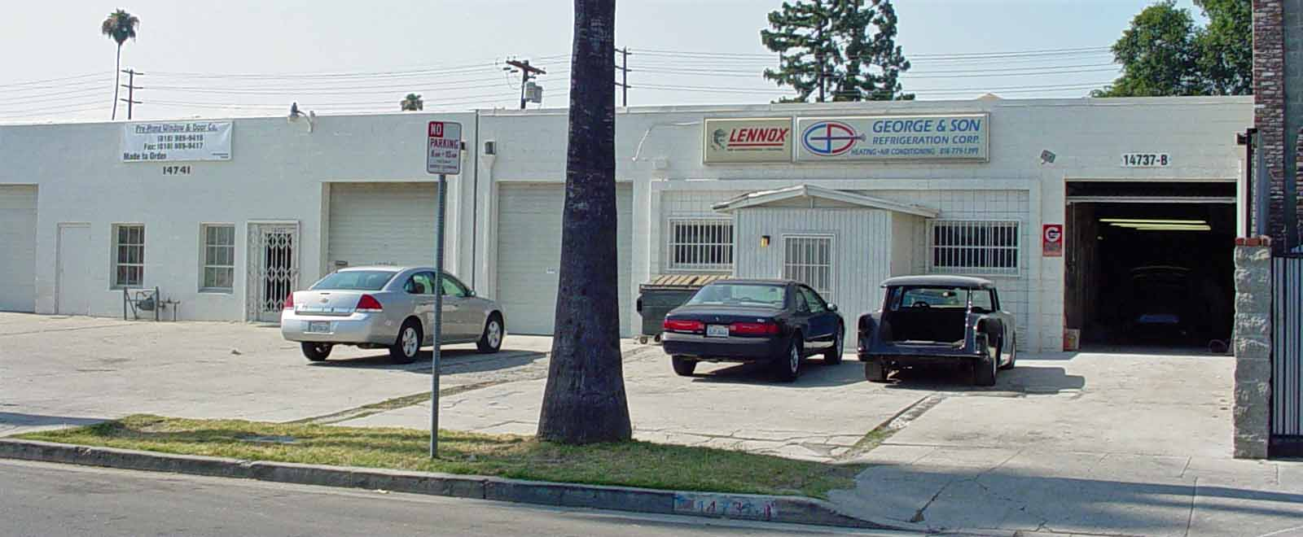

This is the building that Mr. Cannady visited in 1973 in Van Nuys, CA (photo taken in 2007 by author)

Technical Commentary on the Dowd R. Cannady Interview

Technical Analysis of Part #1:

This short commentary discloses some important clarifications as to some of the topology details of the EV Gray “Low Power” energy converter.

1. Mr. Cannady identifies all of the essential subsystems for this “Low Power” technology in far greater detail than what has ever been disclosed before.

2. More important he describes the order in which they are connected. This connection sequence is different than what was disclosed in patent #3,890,548.

3. The subsystems listed in their connection order are:

a.) 12 volt wet cell automotive battery
b.) Adjustable spark gap
c.) 30 to 45 second mechanical timer
d.) Step up transformer
e.) Two or three large storage capacitors – “size of a half-gallon of milk”
f.) A Common Mode Choke” 30” to 35” in diameter 5-6 turns (assume “Floating Flux Field” equivalent)
g.) An old fashion SPDT knife switch
h.) Two identical air core coils – 3” to 3.5” in diameter – 100 turns of #18 AWG
automotive wire

4. By doing simple calculations it appears that the conductor length of the Common Mode Choke and the “jumping Coils” are nearly the same.

Reese Choke (common Mode choke): 30”-35” diameter loop composed of 5-6 turns = 39 to 54 feet

Round Jumping Coils: 3” to 3.5” in diameter of 100 turns = 78 to 99 feet (assuming complete circle)

Palm Wound Jumping Coils: length of wire in one turn around a man’s palm @ 10” = 83 feet

EMA4-E2 Floating Flux Field: 18” x 9 turns x 2 layers = 84 feet

Bedini Monopole Litz Coil recommended length <100 feet

To bring the two EV Gray two coil systems into length balance the diameter of the Reese Choke would have to increase to 53”, or the number of turns in the Jumping Coils would have to be reduced to 65 turns each.

This balance in length between these four air core inductors would certainly improve “impedance matching” issues between these two coil systems

5. Mr. Cannady describes specifically how the Jumping Coils are connected to the Knife switch. It appears that the knife switch is wired in series and in between the two Jumping coils. This is an important little detail that shows how the Jumping Coils and the Reese Choke are pre-charged to the potential of the storage capacitor prior to closing the circuit. This topology draws it roots from Dr. Tesla’s 1892 demonstration HF transformer.

6. The location of the mechanical timer in the circuit implies that the storage capacitors are disconnected from the high voltage supply at the end of the charging time period. Most likely both the negative and positive connections are interrupted.

7. The use of a mechanical timer to determine how much charge is supplied to the capacitors implies that the capacitors are completely discharged after each “firing”.

8. There were no voltage meters, or other instrumentation, used in this demonstration.

9. The location of the adjustable spark gap in relation to the high voltage coil establishes the use of a pulsed induction coil that drives its mechanical interrupter from the intermittent magnetization of the core. This is similar to the operation of a “Ford Coil”. This particular demonstration did not utilize a vibrator type of power supply as shown in all three of Mr. Gray’s later patents.

10. The 30 second charging time for the pair (or trio) of capacitors implies a large capacitance value. If these storage devices were oil filled capacitors then the approximate value would be 15-20 mfd @ 5000 WVDC. This is calculated from the observed volume.
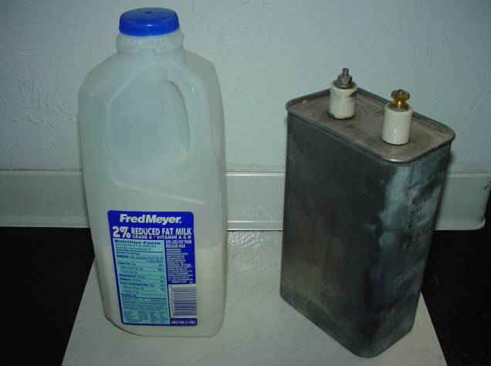
11. This collection of equipment was constructed of all passive components (except the mechanical knife switch). There are no vacuum tubes, thyratrons, or large power transistors. There may have been some small solid state diodes utilized.

Half gallon of 2% Milk as compared to an oil filled 12 mfd @ 5000 WVDC storage capacitor. This was salvaged from an early color copy machine. (circa 1984)

½ gal of milk compared to a 12 uF 5KV Capacitor

The relative volumes are nearly the same, with the milk jug being just slightly larger.

This type of capacitor would be a good candidate for the kind of storage device Mr. Gray was using in his jumping coil demonstration.

Keep in mind that Mr. Cannady reported that there were three capacitors, or capacitor looking devices, that were involved with this circuit. All three devices were housed in a plastic milk crate, which is assumed to be a 4 gallon sized container. The disclosed power supply schematic from the 1976 Pulse Engine patent only shows one capacitor. Some different kind of topology was being used for this 1973 demonstration that is different than what was later disclosed.

These examples show that Dr. Tesla used two capacitors in his circuits. The purpose of two capacitors, as opposed to one, has never really been explained.

