THE MAIN BARRIER BEFORE HYDROGEN POWER INDUSTRY

Ph.M. Kanarev
kanphil@mail.ru

Announcement. Inability of the existing electric power meters to register its pulse consumption is the main barrier before hydrogen power industry. The Russian science has already got total scientific information in order to remove this barrier. We shall give the results of the laboratory experiments, which prove the possibility of the removal of merely a scientific barrier on the way of intense development of hydrogen power industry.

A mathematical model for a calculation of electric power (i.e. energy, which is produced or consumed per second) forms the basis of design of all electric power meters, wattmeters and oscilloscopes.
. (1)
If electric power is consumed by pulses, a result of a graphical integration of the function of voltage and current brings the formula (1) to a simple eventual result for a calculation of an average value of pulse power (2), which takes into account current relative pulse duration.
. (2)
The given formula is a production of the mathematicians who observe correctness of mathematical operations, but demonstrate little interest in a correspondence of these operations to physical reality. As a result, a fundamental physical error, which was included by the mathematicians into the formula (2), remained unnoticed for more then 100 years.

Dear mathematicians,
I have already informed you about the essence of the global physical error in the formula (2) and have suggested a method of its correction [1], [3]. Let us describe it once again (Fig. 1, a).

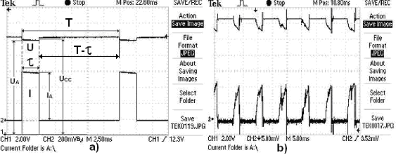

Fig. 1. Oscillogram of voltage and current at the terminals of the accumulator

According to the formula (2), the oscillogram processing process (Fig. 1) begins with a supply of the signals of voltage and current to the multiplier, which can measure and multiply thousands of ordinates of current and voltage per second and register a number of these multiplications. The integrator sums these products and divides the result by a number of products of the ordinates of current and voltage in the specified time interval. It corresponds to the formula (2) and disguises the global physical error, which is eliminated if the signals of voltage and current are supplied to the integrator first and to prescribe a determination of their average values with the following
limitation to it. A current signal should be the first to be processed; then a voltage signal should be the second to be processes (with a small delay). All ordinates of voltage, which correspond to zero ordinates of current, should be equated to zero automatically, and these zero ordinates of voltage should be included into the total number of ordinates of voltage, which have been measured within period. Then the average values of the ordinates of current and voltage should be determined in period interval as well as average power by means of a multiplication of the average values of voltage and current. As a result, an actual average value of pulse power is obtained, and the formula (2) for its determination acquires a new view

(3)

Please, follow our analysis of the regularities of a change of the pulses of voltage and current, which are given in Fig. 1, a. According to the mathematical model (2), the process of the measurement start of the ordinates of pulses of voltage and current in period interval begins in point A. In the duration interval of pulse, the ordinates of pulses of voltage and current are multiplied by the multiplier. After point B, the ordinates of current are equal to zero, and the ordinates of voltage are not equal to zero. As a result, in the interval BC or the products of the ordinates of voltage by zero values of the ordinates of current are equal to zero, and the mathematicians pay no attention to voltage value at this moment.

According to notion “watt”, which is included into SI system, voltage and current should act continuously during a second or T period. The presence of relative pulse duration of current pulses I_{A} in the formula (2) means that its amplitude value is stretched to the duration of T period; it corresponds to notion “watt” completely. The absence of relative pulse duration S_{U} of voltage pulses U_{A} in the formula (2) means that the value has remained non-stretched to the duration of the whole T period and takes part in power formation with all its value U_{A} within the whole T period. It distorts a final result (2) in the number of times, which is equal to relative pulse duration S_{U} of voltage. This is a fundamental physical error of the mathematicians, which was introduced by them into the formula (2) more than 100 years ago.

In Fig. 1, a, it is clearly seen that the voltage value takes part in power formation only in the pulse duration interval τ and does not take part in the interval T-τ; that’s why we should stretch the amplitude (U_{A}) of its action for the whole T period. It is done by means of a division of U_{A} value by relative pulse duration. The absence of this operation in the mathematical model (2) makes the value of average power discrepant to SI system in the number of times, which is equal to relative pulse duration S_{U} of voltage. As the mathematical model (2) is included into the mathematical programs and the principles of operation of all electric power meters, wattmeters and oscilloscopes, all of them overstate its pulse consumption in the number of times, which is equal to relative pulse duration S_{U} of voltage.

Taking into consideration the importance of the problem being analysed, let us repeat. According to SI system, watt is a value of energy, which is produced or consumed continuously during one second. The seconds are formed from the periods; that’s why is sufficient to check correctness of the above-mentioned calculation procedure of the average value of pulse electric power in the interval of T period. In the oscillogram (Fig. 1, a), it is clearly seen that durations of current pulses with average amplitude and voltage pulses with average amplitude are less than duration of T period. SI system requires continuous operation of current and voltage in the interval of the whole T period. This requirement is implemented by stretching of current pulses with average amplitude and voltage pulses with average amplitude for the whole T period, i.e. by a division of the amplitudes of current pulses and the amplitudes of voltage pulses by relative pulse duration of their pulses, which is similar in this case and is equal to. It appears from this that a denominator of the formula (2) should have two relative pulse durations. One relative pulse duration () stretches the voltage amplitude for the whole T period; another relative pulse duration () stretches the current amplitude. But there is only one relative pulse duration in the formula (2). Why?

Dear mathematicians,
Please, have another look at Fig 1, a. Voltage does not take part in power formation in interval, but your formula (2) tries to convince us that it takes part in the formation of average pulse power in this interval with all its average pulse value. Do you understand the contradiction, which is described by us???
As a proof of authenticity of the new law of electrical power formation (3), let us analyse a power balance of MG-2 motor-generator, which consumes energy from the accumulator by pulses directly, without any intermediate electronic devices. The rotor plays the role of the motor, and the stator plays the role of the generator (Fig. 2) [1], [2].
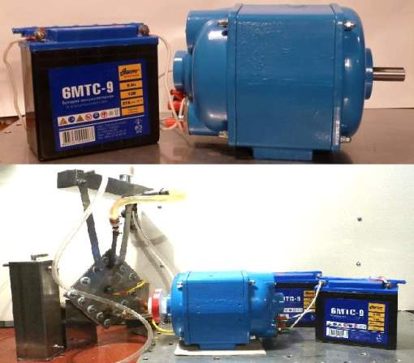

Fig. 2. MG-2 motor-generator and the motorcycle accumulator for its supply

Let us take an electrolyser cell as a load for MG-2 (Fig. 2). Let us watch the discharge process of 6MTC-9 motorcycle accumulators, which supply the motor-generator and compare it with the discharge process of the same accumulators, which supply a set of the lamps with total power, which is calculated according to the oscillogram with the help of the mathematical model of the old law (2) of the formation of average value of pulse electrical power.

MG-2 electric motor-generator operated in the mode of the alternate discharge and charge of the accumulators as a self-contained energy source, which supplied the electrolyser cell at the same time. The electric motor rotor rotated with frequency of 1800 r/min. Herewith, 8.57 litres of H₂+O₂ was obtained. Voltage drop at the terminals of the accumulators is given in Table 1.

Table 1. Voltage drop at the accumulator terminals during 3 hours 10 minutes.
Numbers of the accumulators | Initial voltage at the accumulator terminals, V | Final voltage at the accumulator terminals, V
1+2 (discharge) | 12.28 | 12.00
3+4 (discharge) | 12.33 | 12.00

According to the oscillogram, which is taken from the rotor terminals of MG-2 connected to the accumulators (Fig. 1, b), average pulse power is P_{CC} =37.88 W. Each of two pairs of 6 volt accumulators, which were connected in series when electric energy was supplied by pulses into the rotor excitation winding during 3 hours 10 minutes, reduced voltages at its terminals (Table 1) by 0.10 W/h on average.

Initial voltage at the accumulator terminals, to which the lamps with total power of (21+5+5+5)=36.00 W corresponding to power of P_{CC}=37.88 W, which is calculated according to the formula (2), were connected, was 12.78 V. When 1 hour 40 minutes passed, it was decreased to 4.86 V, or by 7.92 V. It was 7.92/0.3=26.00fold as much than voltage drop rate at the terminals of the accumulators, which supplied MG-2, without taking into consideration various time of their operation (Table 1). It is quite enough in order to make a conclusion that the old law of pulse electrical power formation (2) was completely erroneous. Certainly, we disregarded 8.57 l of the mixture of hydrogen and oxygen, which was obtained by means of water electrolysis by electric energy produced by MG-2. It is so to say additional energy.

The essence of the second experiment, which is connected with a check of authenticity of the new law (3) of the formation of the average value of pulse electrical power is simple as well (Fig. 3).

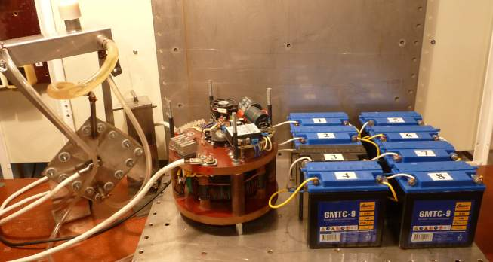
Fig. 3. Photo of MG-1 electric motor-generator without an extraneous drive

Let us take two groups, which consist of four twelve-volt motorcycle accumulators. Let us supply voltage from the first group to an excitation winding of MG-1 rotor by pulses (Fig. 3). As the discharge processes are followed by the charge processes of these accumulators intermittently, a self-contained source of electric power is formed (Fig. 3). The results of the experiment are given in Table 2. Discharge current of the accumulators at the beginning of the experiment is 0.42 A; charge current is 0.21 A.

Table 2. Results of the seventy hour tests of MG-1 in “the continuous operating” electric generator mode
Operation hours | Total voltage of the first group of the accumulators, V | Total voltage of the second group of the accumulators, V
In 1 hour | 51.50-50.00 – discharge | 50.20-52.00 – charge
In 10 hours | 51.00-49.30 – discharge | 49.10-51.50– charge
In 20 hours | 48.60-50.50 – charge | 50.00-48.40 - discharge
In 30 hours | 49.70-48.00 - discharge | 48.00-50.10 - charge
In 40 hours | 49.50-47.30 - discharge | 49.90-47.50 - discharge
In 50 hours | 46.90-48.90 - charge | 49.30-46.80 - discharge
In 60 hours | 48.60-46.10 - discharge | 48.90-46.10 - discharge
In 70 hours | 41.80-47.70 - charge | 48.20-41.40 - discharge
During 70 hours, 43 litres of gas mixture of hydrogen and oxygen was obtained (0.60 l/hour)
The cause of unbalance of the processes of discharge and charge of the first group and the second group of the accumulators results from Table 3.

Table 3. Voltage at the accumulator terminals in the discharge mode in 70 hours of the continuous operation.
The first groups of the accumulators |  | The second groups of the accumulators
Numbers of the accumulators | Voltage, V | Numbers of the accumulators | Voltage, V
1 | 11.03 | 5 | 11.40
2 | 11.57 | 6 | 11.47
3 | 7.99 | 7 | 10.77
4 | 11.64 | 8 | 11.74

Dear mathematicians,
For more than 100 years, your fundamental physical error in the formula (2), which is present in the operation of all electric power meters, was hidden for us. It is high time to erect a monument to the electric power meter (Fig. 4), which distorts pulse energy registration; this monument should have an inscription: “Sample of the most expensive error of the mathematicians”.

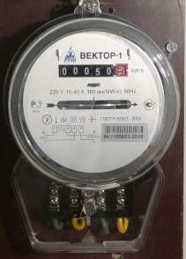 | Fig. 4. Electric power meter, which overstates its pulse consumption in the number of times, which is equal to relative pulse duration S_{U} of voltage - “Sample of the most expensive error of the mathematicians”.

Now let us give the results of the laboratory investigations, which demonstrate the actual expenditures of electrical energy for production hydrogen from water. The new electric power meters, which will register its pulse consumption correctly, will read approximately the same values of specific consumption of electrical energy per litre of hydrogen being produced from water, which are given in Table 4. Three cells of the electrolyzer were supplied from the mains via an electronic generator of electric pulses. The experiment was made on May 22, 2006.
Table 4. Indices of the process of water electrolysis by electrical pulses
Indices | 1 | 2 | 3 | 4 | 5 | 6 | 7
1. Relative pulse duration | 232 | 217 | 210 | 188 | 185 | 220 | 220
2. Water consumption, g/hour | 0.21 | 0.36 | 0.68 | 0.87 | 1.12 | 1.28 | 1.36
3. Hydrogen production . l/hour | 0.29 | 0.49 | 0.85 | 1.19 | 1.53 | 1.75 | 1.86
4. Voltage pulse amplitude according to the oscillogram. V | 11.00 | 17.50 | 29.00 | 25.00 | 25.00 | 26.00 | 27.50
5. Current pulse amplitude according to the oscillogram. V | 66.70 | 120.00 | 155.50 | 177.80 | 182.20 | 191.1 | 200.0
6. Average voltage according to the oscillogram. V | 0.05 | 0.08 | 0.14 | 0.13 | 0.14 | 0.12 | 0.12
7. Average current according to the oscillogram . A | 0.29 | 0.55 | 0.74 | 0.94 | 0.98 | 1.13 | 1.20
8. Average power. | 0.014 | 0.044 | 0.11 | 0.13 | 0.13 | 0.16 | 0.18
9. Specific power. Wh/l | 0.05 | 0.09 | 0.16 | 0.11 | 0.09 | 0.09 | 0.10

Note: specific expenditures for production of 1 litre of hydrogen with the help of the modern industrial electrolyzers are 5 to 7 Wh/l.

CONCLUSION

The scientific barrier on the way of intense development of hydrogen power industry is removed, but the administrative barrier remains; there is no knowing how long it will remain in force.

REFERENCES

1. Ph.M. Kanarev. Pulse power industry. Volume II of the 15th edition of the monograph “The Foundations of Physchemistry of Microworld”. http://www.micro-world.su/
2. Ph.M. Kanarev. The Foundations of Physchemistry of Microworld. Monograph. The 15th edition. 2010. http://www.micro-world.su/
3. Ph.M. Kanarev. On the new law of electrical power formation briefly.
http://www.micro-world.su/ Folder “Articles

