Energy Impulse Secrets
Philipp M. Kanarev
e-mail: kanphil@mail.ru

Energy impulses keep preserving their secrets. The errors in Newton’s dynamics and electrodynamics are the main causes of incomprehension of these secrets. A recovery of these errors will open new energy possibilities before mankind; these possibilities will rescue mankind from an environmental disaster, which is generated by hydrocarbon energy sources. It is not an empty forecast. Its authenticity is proved both theoretically and experimentally.

Foundation of the Theory of Impulse of Force and Impact Force
Mathematicians were the trailblazers of theoretical mechanics. They tried for a description of the mathematics processes of motion of the material points and bodies. It is natural they were concerned about strictness of an implementation of mathematical rules during a process of the derivation of the equations, which describe a motion of the material points and bodies. They were hardly interested in the mechanical essence of the results being obtained. The authority of mathematics being the most exact science preserved the point of view of the mathematicians and blocked a road for an acquisition of the mathematical models, which describe the mechanical essence of the results of the mathematical operations of the mathematicians more exactly. Let us show this in terms of the physical essence of the notions “impulse of force” and “impact force” derived from the mathematical models of the mathematicians.
When the forces, which exert influence on the body, are considered, one takes into account its mass; the product of mass by motion velocity is called momentum of the body or impulse of force. When the body is in a quiescent state, its velocity and momentum are equal to zero. When the body starts motion and acquires velocity, a change of momentum of the body is written in the following way (Fig. 1) [1].
(1)
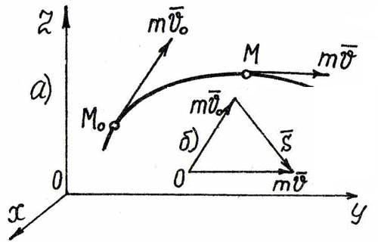
Fig.1. Diagram to a determination of action of force
Thus, momentum of a material point or body is a vector value being equal to the product of mass of the point or body by its velocity. The vector is directed in the same way as the vector tangentially to the trajectory (Fig. 1).
A change of momentum of the material point within a certain time period is an effect of an action of force on the material point. The physicists have called this action an impulse of force and have designated it by a symbol (Fig. 1).
(2)

A Theorem on the Change of Momentum of A Material Point (Mathematical Symphony Fragments)
A connection of impulse of force with the main equation of Newtonian dynamics is expressed by the theorem of a change of momentum of the material point
Theorem. A change of momentum of the material point within a certain time period is equal to an impulse of force (), acting on the material point within the same time period. A mathematical proof of this theorem can be called a mathematical symphony fragment. Here it is
(3)
The differential of momentum of the material point is equal to an elementary impulse of force, which acts on the material point. If we integrate the expression (3) of the differential of momentum of the material point is, we’ll have
(4)
The theorem is proved, and the mathematicians think that their mission is finished, but the engineers, whose fate is to trust the mathematicians, have questions when they use the equation being proved (4). But the questions are blocked by the succession and beauty of the mathematical operations (3 and 4), which charm and invite to call them a mathematical symphony fragment. Many generations of the engineers agreed with the mathematicians and trembled before mysteriousness of their mathematical symbols! But there appeared an engineer, who disagrees with the mathematicians and puts questions to them.
Dear mathematicians, why none of your theoretical mechanics manuals contains a consideration of a process of an implementation of your symphonic result (4) in practice, for example, in the description of a process of an acceleration of a car? The left-hand part of the equation (4) is clear in the limit. The car begins the acceleration from velocity and ends it, for example, at velocity of . It is natural that the equation (4) becomes as follows:
(5)
The first question arises at once: how is it possible to determine the force, under which influence the car is accelerated up to 10 m/s, from the equation (5)? None of the numerous manuals devoted to theoretical mechanics has an answer to this question. Let us go on. After the acceleration, the car begins a uniform motion with the final velocity of 10 m/s. What force moves the car? There is nothing to do but to blush together with the mathematicians. The first law of Newtonian dynamics states that when the car moves uniformly, no forces acts on it, but the car, so to speak, does not take this law into consideration; it consumes fuel, does work and moves, for example, at the distance of 100 km. The symphonic mathematical equation (5) keeps silent; life goes on and requires an answer. Let us start searching it.
As the car moves rectilinearly and uniformly, the force, which moves it, is constant in its value and direction, and the equation (5) becomes as follows:
(6)
Thus, in this case the equation (6) describes an accelerated motion of a body. What is force equal to? How can one express its change in the course of time? The mathematicians prefer to avoid this question and leave it to the engineers supposing that they should search an answer to this question. There is only thing left for the engineers to do: they should bear in mind that when the accelerated motion of the body is over, a phase of the uniform motion, which takes place under the influence of constant force, starts, and they should present the equation (6) for the time of transition from the accelerated motion to the uniform motion in the following way:
(7)
In this equation, an arrow designates a process of a transition from its integral form to a simplified form, and is not a result of integration of this equation. In this equation, force is equivalent to the averaged force, which has changed momentum of the body from zero to the end value. Dear mathematicians and physicists- theorists, as you have no method to determine the value of your impulse, we have to simplify a procedure of the determination of force; as there is no method of a determination of action time of this force, we are placed in a desperate situation, and we have to use an expression for the analysis of the process of a change of momentum of a body. As a result, the longer the action of the force is, the larger its impulseis. This is at variance with the existing notions that the smaller the time of action of impulse of force is, the large this impulse of force is.
Let us pay attention to the fact that momentum of the material point (impulse of force) in case of its accelerated notion is changed under the influence of Newtonian force and motion resistant force in the form of the forces, which are formed by mechanical resistances, and inertial force. But in the absolute majority of problems, Newtonian dynamics ignores inertial force; mechanodynamics states that momentum of the body in case of its accelerated notion is changed due to an excess of the value of Newtonian force over the motion resistant forces, including inertial force [1].
There is no Newtonian force in case of decelerated motion of a body, for example, a car with the switched-off gear, and momentum of the car is changed due to an excess of the motion drag forces over inertial force, which moves the car during its decelerated motion [1].
How is it possible to return the results of the marked “symphonic” mathematical operations into the course of cause and effect connections? There is the only way out: it is necessary to find a new definition of the notions “impulse of force” and “impact force”. Let us divide both parts of the equation (7) by time t. As a result, we’ll have
(8)
Let us pay attention to the fact that the expression mV/t is a rate of the change of momentum (mV/t) of the material point or the body. If we take into account that V/t is acceleration, mV/t is force, which changes momentum of the body. A similar dimension to the left and to the right of an equal sign gives us the right to call the force F the impact force and to designate it with the help of the symbol and impulse S the impact impulse and to designate it with the help of the symbol . A new definition of impact force appears from this. The impact force , which acts on the material point or the body, is equal to a ratio of the change of momentum of the material point or the body to the time of this change.
(9)
Let us pay special attention to the fact that only the Newtonian force, which has changed velocity of the car from the value of zero to the maximal value , takes part in a formation of impact impulse (9); that’s why the equation (9) belongs to Newtonian dynamics completely. As the value of velocity is much easier to register experimentally than the value of acceleration, the formula (9) is very convenient for the calculations.
An unusual result appears from the equation (9).
(10)
Let us pay attention to the fact that according to the new laws of mechanodynamics the Newtonian force is a generator of the impact impulse in case of accelerated motion of the material point or the body [1]. It forms an acceleration of motion of the point or the body when inertial force, which is directed oppositely to Newtonian force, appears automatically, and the impact Newtonian force should overcome an influence of inertial force; that’s why inertial force should be presented a balance of the forces in the left-hand part of the equation (9). As inertial force is equal to mass of the point or the body multiplied by a deceleration being formed by it, the equation (9) acquires the following form
(11)
Dear mathematicians, have a look at the mathematical model, which describes the impact impulse that accelerates a motion of the body being increased from zero velocity to maximal velocity V (11). Let us check its operation in the determination of the impact impulse, which is equal to the impact force, which has blasted the second energy unit of the Sayano–Shushenskaya hydroelectric power station (Fig. 2), and the useless equation (6) is left for you. In order to simplify the description, we examine the formula (10) alone, and also use the formulas which give the averaged values of forces. Have a look at the situation, in which you place the engineer, who tries to solve a specific task.
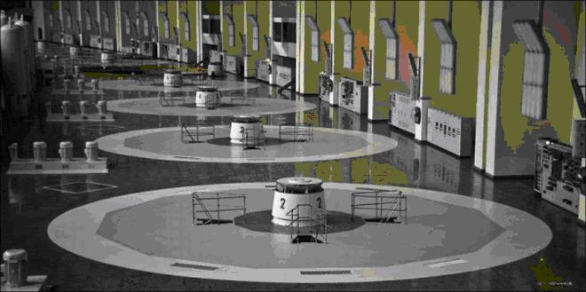
Fig. 2. Photo of the turbine room before the disaster
Let us begin from Newton’s dynamics. The experts determined that the second energy unit was raised at the height of 14 m. As it was raised in the gravity field, its potential energy at the height of 14 m was equal to
(12)
Its average kinetic energy was equal to
(13)
The average rate of the rise of the energy unit (Figs 3, 4) appears from the equality of kinetic energy (13) and potential energy (12)
(14)
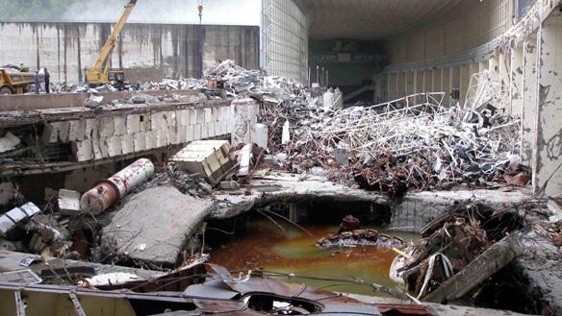
Fig. 3. Photo of the turbine room after the disaster
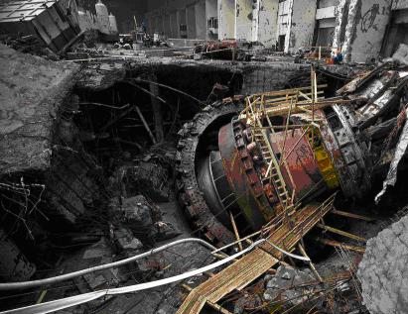
Fig. 4. View of the well of the energy unit and of the energy unit itself after the disaster
According to the new laws of mechanodynamics, the rise of the energy unit consisted of two phases (Fig. 5): the first phase OA is the accelerated rise and the second phase AB is the decelerated rise [1], [4], [5].
Time and distances of their action are approximately equal (h₁=h₂=7 m). The kinematical equation of the accelerated phase of the rise of the energy unit may be written in the following way [4]:
(15)
In the first phase, the law of the change of velocity of the rise of the energy unit has the following form:
(16)
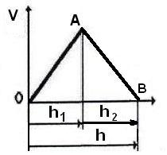
Fig. 5. Regularity of a change of velocity V of the flight of the energy unit
If we place time from the equation (15) into the equation (16), we’ll have
(17)
The time of the rise of the energy unit in the first phase is determined from the formula (15)
(18)
The total time of the rise of the energy unit to the height of 14 m is equal to t=2t₁=1.68 s. The mass of the energy unit and the cover weighs 2580 tons. According to Newton’s dynamics, the force, which has raised the energy unit, is equal to [4]
(19)
Dear mathematicians, we are guided by your symphonic mathematical results and write your formula (6), which results from Newton’s dynamics, in order to determine the impact impulse, which has blasted the second energy unit.
(20)
And we set forth an elementary question: how is it possible to determine the time of action of the impact impulse, which has blasted the second energy unit?
Dear sirs, please, try to imagine tons of chalk being used by the generations of your colleagues for writing on the blackboards teaching the students transcendentally how to determine the impact impulse, and nobody explained how to determine action time of the impact impulse in each specific case. You assert that the action time of the impact impulse is equal to the time interval of the change of velocity of the energy unit from zero to, say, the maximal value of 16.75 m/s (14). It results from the formula (18) and is equal to 0.84 s. We accept this for the time being and determine an averaged value of the impact impulse.
(21)
A question arises at once: why is the value of the impact impulse (21) less than the Newtonian force of 50600 tons (19)? Dear mathematicians, you have no answer to it [4]. Let us go on.
According to Newton’s dynamics, the main force, which resisted a rise of the energy unit, was force of gravity. As this force is directed opposite the motion of the energy unit, it generates a deceleration, which is equal to free fall acceleration g=9.81 m/s². Gravitation force, which acts on the energy unit moving upwards, is equal to
(22)
Newton’s dynamics does not take into account other forces, which counter the action of Newtonian force of 50600 tons (19); mechanodynamics states that the inertial force countered rise of the energy unit; this inertial force is equal to [1]
(23)
A question arises at once: how is it possible to find the value of deceleration of motion of the energy unit? Newton’s dynamics keeps silent; mechanodynamics replies: the force of gravity and inertial force resisted the Newtonian force, which raised the energy unit; that’s why the equation of the forces, which operated on the energy unit at that moment, is written as follows [1]:
(24)
From here, we find deceleration
(25)
The value of this inertial force, which decelerated the motion of the energy unit in the first phase of its motion, is equal to
(26)
Thus, a sum of the forces, which resisted the action of Newtonian force, is equal to Newtonian force itself (19)
(27)
Please, do not be astonished: this result is an effect of the main principle of mechanodynamics, which you do not know as yet. It replaced the similar erroneous d’Alembert’s principle, which has been used long ago. It is a beautiful balance (27), but it contains no forces of resistance to break of 80 studs, which fastened the cover of the energy unit (Fig. 6).
As it is clear from Fig. 6, an unbroken stud (to the left) is not even slightly bent; this took place under the conditions when it fastened the cover shielded the rotating object, which weight was 1780 tons. The rest of the broken studs (to the right) had not the smallest appearance of being cut. Their condition proves that only the breaking forces exerted any influence on them; there were no shear forces, because if they were present, the surviving stud would be cut as well, despite of the presence or absence of the nuts. As the broken studs have no area of gradual reduction of the diameter towards the surface of the break, it proves a simultaneous nature of the action of the vertical force, which broke them (Fig. 6, to the right)

Fig. 6. Photo of the studs, which fastened the cover of the energy unit
The average specific stress of break of the rods made of CT-35 quality steel is. The studs had diameters of . Section of a stud is. As a result, breaking load of one stud is.. If we take into account that the threads of the nuts of six unbroken studs were cut, the load of this cut differed insufficiently from the breaking load of the studs, and we can take into consideration all 80 studs. The total load, which broke 80 studs, then equals .
Dear mathematicians, what shall we do with your mathematics in Newtonian dynamics? When the energy unit started its rise, three main forces of resistance to its rise acted on it: gravitation force, inertial force and stud break resistance force. Their total value is equal to [4]
(28)
The results of your symphonic mathematical operations give the value of impact impulse of 42504 tons (21). As I also spent 20 years writing your symphonic derivation of impulse of force and impact force on the blackboard, I too am guilty before my numerous pupils and I must apologize for my deep but unfounded belief in the authority of mathematicians who were unable to make an elementary analysis of physical essence of the phenomena or processes being described.
Thus, in order to determine of impulse of force and impact force, one should know the time, within which the velocity of the energy unit changed from zero to the maximal value of 16,57 m/s (14). It is equal to 0.84 s (18). Then, we’ll have [4]
(29)
Dear mathematicians, what shall we do? Shall we protest against the quotation marks, with which the word “symphony” mentioned in this article should be used?
There is one other solution of this task. Let us consider a bullet, which has left a cartridge. The main criterion of the determination of a distance of action of impact force will be the moment when, according to the notions of orthodox physics, the gases, which form the pressure and move the bullet, leave the closed space. Then, the length of a barrel of the arm can be considered as the distance, at which the impact force, which moves the bullet, acts. As velocity of a flight of the bullet from the barrel is known, action time of impact force can be determined as a quotient from a division of the length of the barrel, along which the bullet moves, by velocity of its motion.
In the task being considered by us, the above-mentioned functions belong to the upper part of the well of the energy unit (Fig. 7); distance L of action of impact force is equal to the distance from the place of location of the studs fastening the cover of the energy unit to the level of the floor of the turbine room (Fig. 7). We do not know yet the nature of the forces, which blasted the energy unit, but when the cover of the energy unit was torn out, a closed space of the energy unit became an open space in the same way as the closed space of motion of the bullet in the barrel becomes the open space when the bullet leaves the barrel.
We do not know this distance exactly; that’s why we accept for the calculation its approximate value being equal to L=0.80 m (Fig. 7). Then, time of action of impact force on the energy unit will be equal to the part of total time of the rise of the energy unit of 1.68 s, which was spent for its displacement within the interval of 0.00…0.80 m, i.e.
(30)
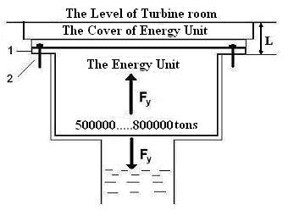
Fig. 7. Diagram of a determination of time of impact force action on the energy unit
It is only reasonable that the initial value of the impact impulse, and consequently the impact force, will be equal to the total force of resistance to the motion of the energy unit of 25300+2530+21764=72364 tons divided by the impact time
(31)
Dear mathematicians, what shall we do? Shall we take into consideration the time (30) of the action of impact force or average velocity (14) of the flight of the energy unit? None of your newest manuals devoted to theoretical mechanics contains an answer to this question: that’s why we give the results of a calculation, which takes into account average velocity as well (14).
The impact impulse (11), which is equal to impact force, will be equal to [4]
(32)
Which value of the impact force is closer to reality?
Dear mathematicians, where are your recommendations concerning this matter? The answer to this question results from the mathematical model, which takes into account all forces of resistance to motion. Formula (31), from which a value of impact force results, is the closest one to reality: F_{y} =723640 tons [4].
Let us try to formulate a hypothesis, which would make it possible to find a physical essence of the process that has generated the impact force being equal to 723640 tons. First of all, such force is a result of an explosion. As the photons are the main participants of pressure formation in case of any explosion, one cannot exclude their participation in this process as well.
It is known that a gramme-molecule of water is equal to 18 grams. One litre of water contains 1000/18=55.56 gramme-molecules of water. It is also known that quantity of molecules of water in its one gramme-molecule is equal to Avogadro number 6.02⋅10²³. It appears from this that one litre of water contains 6.02⋅10²³⋅55.56=3.34⋅10²⁵ molecules of water.
The equipment at the Sayano–Shushenskaya hydroelectric power station showed the total area between the buckets of the hydraulic turbine, which was equal to 8.14 m² when the water stream velocity via this section was 38.30 m/s [6]. The total volume of water, which passed per second via this section, was 8.14⋅38.30=253.77 m³=2.54⋅10⁵ litres =254 tons. The devices of the Sayano–Shushenskaya hydroelectric power station showed that nearly 5 seconds passed from the run-away of the electric generator till its blast [6]. Within this time, 254x5=1270 tons of water arrived into the well of the turbine.
We must congratulate the water hammer adherents! They have an opportunity to blush. The water mass, which formed their water hammer, is 50600/1270=40fold less than Newtonian force and 723640/1270=570fold less than impact force, which blasted the energy unit.
The water volume of 2.54⋅10⁵ litres contained 2.54⋅10⁵⋅3.34⋅10²⁵ = 8.48⋅10³⁰ molecules of water. A molecule of water is given in Fig. 8, a; a cluster of two molecules is given in Fig. 8, b. Actually a water cluster contains many more molecules.
When water leaves the buckets, its velocity being equal to 38.3 m/s broke the clusters; they reached the turbine buckets and fused again emitting the photons. The wavelengths of the photons are equal to their radii, which values depend on water temperature. Let accept it as . This temperature determines the maximal number of the photons in the medium, having the same temperature; in the water medium, these photons determine the binding energies of the electrons in the water molecules and water clusters. The value of radius r of the photons is determined according to Wien’s formula
(33)
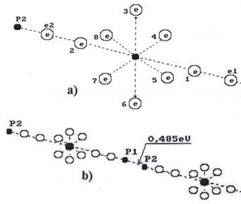
Fig. 8. Diagrams and photos of water clusters
The energy of these photons is equal to
(34)
They are the infrared invisible photons.
It is natural that water in the gap between the buckets moved in the form of linear clusters (Fig. 8, b), which were broken at the exit from the gap between the buckets; they fused again in the area of the turbine buckets emitting the photons. Approximately, the volume of one photon is equal to [4]
(35)
For a comparison, let us give the volume of the electron, which has emitted this photon. It is equal to
(36)
Thus is a central item of the problem being analysed. The volume of the photon, which is emitted by the electron in this case, exceeds 20fold the volume of the electron. Thus, almost in all processes of pressure formation, the main role is played by the photons, not the gases as has been considered previously.
An area of the cover of the energy unit is
(37)
Then, the value of the specific impact force will be
(38)
We have no information concerning the depth of the turbine well from the level of the floor of the turbine room to its bottom (Fig. 9); that’s why we accept this value being equal to 20 m approximately. Then, the volume of the turbine well will be
(39)
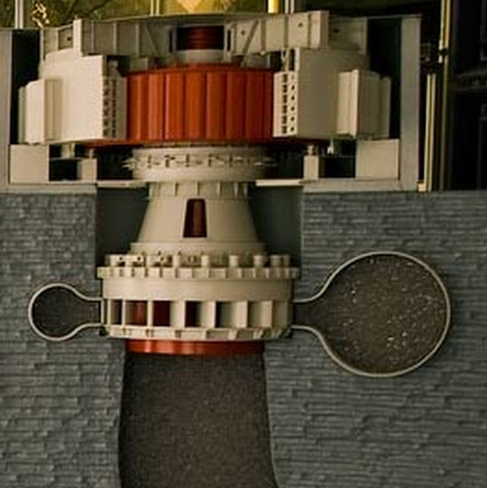
Fig. 9. Diagram of the energy unit and the turbine well
Now let us designate the total volume of all photons, which have formed pressure, via Ww and determine a multiplicity coefficient K of an excess of pressure inside the well being formed by the photons, over atmospheric pressure [4]
(40)
Taking into account the fact that total pressure on the lower plane of the energy unit well was formed from atmospheric pressure and the pressure which was created by the emitted photons and that only the atmospheric pressure Pa acted on the upper plane of the cover, we have the following dependence
(41)
As a result, the volume of all photons, which formed pressure on the lower plane of the cover of the energy unit, will be equal to
(42)
Taking into account the volume of one photon (35), we shall find the number of the photons generating the pressure:
(43)
The equipment at the Sayano–Shushenskaya hydroelectric power station registered that showed that nearly 5 seconds passed from the run-away of the electric generator until its blast [5]. During this time, the repeated fusion of the water clusters emitted of the infrared photons, which formed specific pressure on the cover of the energy unit, being equal to.. This hypothesis is closer to reality; moreover, it is implemented by the military men in some of their devices, but they do not know the theory of their action and so do not see this analogy.
Thus, we have understood energy power of the impulses of force. How is it possible to use this power for the benefit of mankind? Certainly, electric generators are the main devices, which produce energy. They are mechanical devices, which consist of a rotating rotor and a still stator. Usually, the stator has powerful magnetic poles. The magnetic poles of the rotor interact with the magnetic poles of the stator; and voltage, which is supplied to a consumer, is induced in the rotor winding. The consumer uses current, which increases expenditures of mechanical energy to the rotor rotation sharply. The generators of the hydroelectric power stations, thermal power stations and atomic power stations operate in this mode. In order to support the specified rotations of the rotor of the generator, energy is consumed continuously in the form of falling water or heated steam. And what if the consumer needs energy being supplied in the form of the electric pulses to an electrolyser, for example? Then, it becomes unnecessary to rotate the rotor of the generator continuously because it has a stock of kinetic energy, which can be used for a generation of the pulses of voltage and current. As a result, the total energy costs for the rotation of the rotor should be decreased [2, 3].
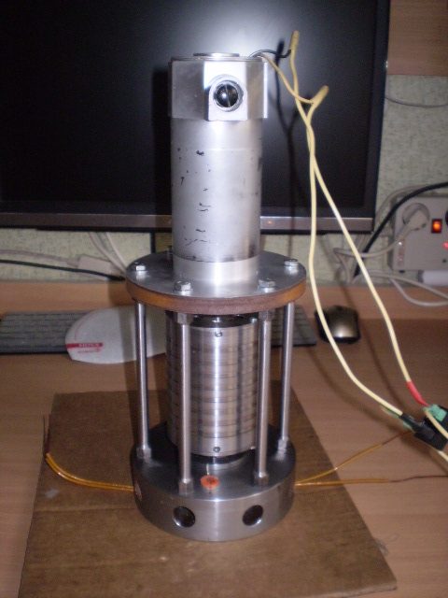
Fig. 10. Electromechanical generator of electric pulses
In order to check this hypothesis, an electromechanical generator of electric pulses was made with the constant magnets, which rotor was rotated by the electric motor with the power of 200 watts (Fig. 10). It turned out that the energy costs for its idle run were 150 watts, i.e. the efficiency of this generator was 25% only. The problem of the improvement of the device’s efficiency became apparent at once.
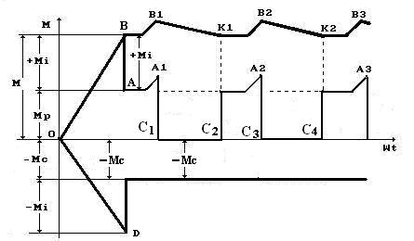
Fig. 11. Diagram of the change of the torques, which act on the rotor at the time of its start and during uniform rotation
We do not any pay attention to the fact that the initial energy, which was given to the rotor at the time of its run start, is preserved in it in the form of kinetic energy of its rotation as we do not know how to use it. In Fig. 11, a diagram of the change of momentum of the rotor is shown.
At the moment of the rotor rotation start, its starting torque overcomes resistance in the form of the moments of mechanical resistances and in the form of inertial torque. As the rotor starts its uniform rotation, inertial torque becomes positive and does not resist the rotor rotation; it aids its rotation (Fig. 11). It appears from this that in order to support the uniform rotation of the rotor, it is unnecessary to expend energy continuously in order to support a constant value of operating torque. Impulse supply of energy, which will increase operating torque for a short time up to the value that is designated by letter, is enough. Simultaneously, the value of inertial torque will be increased up to the value that is designated by letter (Fig. 11). At this moment, energy costs for the rotary drive will be decreased almost to zero, and it will become possible to turn off energy supply to the rotor shaft, because it will keep rotating for some time() because of inertia (Fig. 11). When its inertial torque is decreased to the value, which is designated by letter, the automatic controls will turn on the external power supply.
From the above-mentioned facts, it is clear that it is possible to save energy used in the driving of the rotor due to its feeding by pulses. There are mechanical devices for use in the pulse feeding of energy to the rotating rotor. They are called overrunning clutches. But they are unsafe. What if we use electronics for the management of the electric power feed process for an excitation of magnetic field of the rotating rotor? The new laws of mechanodynamics and electrodynamics of microworld, which were in possession of the author of this article at that time, gave an astonishingly simple and effective solution of this problem. As a result, a self-rotating electric pulse generator was made and tested (Fig. 12). Its capacity was increased, and energy costs for idle run were decreased 15fold and were 10 W (Fig. 12).
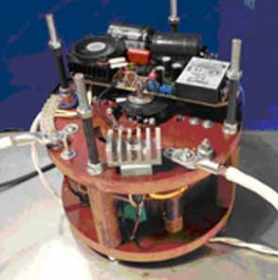
Fig. 12. The first in the world self-rotating electric pulse generator
The world’s first self-rotating electric pulse generator was designed and made by S.B. Zatsarinin, a talented Russian engineer, according to our technical assignment. As a result, the law of conservation of energy was buried, and a new law of inertial increase of electric power, which hitherto was unknown, was discovered [2].
(44)
The world’s first self-rotating electric pulse generator generates current pulses up to 120 A. We shall not mention all the prospects of an implementation of all possibilities of this self-rotating electric pulse generator, which have already been checked. They originate from new knowledge concerning microworld; that’s why they are accessible to those who will master this knowledge.

Conclusion
The physical chemistry calculation of the process of the generation of the force, which has blasted the energy unit at the Sayano–Shushenskaya hydroelectric power station, will be given. But even their approximate results prove that the physicochemical process of a break and further fusion of water clusters is the only source that can form the forces, which blasted the second energy unit at the Sayano–Shushenskaya hydroelectric power station.
Television informed us that the disasters, which were similar to the one that happened at the Sayano–Shushenskaya hydroelectric power station, took place at Soviet time in the Middle Asia. It means that they can happen again, and not only in Russia. Specific recommendations concerning avoidance of such disasters result from the facts, which have been described by us. But we refrain from publishing them, because the experts of the state commissions hope to find other causes of this disaster still. It only remains to wish them success.
Let us note the main thing. Obsolete Newton’s dynamics cannot solve such problems. Its old notions “impulse of force”, “impact force” and the mathematical models for their determination are erroneous. All mathematical models, which describe the vibrations, especially vertical ones, are erroneous as well, because such vibrations amount to an addition of the forces of inertia with the forces of gravitation, which resulted in a sinusoidal dance of the bridge in the city of Volgograd. Certainly, such dance will be repeated as its main causes have not been found. They are not found, because there is no theory for modelling such dance; that’s why the losses caused by a disregard of new mechanodynamics are growing, and they go on growing largely.
The law of inertial increase of electric power appears from the new laws of mechanodynamics and electrodynamics of microworld. They have originated in Russia from a new theory of microworld, which is not accepted by the Russian Academy of Sciences. As a result, the Russian authorities do not know that it is high time to include new knowledge concerning microworld into the curriculum, because there is no other accelerator of scientific progress at the present stage of development of our knowledge.

References
[ 1 ] Ph.M. Kanarev, Mechanodynamics Study guide (Krasnodar, 2010). http://kubsau.ru/science/prof.php?kanarev.
[ 2 ] Ph.M. Kanarev, Answers to the Questions Concerning Microworld Study Guide, http://kubsau.ru/science/prof.php?kanarev.
[ 3 ] Ph.M. Kanarev, The Foundations of Physchemistry of Microworld, Monograph (Krasnodar, 2010), 1050 pp, In Russian, http://kubsau.ru/science/prof.php?kanarev.
[ 4 ] Ph.M. Kanarev. Mathematical “Symphony” Fragment http://kubsau.ru/science/prof.php?kanarev.
[ 5 ] Yu.I. Lobanovsky. “Technical causes of the disaster at the Sayano–Shushenskaya hydroelectric power station”.

